

**Students receiving financial aid to attend university because of poverty**

Uttaranchal University firmly believes that education is the most powerful tool for eradicating poverty. Since its inception, the university has been committed to this mission by offering top-tier undergraduate, postgraduate, and Ph.D. programs, while also leading impactful community outreach efforts. A centrepiece of its work is the adoption of villages where students are actively involved in organized groups to address social issues and contribute to the holistic development of society. Over the past two years, this initiative has channelled students' energy into solving real-world problems that directly impact people's lives.

Additionally, Uttaranchal University follows a stringent admission process, giving priority to students from households in the bottom 20% income bracket (or a more specifically defined group). The university adheres to state and central government reservation policies, ensuring its admissions align with national equity and inclusion guidelines.



**Number of Students in the Academic Session 2024-25**

**13582**

**Total number of Students benefited from the scholarship in the Academic Session 2024-25**

**9495**

**Number of Female Students benefited from the** scholarship in the Academic Session 2024-25

**3231**

**Number of Male Students benefited from the** scholarship in the Academic Session 2024-25

**6018**

**University anti-poverty programmes**

To eradicate all forms of poverty and protect the rights of the poor and disadvantaged, especially in education, Uttaranchal University has implemented the following measures to support domestic low-income students and those meeting specific criteria:

**Scholarships**

In alignment with **Sustainable Development Goal 1 - No Poverty**, Uttaranchal University is dedicated to fostering academic excellence while ensuring equitable access to education. To attract the brightest minds and support students from economically disadvantaged backgrounds, the University offers a range of merit-based scholarships and need-based financial aid. These initiatives empower students to pursue their undergraduate and postgraduate studies without the burden of financial constraints, contributing to the broader goal of eradicating poverty through education:

**Student Studying in the university from the bottom 20% of household income Group**

At our university, we are committed to creating opportunities for students from the bottom 20% of household income groups. We understand the challenges these students face and have put in place a range of initiatives to support their academic journey. This includes financial aid packages, scholarships, and fee waivers aimed at reducing the burden of tuition and other related expenses. We also provide access to resources such as mentorship programs, career counselling, and skill development workshops to ensure they have the tools and guidance needed to succeed. By fostering an inclusive environment, we aim to empower these students to reach their full potential and contribute to society, regardless of their economic background.

**Scheduled Castes (SCs), Scheduled Tribes (STs), and Other Backward Classes (OBCs)**

Scheduled Castes (SCs), Scheduled Tribes (STs), and Other Backward Classes (OBCs) in India face significant challenges, including discrimination, poverty, and limited access to education and healthcare. To combat these issues and promote their socio-economic development, the government has introduced various programs aimed at improving their quality of life and opportunities.

Our university is committed to addressing the challenges faced by Scheduled Castes (SCs), Scheduled Tribes (STs), and Other Backward Classes (OBCs) through a range of initiatives aimed at promoting equity, inclusion, and opportunity. Recognizing the systemic issues these communities face, such as poverty, limited access to education, and inadequate healthcare, we have introduced scholarship programs, mentorship opportunities, and skill-building workshops tailored to their needs. Additionally, our outreach efforts focus on creating awareness about available resources and fostering a supportive campus environment. These initiatives align with the Government of India's policies on social justice, ensuring that students from these communities have the support they need to succeed academically and professionally.

**University anti-poverty programmes**

Uttaranchal University is dedicated to offering educational opportunities to low-income students both nationally and internationally. Our policy ensures that financial barriers do not limit access to education. Scholarships are awarded based on financial need, following guidelines established by the Government of India and university authorities. The primary goal is to support students whose household income is at or below the poverty line, providing one or more scholarships to help cover educational expenses. This includes the Foreign Student Scholarship Program, which is open to international applicants. Importantly, scholarships for food, accommodation, and tuition fees are maintained even if a student's academic performance declines.

Additionally, we offer a Meal Assistance & Accommodation Program that primarily supports students from low-income families, as well as the relatives of martyrs, veterans, and students with disabilities. Uttaranchal University provides affordable, quality meals, and students eligible for the Meal Assistance Program receive lunch and dinner free of charge.

Beyond financial aid, students receiving assistance are closely monitored by mentors to ensure their academic success. Academic mentors are assigned to support and guide these students throughout their studies.

**University's Meal Assistance Program**

Uttaranchal University is committed to addressing the issue of hunger and shelter, ensuring the well-being of its students and staff. As part of our ongoing efforts, we provide various interventions to prevent and alleviate hunger. These interventions include the establishment of food banks and pantries on campus, which are easily accessible to all members of the university community.

The university offers free accommodation to students from low-income families, ensuring they have access to a safe and supportive living environment without financial strain. In addition, the university provides residential benefits to employees who demonstrate need, helping to foster a balanced work-life environment and ensuring that both students and staff are supported in their daily lives.

**University Transportation Service for Student & Staff Members of the University**

Uttaranchal University provides transport facility to its day scholars on nominal charges through its fleet of self-owned luxurious buses. The buses ply on different routes of the city to pick and drop students from various areas. The students are spared the difficulty of commuting to the University by public transport. This also contributes to inculcating an element of punctuality among students. There are separate buses plying for the staff at free of cost.

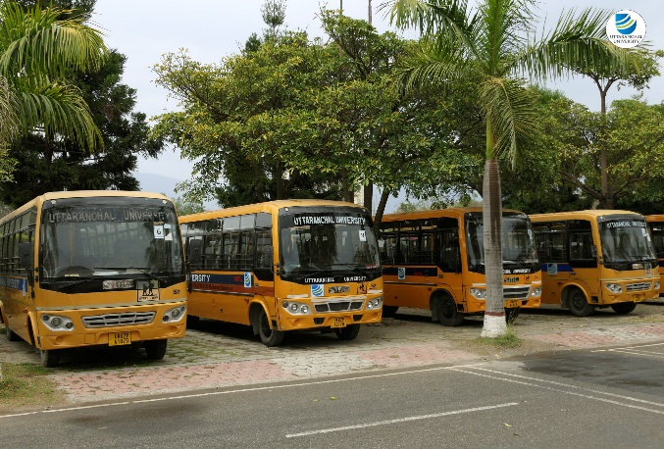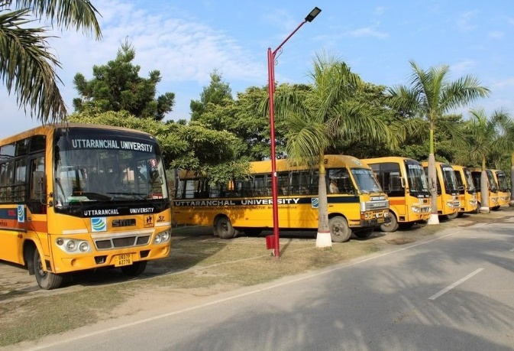

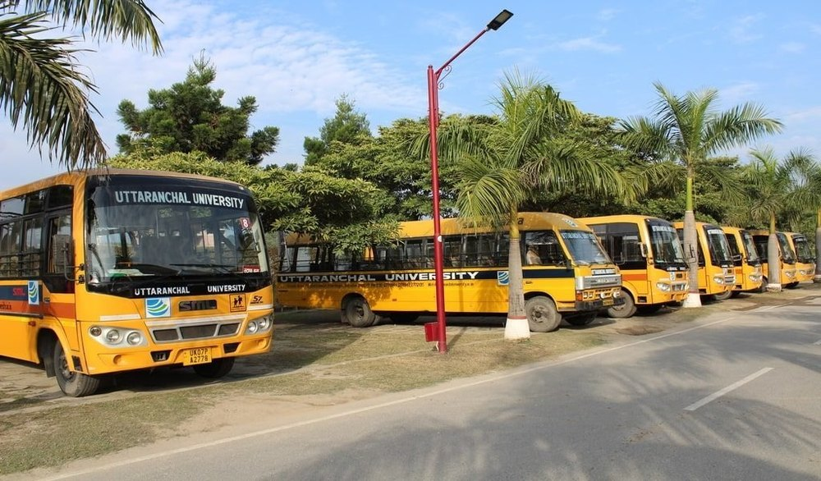

**Community anti-poverty programmes**

Our university is deeply committed to addressing poverty in the local community through a range of impactful anti-poverty programs. These include mentorship programs that provide guidance and support to local youth, training workshops that equip individuals with valuable skills in entrepreneurship, research projects in areas on various disciplines, agriculture, and trades, and access to university facilities for hands-on learning. By fostering education, skills development, and community engagement, these initiatives empower individuals to improve their livelihoods, create sustainable businesses, and break the cycle of poverty.

**Central Instrumentation Facility**

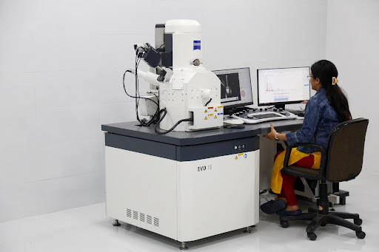Our advanced analytical tools, including the Scanning Electron Microscope (SEM) with Energy Dispersive Spectroscopy (EDS), X-Ray Diffractometer (XRD), and Fourier-Transform Infrared (FTIR) Spectrometer, are pivotal in promoting community welfare and enhancing the financial empowerment of nearby village populations through their occupations. By offering precise imaging and elemental analysis, the SEM-EDS allows local artisans and industries to improve product quality, especially in fields such as agriculture, pottery, and metalwork. The XRD enables villagers engaged in mining and materials extraction to better understand the properties of minerals and metals, leading to more efficient and sustainable practices. The FTIR Spectrometer provides valuable insights into organic and inorganic materials, helping local businesses refine their processes and develop new products. Together, these technologies not only support scientific innovation but also foster economic growth, education, and sustainable development, empowering rural communities to improve their livelihoods.

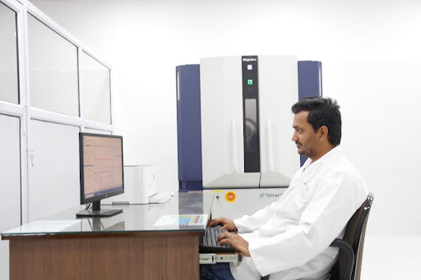

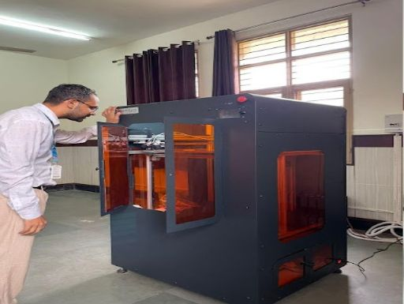

**University Soil Health Testing Facility**

University’s Soil Health Testing Facility is committed to improving community welfare and empowering nearby villages by enhancing their agricultural practices. With a team of experts in soil science, ecology, and agronomy, the facility helps local farmers improve soil health, leading to higher crop yields and more sustainable farming. Through advanced soil testing, field studies, and outreach programs, the facility provides farmers with crucial insights into soil composition, nutrient management, and regenerative techniques. These efforts not only increase agricultural productivity but also help farmers adopt eco-friendly practices, reducing costs and increasing their income. By fostering healthier ecosystems and promoting long-term agricultural resilience, the facility plays a key role in boosting the financial empowerment of rural communities and ensuring food security for the future.

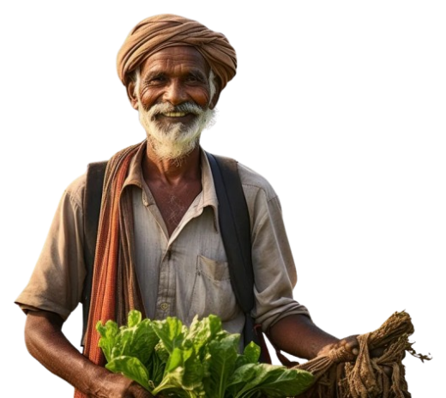

***Empowering farmers with insights for***

 ***healthier soil and better yields***

**Soil Health Card**

*Status of soil with respect to 12 parameters,*

*namely N,P,K (Macro-nutrients); S (Secondary- nutrient); Zn, Fe, Cu, Mn, Bo (Micro - nutrients); and pH, EC, OC (Physical parameters).*

**Awareness Programs**

Uttaranchal University is actively engaged in the development of the nearby community through a variety of impactful initiatives. We organize Legal Aid Awareness Camps to educate people about their rights and provide access to free legal support. Our Agricultural Awareness Camps offer guidance on modern farming techniques and sustainable practices to boost productivity for local farmers. Additionally, we conduct Awareness Camps on critical social issues such as drugs, alcohol, domestic abuse, child health, sanitation, gender equity, and waste management to foster healthier and more informed communities. To promote self-reliance, we offer Training on Self-Employment and Entrepreneurship, equipping individuals with the skills needed to start their own ventures. We also provide Free Health Checkup Camps to ensure the well-being of residents and conduct Environment Awareness Camps to encourage sustainable practices and environmental stewardship. Through these efforts, our university is committed to enhancing the quality of life and fostering the sustainable development of the local population.

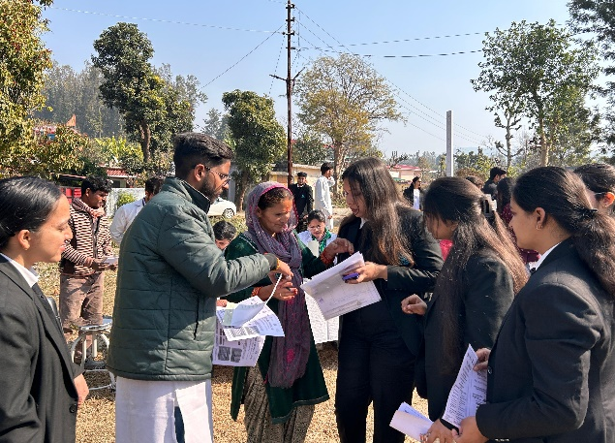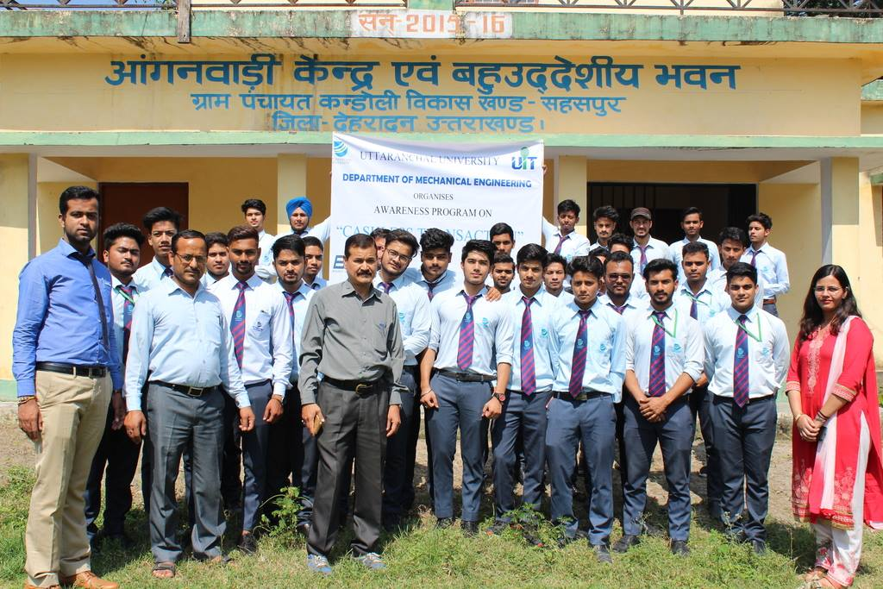

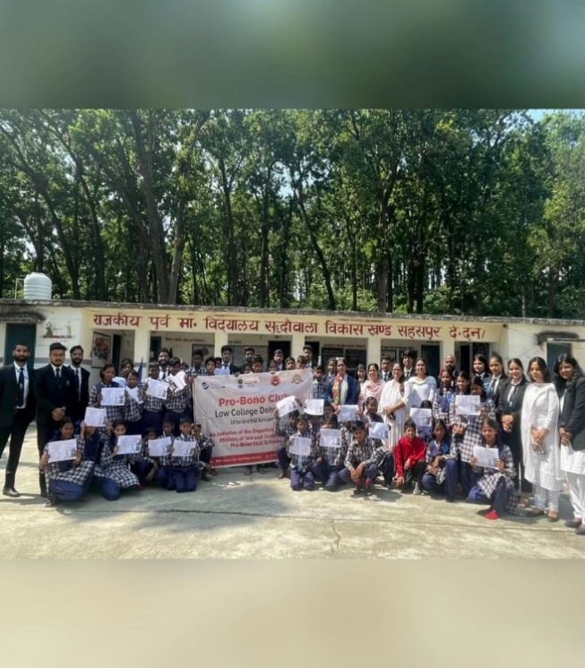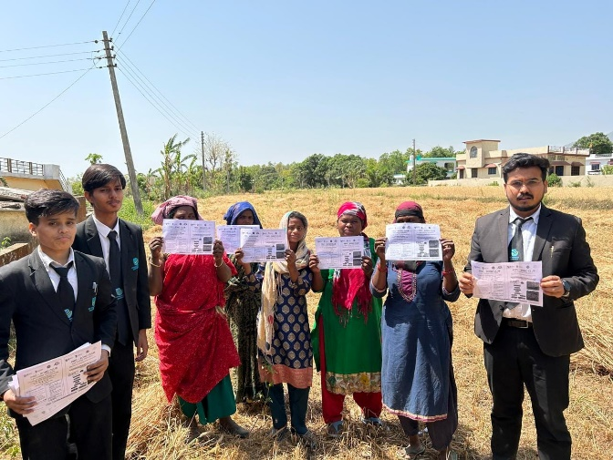

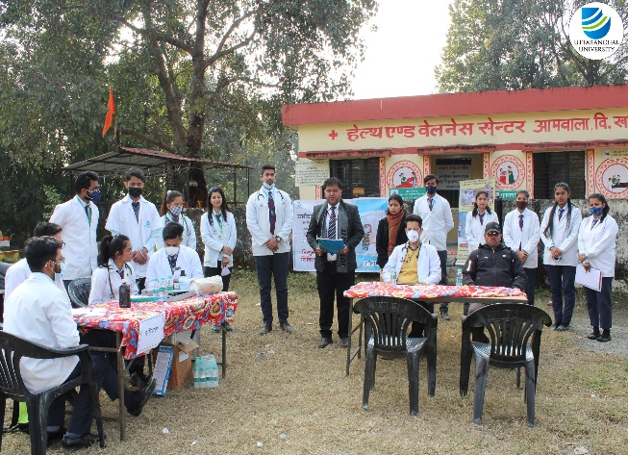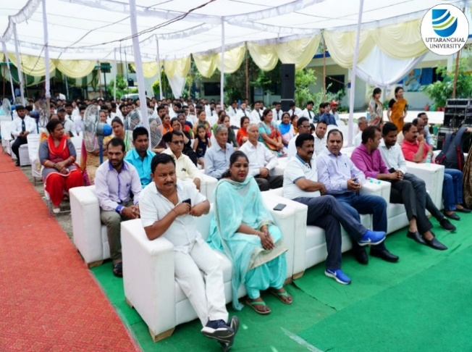

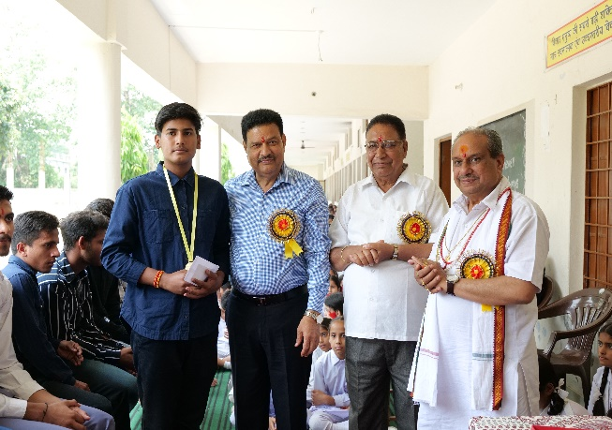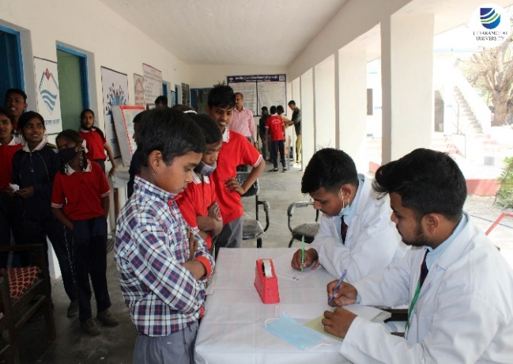

**Local start-up financial assistance**

Uttaranchal University’s Startup, Incubation & Entrepreneurship Cell is officially registered under the Uttarakhand Startup Council, Directorate of Industries, Government of Uttarakhand, India. It is dedicated to supporting startups from the local community, students, and staff, fostering innovation and entrepreneurial growth in the region.

**Programmes for services access**

The university plays a vital role in supporting the local community by offering a wide range of free services and educational opportunities. These include training programs focused on agriculture, sanitation, and food and nutrition, which aim to improve local practices and raise awareness about sustainable living. The university also regularly organizes free health checkup camps, ensuring that community members have access to essential healthcare services.

In addition to health and education, the university provides access to state-of-the-art laboratory facilities for soil testing, helping local farmers enhance their agricultural productivity. Workshops on startups and entrepreneurship are also available, encouraging innovation and fostering economic growth by equipping participants with the skills and knowledge needed to start and manage successful businesses. Through these initiatives, the university actively contributes to the social, economic, and environmental well-being of the community.

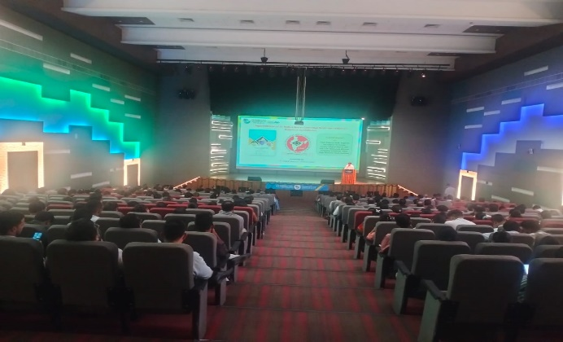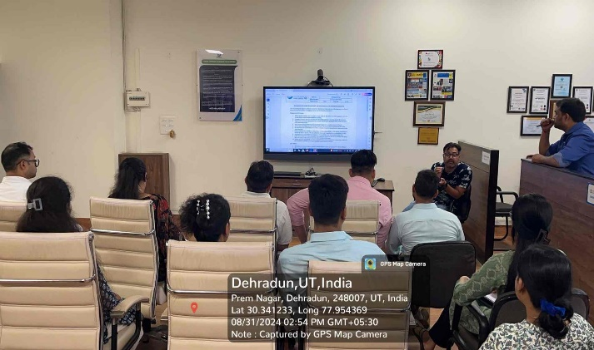

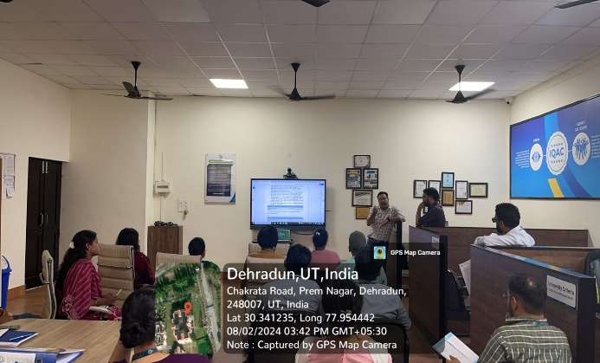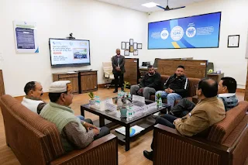

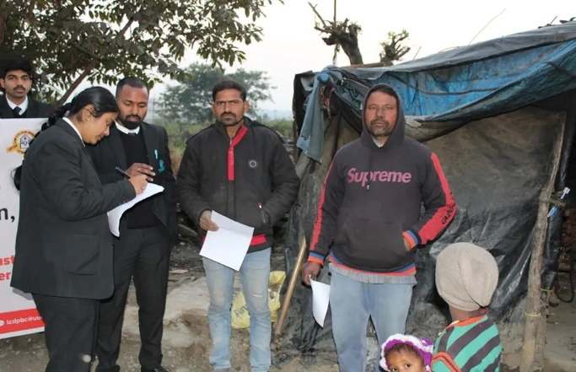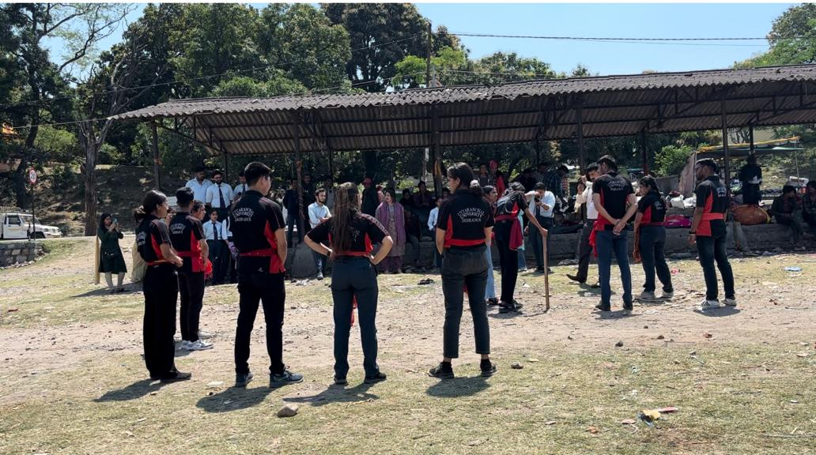



**Amount of food waste generated from food served within the university**

* Uttaranchal University takes great pride in promoting sustainability and actively monitoring our environmental impact, including the measurement of food waste generated from food served within the university on campus.
* Our university remains committed to minimizing food waste and is continuously working towards further reduction and sustainability initiatives.
* We firmly believe in the importance of responsible food consumption and waste reduction to contribute to a more environmentally friendly and socially responsible community.
* Uttaranchal University does not outsource its food services.

Uttaranchal University is committed to promoting sustainability and closely monitoring its environmental footprint, including tracking food waste generated from campus’s dining services. The table below presents data from the last two years, reflecting our ongoing efforts to measure and reduce food waste. Notably, all food services are managed in-house, with no outsourcing involved.

|  |  |
| --- | --- |
| **Year** | **Amount of food waste generated in a year (in Metric Tons)** |
| 2023 | 2.52 |
| 2024 | 3.67 |
| 2025 | 134.44782 |

The data indicates a sudden and significant surge in 2025, which is unusually high compared to the previous years. This spike could be attributed to several potential factors:

**Increase in Campus Population or Events:** A higher number of students, staff, or large-scale events might have contributed to excess food being prepared and not consumed.

**Changes in Food Service Practices:** Over-ordering or poor portion management in cafeterias or hostels may have resulted in more unutilized food.

**Reporting/Measurement Changes:** The sudden jump could also be due to more accurate measurement techniques or inclusion of previously unaccounted food waste streams.

**Steps Taken by the University to Reduce Food Waste**

* Uttaranchal University has implemented several initiatives to minimize food waste and promote sustainability:
* Educational programs and awareness drives among students and staff to encourage mindful consumption.
* Adoption of better inventory management in cafeterias to align food preparation with actual demand.
* Leftover food is redirected to local NGOs or community programs whenever possible, reducing wastage.
* Organic food waste is composted or converted into bio-fertilizer, contributing to a circular waste management system.
* Regular tracking of food waste generation helps identify critical areas and implement corrective actions.

While the sharp increase in 2025 is concerning, it provides the university an opportunity to strengthen its food waste management practices. Through continuous awareness, monitoring, and sustainable waste handling, Uttaranchal University aims to significantly reduce its food footprint and promote a greener campus.

**List of a few of the academic programs offered by the institution in response to the query.**

|  |  |  |  |
| --- | --- | --- | --- |
| **S. No.** | **Program Name(s)** | **Program Description** | **Applicable School(s)** |
| **1** | **M.Sc. Food Nutrition and Dietetics** | The M.Sc. Food Nutrition and Dietetics program advances SDGs by promoting food security (SDG 2), improving public health (SDG 3), fostering sustainable consumption (SDG 12), and enhancing quality education in nutrition (SDG 4) | School of Applied & Life Sciences |
| **2** | **B.Sc. (Hons.) Agriculture** | B.Sc. Agriculture program is highly relevant to the SDGs, as it equips students with the knowledge and skills needed to address key global challenges related to food security, poverty reduction, environmental sustainability, and more. | School of Agriculture |
| **3** | **B.Sc. Food Technology** | B.Sc. in Food Technology program is related to UNSDGs, especially the goals related to food security, health, responsible consumption and production, environmental sustainability, and economic development. | School of Applied & Life Sciences |
| **4** | **M.Sc. Environmental Science** | M.Sc. in Environmental Science equips individuals with the knowledge and skills needed to address various environmental challenges, contributing significantly to the achievement of multiple SDGs. | School of Applied & Life Sciences |
| **5** | **B.Sc. (Chemistry, Biology, Zoology)** | Bachelor of Science (B.Sc.) degree that combines chemistry, biology, and zoology addresses a wide range of global challenges related to environmental conservation, public health, and biodiversity. | School of Applied & Life Sciences |
| **6** | **B.Sc. Biotechnology** | B.Sc. Biotechnology graduates have the potential to drive innovation, conduct research, and develop solutions that directly contribute to achieving the SDGs, particularly in the areas of health, agriculture, environment, and industry. | School of Applied & Life Sciences |
| **7** | **Open Electives** | The pool of SDG courses from the central basket of open electives addresses global challenges pertaining to biodiversity and eco-sustainability. | 12 Academic Schools |
| **8** | **Doctoral Research** | The various doctoral research programs contribute well to the sustainable development goals of the mother Earth. | School of Applied & Life Sciences |

Uttaranchal University is committed to addressing the issue of hunger and ensuring the well-being of its students and staff. As part of our ongoing efforts, we provide various interventions to prevent and alleviate hunger. These interventions include the establishment of various **eateries and pantries on campus**, which are easily accessible to all members of the university community.

**The table below outlines some of the key initiatives and services we offer:**

* **On-Campus Food Eateries & Pantries:** We maintain on-campus eateries & food pantries stocked with a variety of non-perishable food items to ensure that students and staff in need have access to essential provisions.
* **Meal Assistance Programs:** We offer meal assistance programs that provide nutritious meals to those facing food insecurity, enabling them to focus on their academic and professional pursuits.
* **Awareness & Education:** We conduct awareness campaigns and educational initiatives to inform the university community about the available resources and support for addressing hunger- related issues.
* **Collaboration with local NGOs:** We collaborate with local non-governmental organizations to enhance our efforts in providing support to those in need.
* **Confidential Assistance:** We ensure that assistance is provided confidentially and with dignity to protect the privacy of individuals seeking support.

At our university, the University Meal Assistance Program (UMAP) is designed to ensure that both students and staff have access to essential dining services and accommodation support. Each year, the program provides crucial assistance to individuals who may face financial challenges, helping them maintain their well-being while focusing on their academic or professional responsibilities.

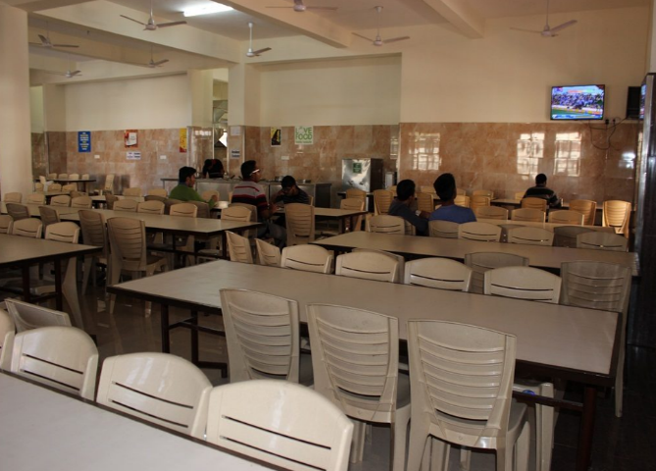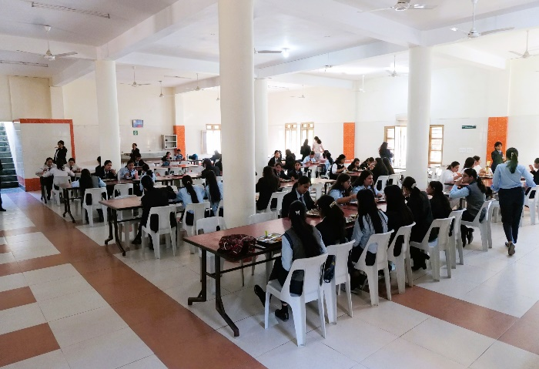

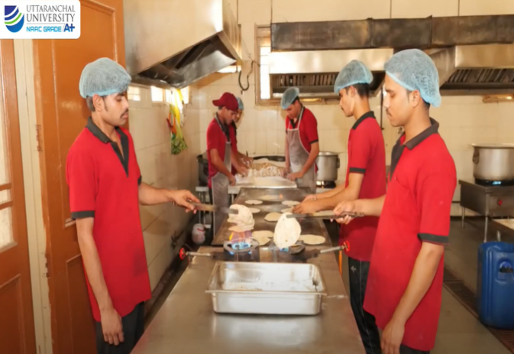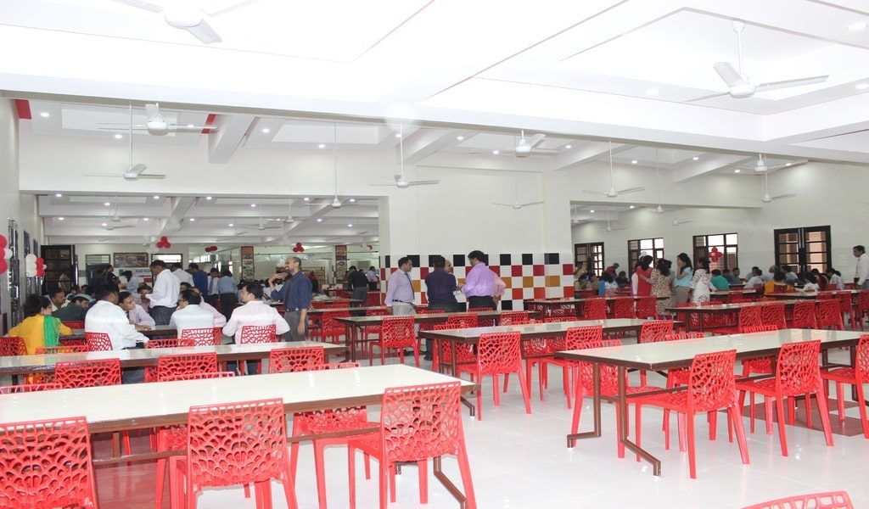

Uttaranchal University is dedicated to offering sustainable food choices to all members of the campus community, with a focus on vegetarian and vegan options. This initiative reflects the university's commitment to promoting health and environmental sustainability.

* **Sustainable Sourcing:** The university collaborates with suppliers and vendors who emphasize sustainable sourcing. This includes locally grown produce, organic options, and ethically sourced ingredients.
* **Vegetarian & Vegan Menus:** A wide variety of plant-based meal options are available daily, ensuring that sustainable, vegetarian, and vegan choices are always accessible. This variety supports a balanced and eco-conscious diet.
* **Menu Diversity:** The dining services offer an extensive selection of sustainable and plant-based meals, promoting an environmentally responsible and diverse dietary approach.
* **Eco-Friendly Practices:** Dining facilities have adopted eco-friendly measures, such as reducing food waste, offering reusable utensils and containers, and minimizing single-use plastics. These practices enhance the sustainability of the campus dining experience.
* **Student Feedback:** Students and staff have expressed positive feedback about the quality, variety, and availability of sustainable food options, highlighting the success of these initiatives.

*This above detail offers a comprehensive overview of the practices and options in place at Uttaranchal University, confirming the provision of sustainable food choices, including vegetarian and vegan offerings on campus.*

**Well-being and overall health of our students**

At Uttaranchal University, **we are committed to promoting the well-being and overall health of our students, faculty, and staff**. One crucial aspect of this **commitment is ensuring that everyone on our campus has access to a variety of healthy and affordable food choices**. **We understand the importance of a balanced diet in supporting the physical and mental health of our university community**.

To this end, we have implemented a range of food services on our campus, offering a diverse selection of nutritious and budget-friendly options to cater to the diverse preferences and dietary needs of our community.

|  |  |  |
| --- | --- | --- |
| **Dining facility** | **Cuisine Type** | **Menu Highlights** |
| University Mess & Cafeteria | Multi cuisine | Nutritious daily specials, vegetarian and non- vegetarian options (On demand) |
| Health, Food Kiosk (Lamour) | Healthy Choices | Fresh salads, smoothies and organic snacks |
| Cafe | Global Flavors | Delicious cuisine, including pizza, pasta, and more |
| Coffee Shops | Beverages & Snacks | A variety of coffee, tea, pastries, and light snacks |

Moreover, our food services are designed to cater to **different budget preferences, ensuring that everyone can find options that suit their financial resources**. It is our goal to make nutritious meals accessible to all members of the Uttaranchal University community.

**Uttaranchal University plays a significant role in enhancing food security and promoting sustainable agriculture and aquaculture in the region by providing knowledge, skills, and technology to local farmers and food producers**.

**Here is a tabulated summary of the evidence supporting these efforts:**

|  |  |  |
| --- | --- | --- |
| **Initiatives** | **Description** | **Actions** |
| **Research Programs** | The university conducts research in agricultural and aquaculture sciences, leading to innovations and best practices. | Research publications, patents, and projects in these fields. |
| **Extension Services** | The university offers extension services to educate local farmers about modern farming techniques, crop management, and sustainable practices. | Workshops, training sessions, and outreach programs organized for farmers. |
| **Collaboration** | Collaboration with govt. agencies, NGOs, and industry partners to promote sustainable agriculture and aquaculture. | Memorandums of Understanding and partnership agreements with various organizations. |
| **Curricular Focus** | Academic programs are designed to equip students with knowledge and skills related to food security and sustainable agriculture. | Course syllabi, curriculum development |
| **Demonstration Farms through Rural Agricultural Work Experience** | Establishment of demonstration farms for showcasing modern farming and aquaculture methods. | Field visits, farm tours, and practical learning opportunities for students and locals. |

Uttaranchal University is dedicated to fostering **connections and knowledge transfer opportunities for local farmers and food producers**. We are fully committed to organizing events and initiatives that facilitate these interactions.

**Here is a summary of the activities conducted in the university:**

* **Campus Haat:** A market where local farmers from registered nearby villages can sell their produce directly to the academic community on university campus.
* **Food Producer Workshop:** An interactive workshop that provided food producers with insights on the latest industry trends and best practices.
* **Agricultural Workshops & Other Activities:** A large-scale event that brought together farmers, food producers, and experts to discuss and exchange knowledge.
* **Farm Tours:** Guided tours of our university's research farm to offer practical insights to local farmers.
* **Collaborative Projects:** Ongoing partnerships with local farmers and food producers to jointly develop and test innovative agricultural practices such as by issuing them **soil health cards, efficient mushroom cultivation techniques, apiculture, aquaculture** and **water test reports** etc.

Uttaranchal University is dedicated to providing local farmers and food producers with **access to our university facilities, including labs, technology, and plant stocks, to enhance sustainable farming practices**.

**Below is a table illustrating some of the key instances where we have facilitated such access:**

|  |  |  |
| --- | --- | --- |
| **Access Initiative** | **Facility Offered** | **Description** |
| **Lab Access Program** | University laboratories, equipment | A program allowing local farmers to utilize our state-of-the-art laboratories and equipment for research and testing such as **soil** and **water testing** etc. |
| **Technology Sharing** | Technological resources | Sharing of technological resources and expertise with local farmers to aid in optimizing their farming practices. |
| **Plant Stock Access** | Plant stocks, University research farms | Providing local farmers with access to our research farms and diverse plant stock collections for experimentation and cultivation. |

These initiatives showcase our commitment to promoting sustainable farming practices and supporting our local agricultural community. **We firmly believe that by opening our resources to local farmers and food producers, we contribute to the development of innovative and eco-friendly farming methods.**

Uttaranchal University prioritizes purchases contributing to our sustainability initiatives and supporting the local economy. Uttaranchal University supports the campus food needs through its canteens, mess, and food courts, actively sourcing local farm products. The university also promotes sustainable purchasing. The well-known **Niranjanpur Mandi**, a popular city destination, receives its diverse supply of **fresh food, fruits, vegetables, millet** & other **local produce** and various provisions from local farmers and agro-producers.

|  |  |  |
| --- | --- | --- |
| **Initiative & Policy Name** | **Description of Initiative** | **Impact** |
| **Sustainable Food Procurement Practices** | Implementation of a formal policy that mandates the preference of products and services from local, sustainable sources. | Reduced carbon footprint, support for local businesses. |
| **Local food sourcing** | A program dedicated to sourcing a significant portion of our institution's food products from local farmers and producers. | Promotion of local agriculture and reduced food miles. |



**Number graduating in health professions.**

The number of students graduating from the university's health profession programs at both undergraduate (UG) and postgraduate (PG) levels has been steadily increasing. This overall growth reflects the increasing demand for skilled professionals in the healthcare field, as well as the university's commitment to providing quality education in health-related disciplines.

**Collaborations and health services**

Collaborations with health services in our university span across local, national, and global levels, enriching our approach to student health and well-being. Locally, we partner with nearby hospitals, clinics, and Pharma Companies to provide accessible, timely care and health education to students. These partnerships also offer practical experiences for students pursuing healthcare-related fields. Nationally, our university collaborates with leading healthcare organizations and government health bodies, allowing us to adopt best practices, participate in research initiatives, and contribute to nationwide health campaigns. On a global scale, we engage with international health institutions and universities, facilitating the exchange of knowledge, innovative health solutions, and cross-cultural perspectives on wellness. These multi-level collaborations ensure our university stays at the forefront of healthcare delivery, research, and education, benefiting both the student body and the wider community.





**Velmed Hospitals, Dehradun**



**Ved Lifesaver (P) Ltd.**





**Health outreach programmes**

Our university’s health outreach initiatives for local communities, disadvantaged populations, and refugee/immigrant groups aim to reduce health disparities and improve access to essential care. Through health camps, health education workshops, and partnerships with community organizations, these programs provide free medical services such as screenings, immunizations, and preventive care. Special initiatives for disadvantaged populations address barriers like cost, transportation, and awareness by offering services such as psychological health support, chronic disease management, and nutrition education. For refugee and immigrant communities, the programs offer culturally sensitive care, multilingual resources, and assistance in navigating healthcare systems. These efforts promote equity, enhance health outcomes, and create stronger connections between the university and the communities it serves.

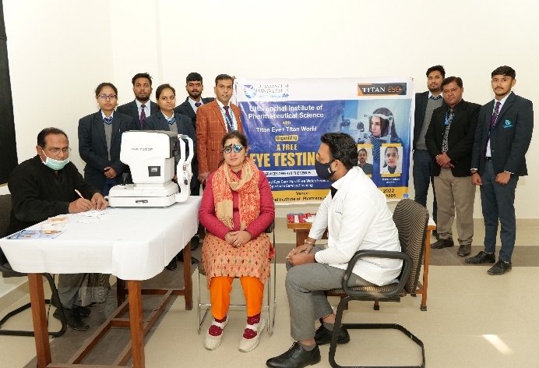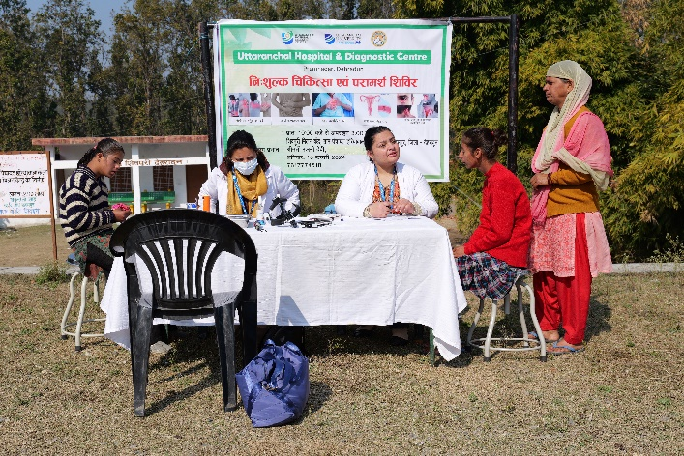

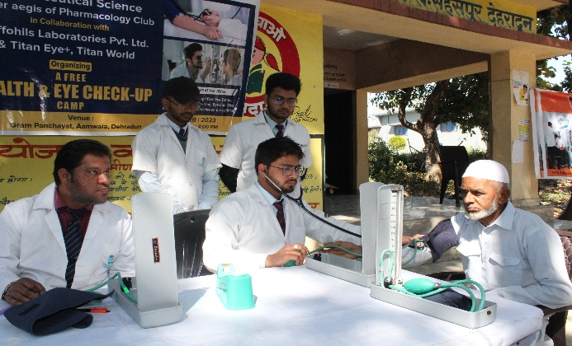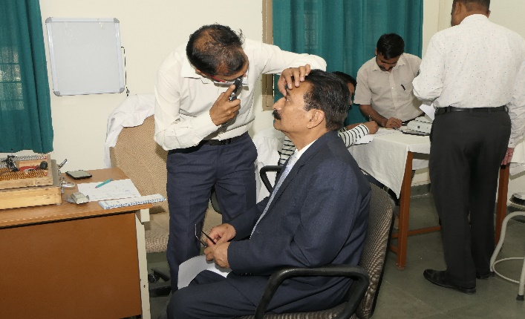

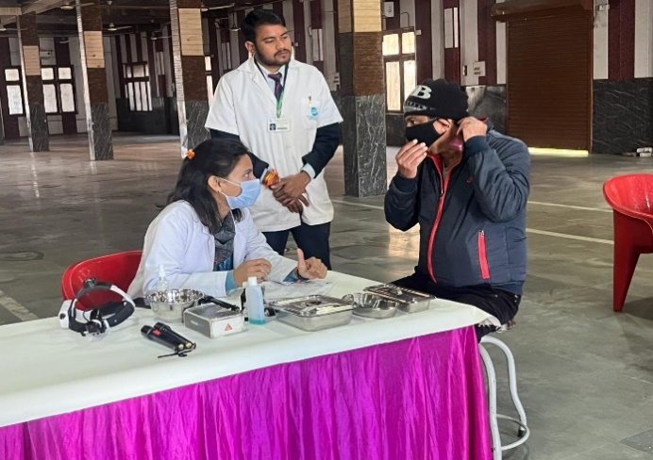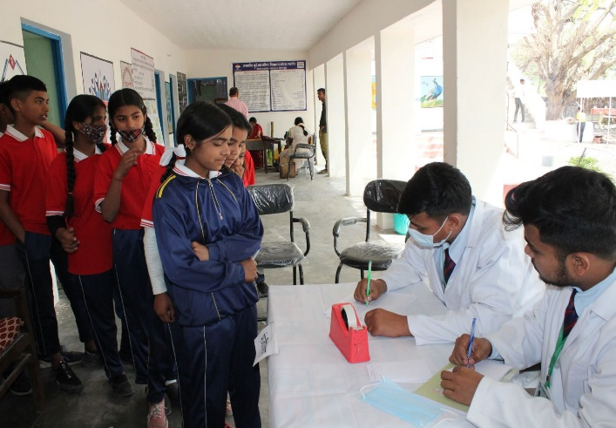

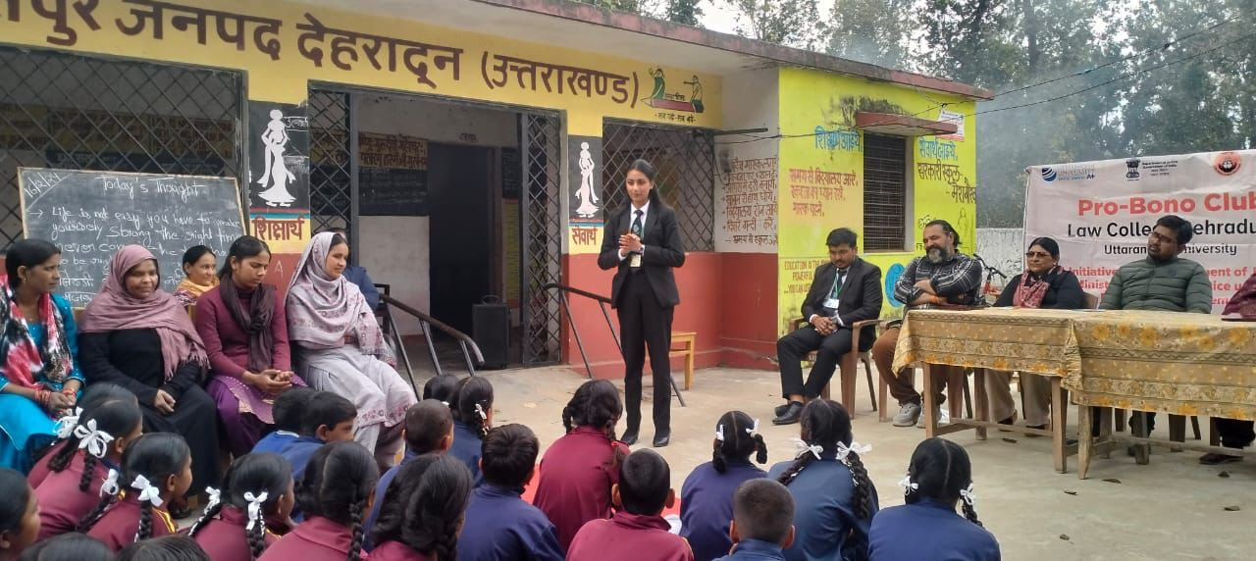

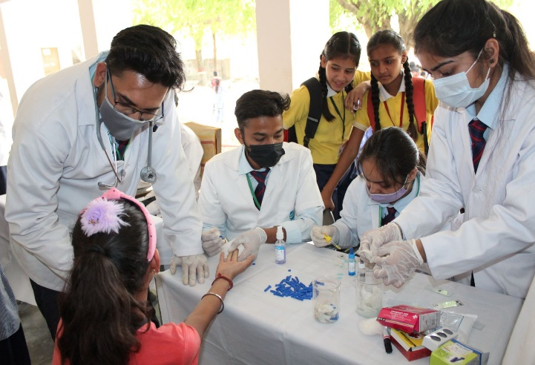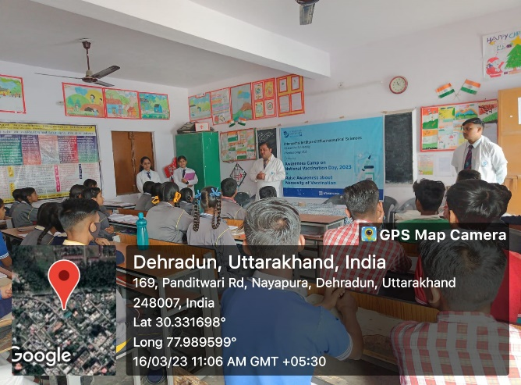

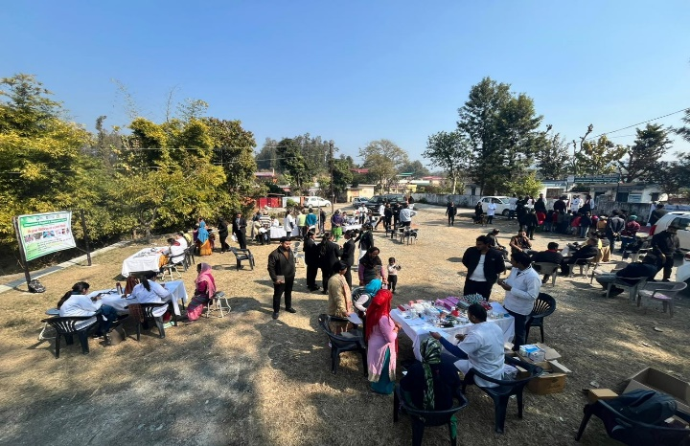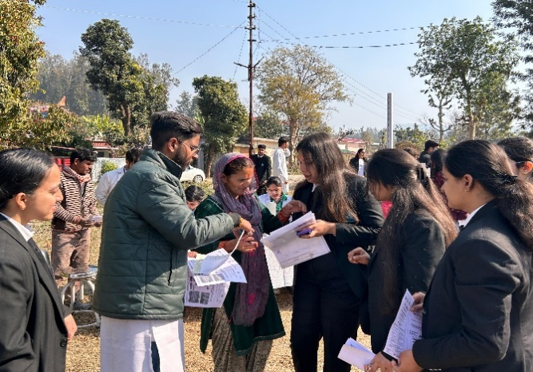

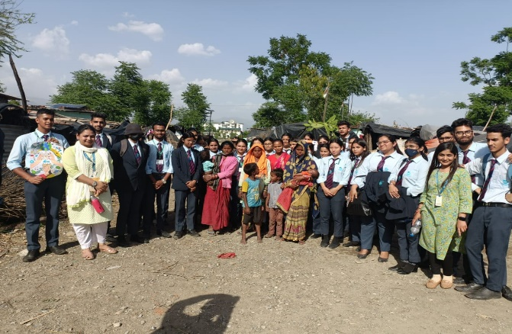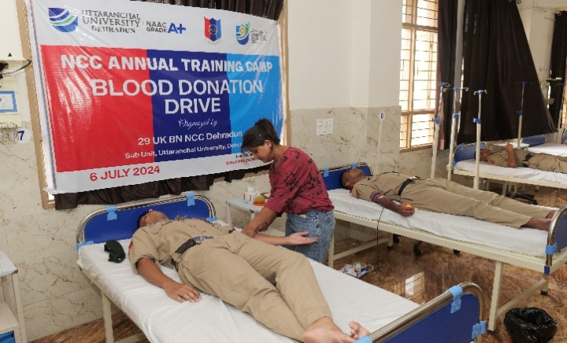

**Shared sports facilities**

**Yoga**

The university is dedicated to fostering both academic achievement and holistic development among its students. Recognizing the importance of physical and mental well-being, the university offers a comprehensive sports and fitness program that includes yoga. Practicing yoga supports the balance of mind, body, and soul, promoting a healthy body, a peaceful mind, and enhanced flexibility, while also helping manage stress and anxiety.

To support these goals, the university has invested in a spacious Yoga Hall. This facility is not only a resource for students, faculty, and staff but also serves as a hub for the local community and nearby schools. The Yoga Hall is available for community fitness events and workshops, providing a valuable space for residents and students from neighbouring schools to engage in yoga and meditation practices. This initiative extends the university's commitment to wellness beyond its campus, fostering a collaborative environment for physical and mental health within the broader community.

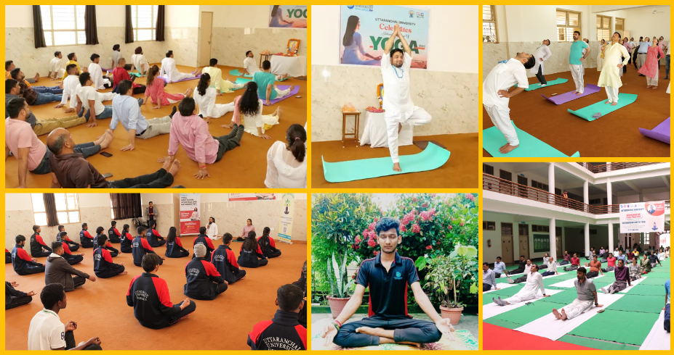

**Outdoor**

The university is dedicated to promoting outdoor sports and physical activity, offering extensive infrastructure, coaching facilities, and attendance concessions to support students. Recognizing the broader community's need for access to quality sports resources, the university also makes these facilities available to local residents and nearby schools.

Our expansive playing fields are equipped to host a diverse range of games, including Cricket, Volleyball, Football, Hockey, and Tennis. Additionally, our outdoor facilities feature courts for Basketball, Volleyball, Handball, and Tennis. By sharing these resources, the university fosters a spirit of collaboration and encourages community engagement, providing valuable opportunities for local schools and residents to participate in and benefit from top-notch sports amenities.



**Indoor Sports**

The university gives equal prominence to sports activities which are required for overall physical and intellectual development of the students. The university has a sports room, which is a hub of many indoor games like carom, table tennis, chess and many more. These games inculcate the spirit of true sportsmanship among students.

* **Carrom -** It is a game which develops bonding among students and at the same time relaxes and refreshes their minds.
* **Table Tennis -** It's a game which requires great hand-eye coordination and improves concentration and mental alertness among students, thus making them more attentive in academics.
* **Chess -** It is a game which improves creativity among students and also makes them more efficient in problem solving. It improves their neural qualities.

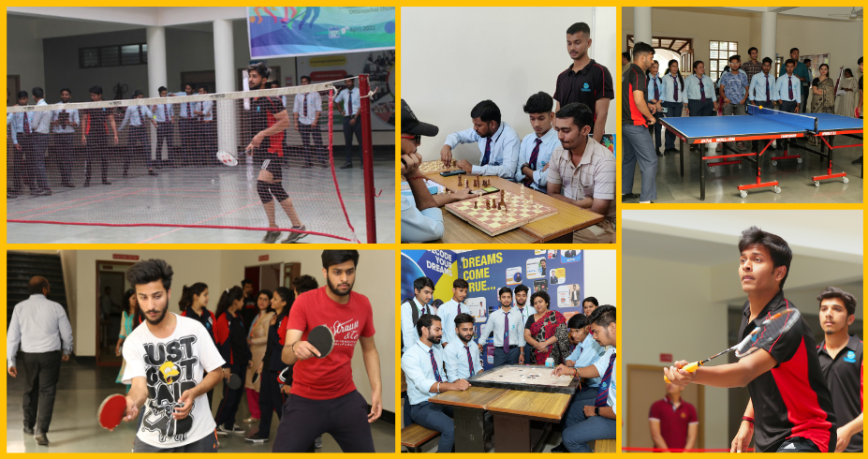

**Gym**

We embrace the motto "health is wealth," which is why our campus features a state-of-the-art gymnasium designed to support the fitness goals of both students and staff. Equipped with the latest machines and fitness instruments, our gym ensures you have access to top-quality resources. Professional trainers are available throughout the day to assist beginners and help everyone achieve their fitness aspirations.

To accommodate diverse schedules and preferences, we offer designated time slots for faculty and students, as well as separate hours for girls and boys, ensuring a comfortable and inclusive environment for all. The gym includes specialized areas for general exercise, weight training, and advanced workouts, catering to a wide range of fitness needs.

For detailed membership rules and information, please visit the campus office.



**Sexual and reproductive health care services for students**

Our university is dedicated to promoting sexual and reproductive health through a variety of initiatives that cater to both students and the wider community. These initiatives are designed to provide education, access to care, and support for individuals at every stage of their reproductive health journey.

* **Health Camps:** We regularly organize health camps focused on sexual and reproductive health. These camps offer free screenings, consultations, and educational workshops on topics such as STI prevention, contraception options, and general reproductive health. Health professionals and specialists are on hand to provide valuable information and support in a convenient and accessible setting.
* **Menstrual Cycle Education:** Understanding and managing menstrual health is crucial, which is why we conduct workshops and seminars on menstrual cycle awareness. These sessions cover topics such as menstrual hygiene, managing menstrual symptoms, and the impact of menstrual health on overall well-being. We also distribute menstrual hygiene products and provide resources to ensure students have what they need for their health.
* **Reproductive Health and Hygiene Awareness:** Our university hosts awareness campaigns and educational programs to inform students and community members about reproductive health and hygiene. These initiatives aim to debunk myths, clarify misconceptions, and provide accurate information on topics such as contraception, safe sex practices, and reproductive health care.
* **Confidential Counselling Services:** We offer confidential counselling services to address personal concerns related to sexual and reproductive health. Our trained counsellors provide a safe space for students to discuss issues such as sexual health, reproductive planning, and emotional support, ensuring that everyone has access to the help they need.
* **Community Partnerships:** We collaborate with local health organizations and clinics to enhance our support services. These partnerships allow us to offer additional resources, such as specialized clinics and referral services, ensuring that both students and community members receive comprehensive care.
* **Regular Workshops and Seminars:** In addition to health camps, we organize regular workshops and seminars on a variety of reproductive health topics. These events are designed to engage students and community members in meaningful discussions, provide valuable information, and foster a culture of health and wellness.

Through these comprehensive initiatives, our university is committed to supporting the sexual and reproductive health of our students and the broader community, ensuring that everyone has access to the information and resources they need to lead healthy lives.

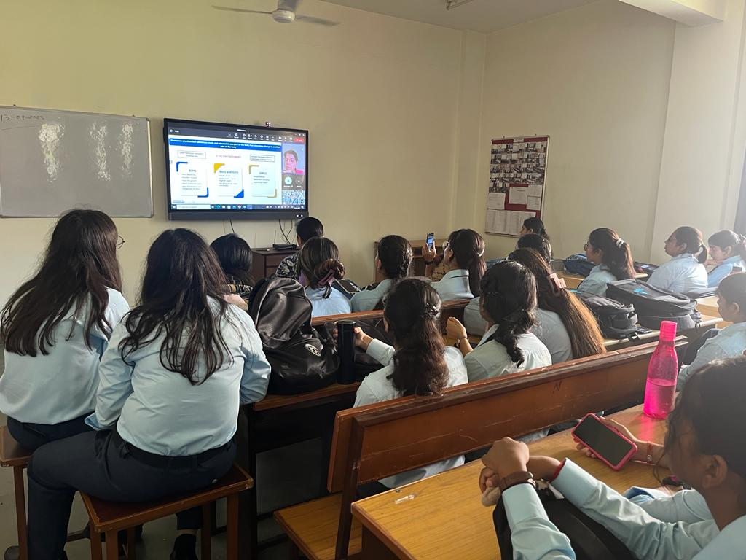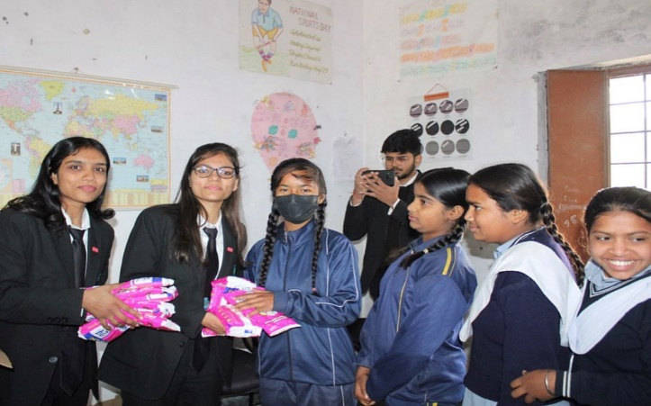

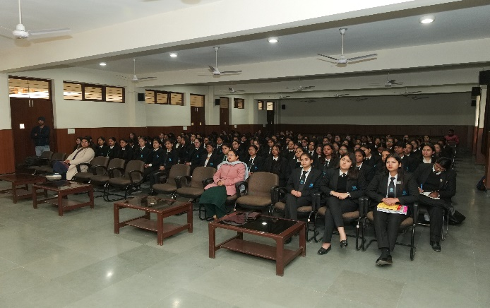

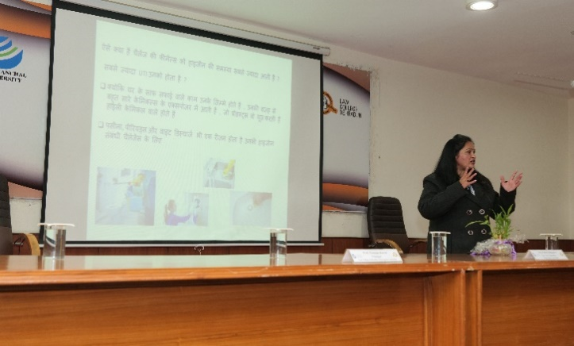

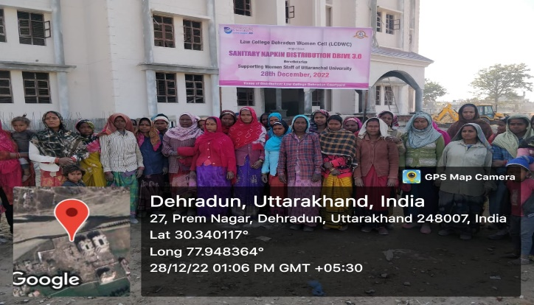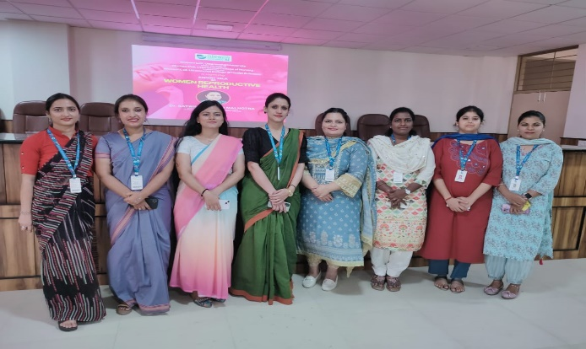

**Mental health support**

**Psychological Counselling Cell**

To foster the emotional and psychological well-being of both the student community and the nearby residents, Uttaranchal University in Dehradun has established the University Psychological Counselling Cell, "Relax and Rewire." This dedicated space, supported by faculty and a professional counsellor, addresses mental health challenges by offering guidance and support to students, staff, faculty, and, where possible, extends its support to the local community.

"Relax and Rewire" encourages individuals to explore their emotions and work through personal challenges. Through individual and group counselling sessions, the Cell provides a safe and confidential environment for addressing emotional and psychological concerns. By working closely with participants, the Cell helps uncover strengths and develop coping mechanisms to handle life’s challenges more effectively.

The Cell also provides guidance on various issues such as personal, social, academic, and interpersonal challenges, equipping individuals with the tools they need for academic achievement, personal development, and career progression. The counselling sessions foster empathy, interpersonal skills, and promote healthier relationships and a balanced lifestyle. Additionally, the counsellor ensures that everyone is supported through a confidential, non-judgmental, and timely approach, fostering a culture of care and emotional well-being.

By extending its resources to both the university and the surrounding community, the Psychological Counselling Cell aims to create a positive impact on mental health and well-being for everyone involved.



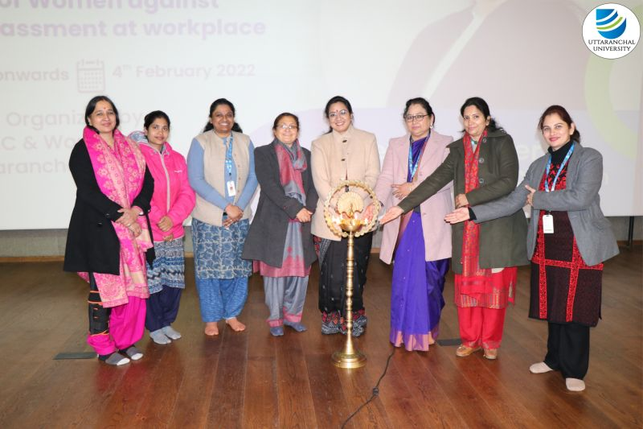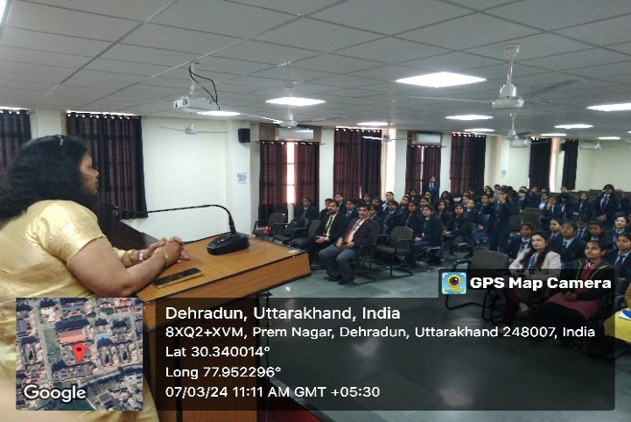

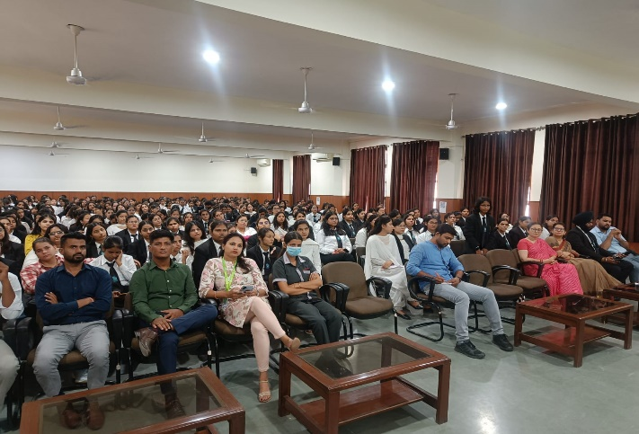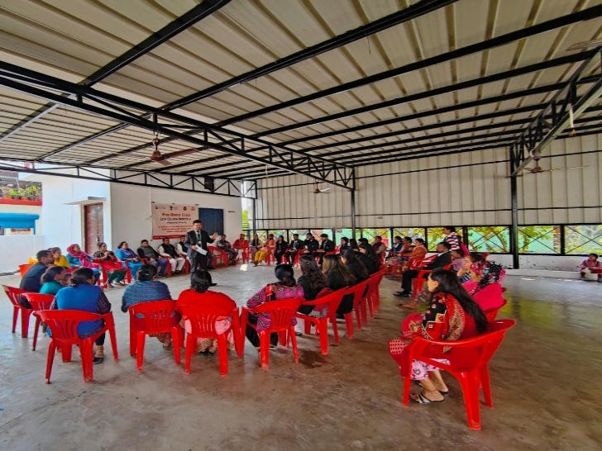

The university extends its commitment to psychological well-being beyond its campus by offering free mental health support to nearby community residents, staff members, and students. Recognizing the importance of mental health in fostering a thriving community, the university’s psychological counselling services are designed to be accessible and inclusive for all, regardless of financial constraints.

By providing these **services at no cost**, the university ensures that individuals who may otherwise have limited access to mental health care can receive the support they need.

**Smoke-free policy**

Our university is dedicated to creating a tobacco-free and smoke-free campus through a range of initiatives aimed at raising awareness and promoting healthier lifestyles. We conduct regular awareness programs that educate the community about the dangers of smoking and tobacco use, highlighting the physical, emotional, and social impacts. To further strengthen this commitment, clear signage across the campus reminds everyone of the university’s smoke-free policy. Additionally, the establishment of an Anti-Drug Cell plays a critical role in monitoring, counseling, and providing support for those struggling with tobacco addiction, ensuring a holistic approach to maintaining a drug-free environment. These combined efforts reflect our commitment to fostering a safe and healthy campus for all.

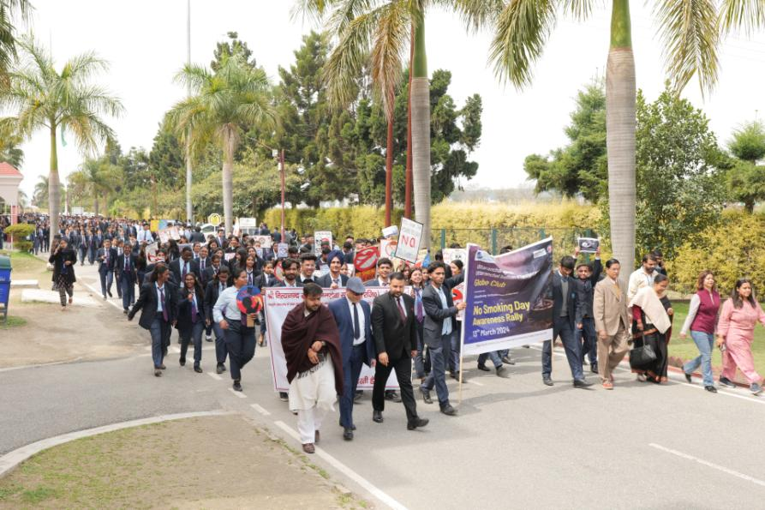

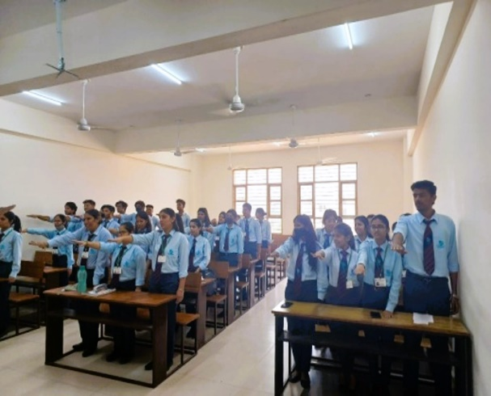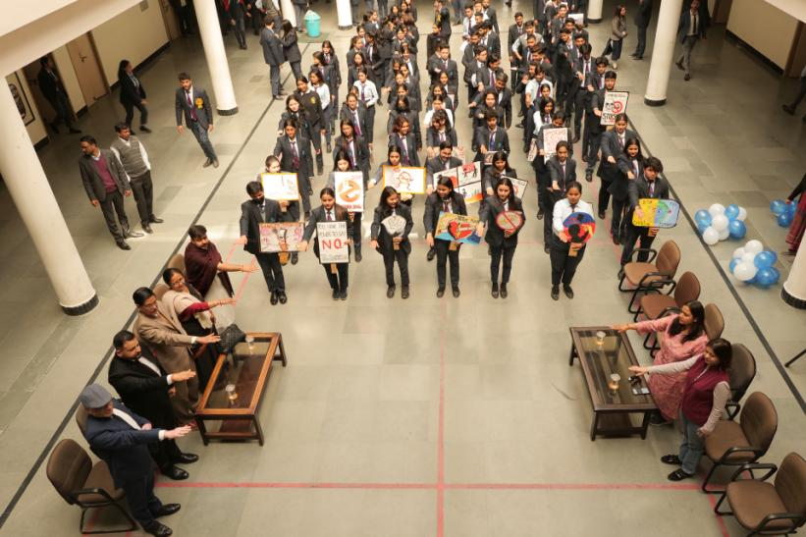



**Proportion of graduates with teaching qualification**

Our university offers variety of programs designed to prepare students for teaching at the primary school level. Students engage in both theoretical coursework and practical teaching experiences, such as internships in local primary schools, which allow them to apply their knowledge in real-world settings. Additionally, the university provides training in inclusive education, classroom management, and the use of technology in teaching, ensuring that future educators can address diverse student needs and adapt to modern educational environments. Graduates of these programs earn qualifications that entitle them to teach in primary schools, contributing to the development of future generations.

**Lifelong learning measures**

Our university offers a range of multidisciplinary programs and continually provides free training courses for university teachers across within cities. Additionally, we offer complimentary physical and online educational resources to government employees and community members who are not enrolled at our institution. Our campus facilities, including libraries, sports fields, and stadiums, are open to the public. We also provide access to computers, WiFi, online courses, and lectures for community use.

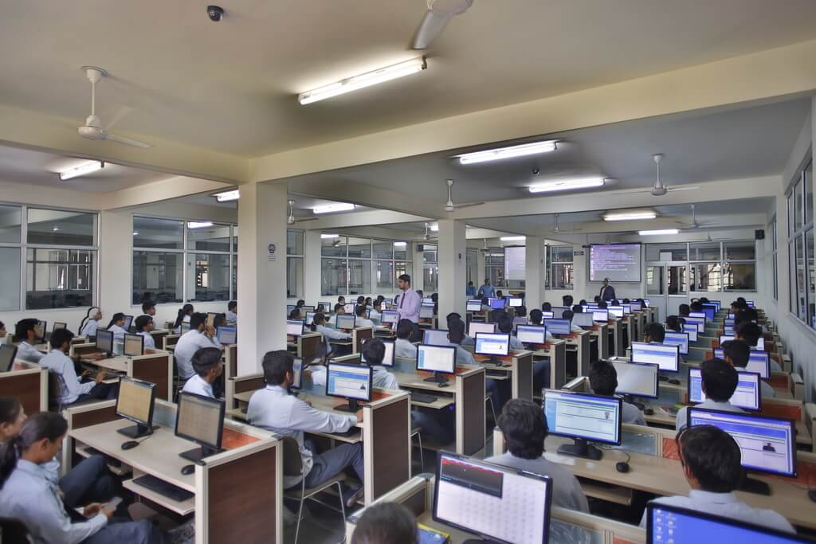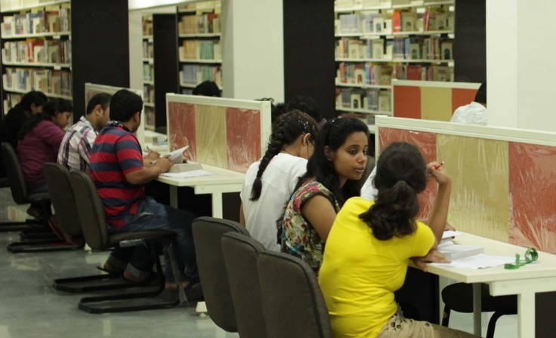

**Library E-Services**

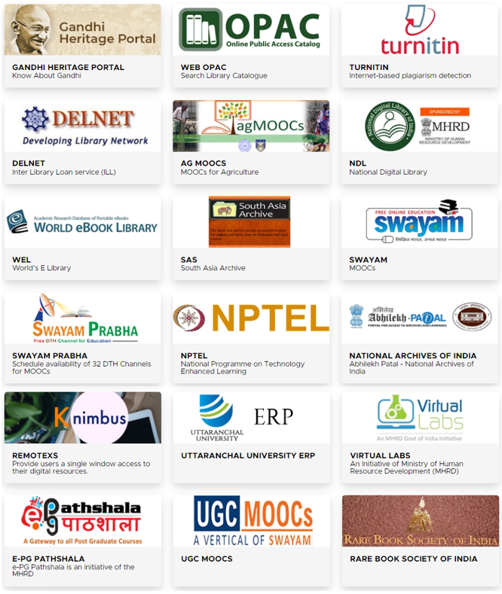

**Infrastructure Facilities for those not studying at the university**

Uttaranchal University is deeply committed to supporting the local community in Dehradun, particularly the schools in the region. As part of this dedication, the university undertakes various innovative and creative initiatives to share its "Learning Resources" with underprivileged communities, especially students from rural schools. These efforts reflect the university's broader mission to foster education and development within its surrounding environment.

* On-campus Residential Facility (on Nominal Charges)
* Hygienic and trending eat-out options
* Ease of Banking & Medical Facility
* Free of cost WIFI enabled Campus
* Modern Sporting Facility
* Gymnasium
* Well stacked Print and Digital libraries
* Digital Kiosks of Library for ease of information across the globe.
* Reading & Studying spaces
* High Performance Computational Labs
* 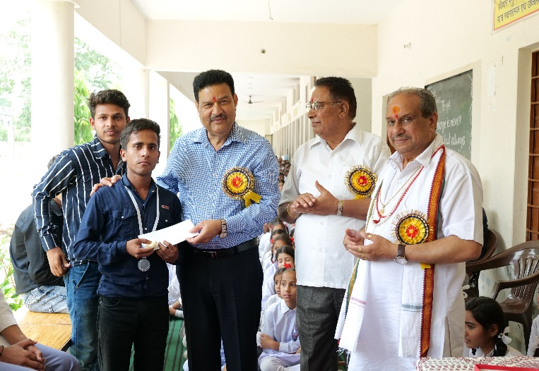Clean & Green Campus

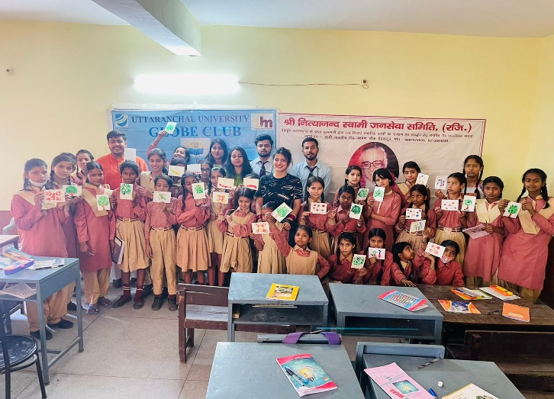

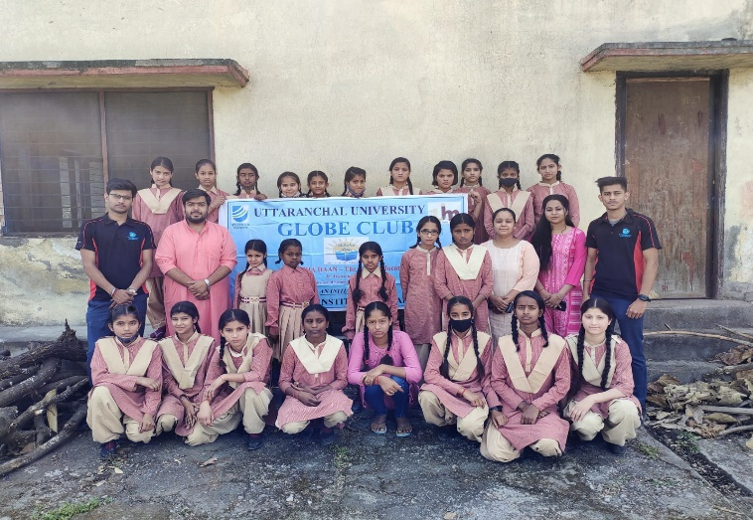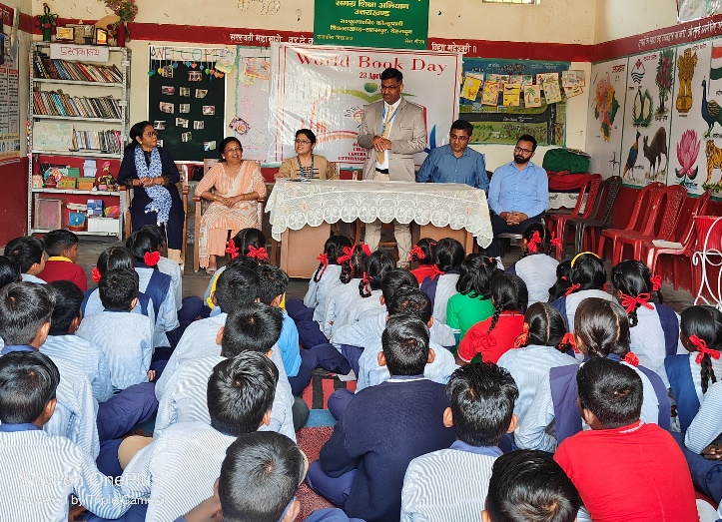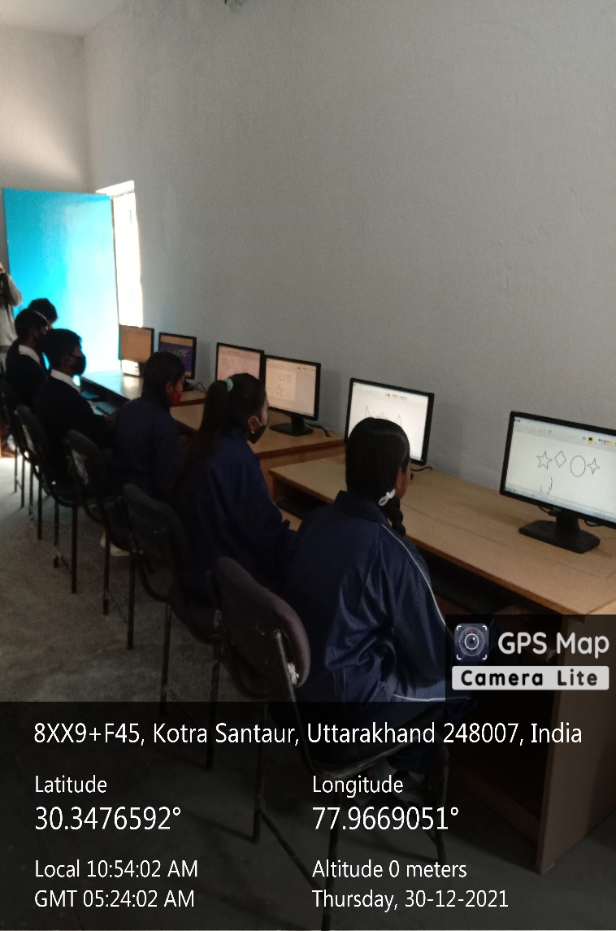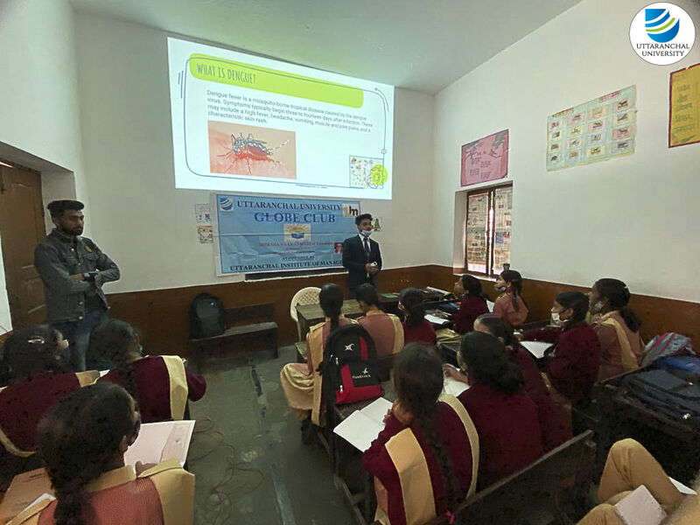

**Public events (lifelong learning)**

Uttaranchal University embraces the concept of Lifelong Learning and has undertaken various initiatives to educate the general public through continuous methods beyond the classroom. To support this, diverse modes of learning are practiced, including Flipped Classrooms, Blended Learning, and Online Learning. Additionally, the university organizes a series of web-based events such as Regional, National, and Global Seminars, Conferences, and lectures by scientists and renowned speakers. These events attract a targeted audience, including professionals from various fields, who then apply their expertise to benefit the wider community.

Several clubs and centres, led by senior professors, operate at Uttaranchal University to further this mission. Community Medical Awareness sessions are also conducted in areas where age-related ailments are prevalent, offering remedial measures to the underprivileged local population.

Specific community-based educational events are organized for local residents, particularly in and around Dehradun, focusing on the elderly, women, and children. These events address issues such as age-related illnesses, vision problems, malnutrition, women's health, and children's health, while providing attendees with preventive measures and intervention methods as needed.

* Health Camps
* Agricultural Awareness Sessions by Scientists
* Women & Child Health Care Awareness sessions by Experts
* Surveys to identify Issues in the nearby community
* Computer Literacy programs
* Food Nutrition Awareness Session for Village Schools Children
* Women Health & Hygiene Camps
* Educational Talks for Village Schools

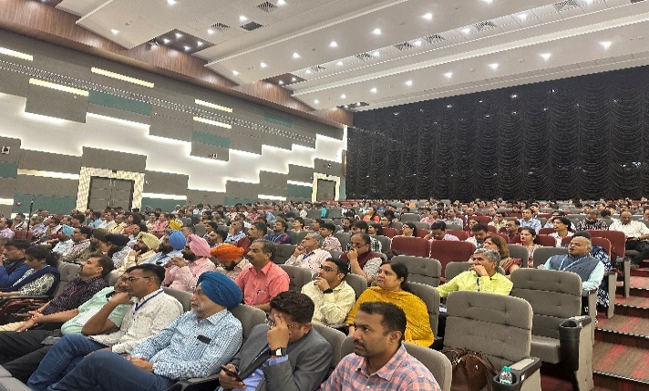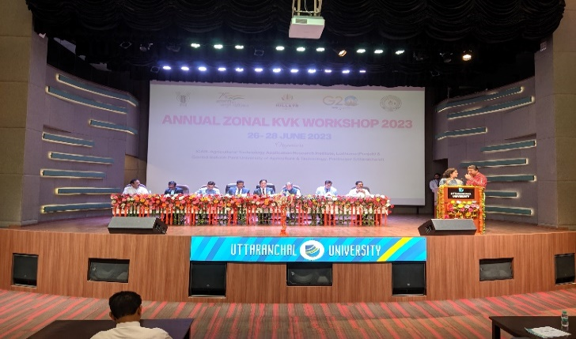

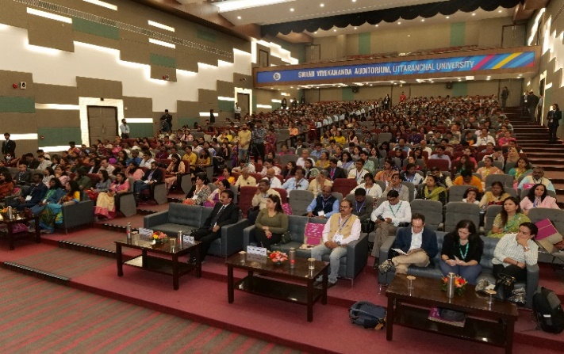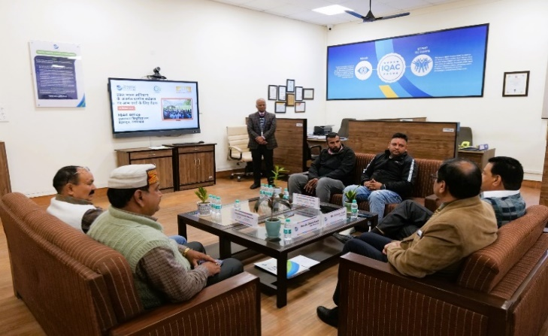

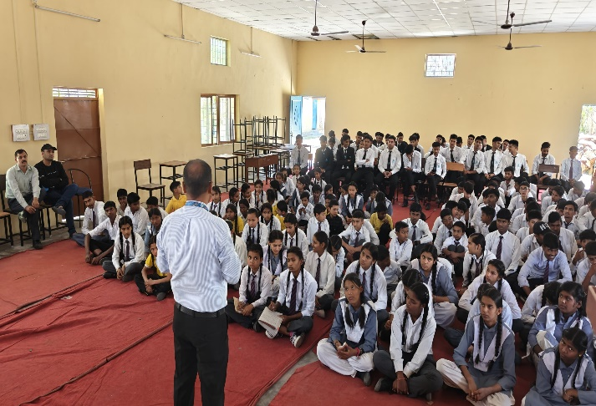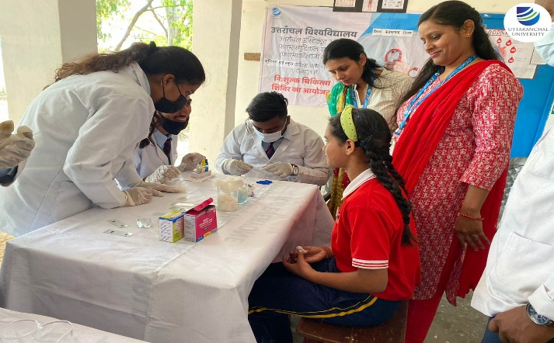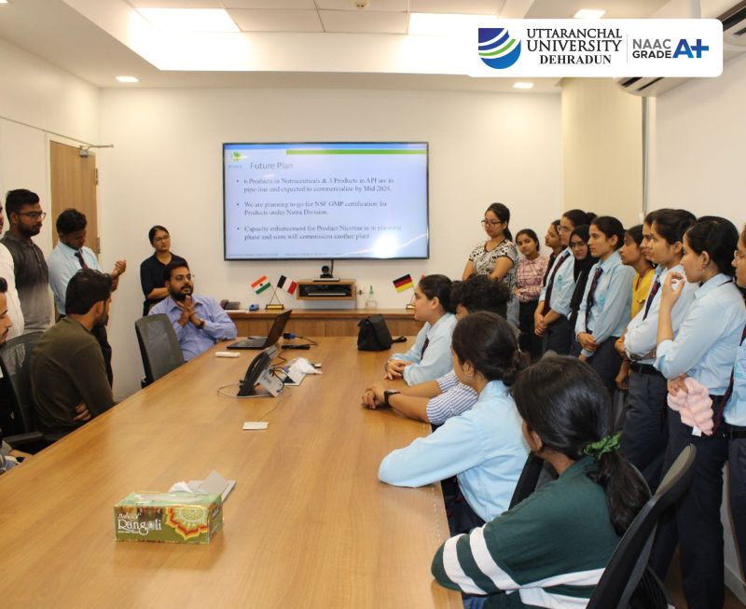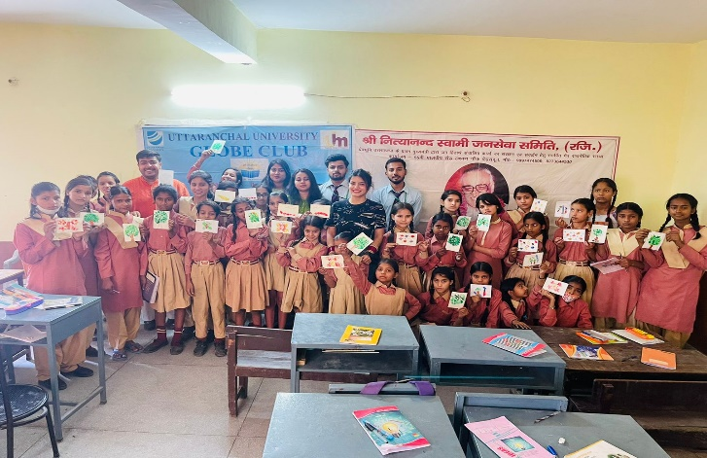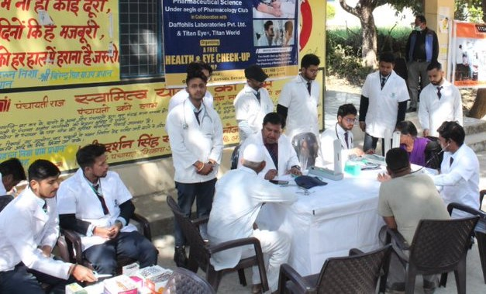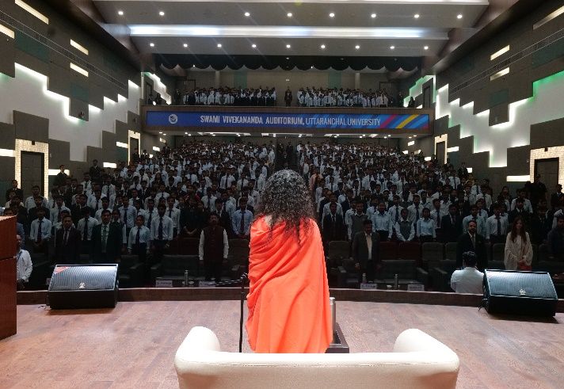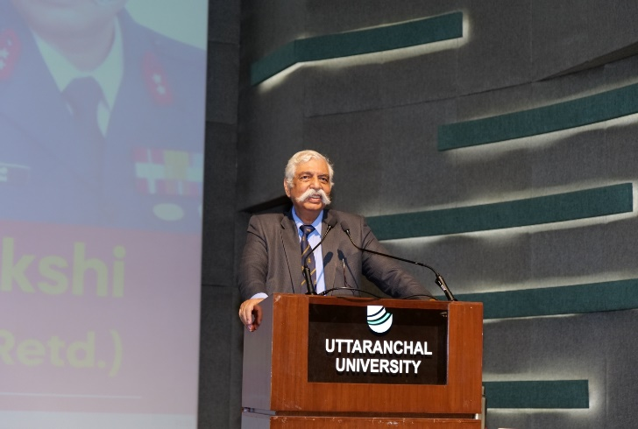

**Vocational training events (lifelong learning)**

**National & International Executive Development Programs**

Executive Development Programs (EDPs) are advanced training and education programs designed for working professionals, typically at the executive level. These programs can be offered by universities, business schools, and other organizations.

In India, many universities offer EDPs in various fields such as management, finance, leadership, and technology. These programs are typically designed to provide participants with the latest knowledge, tools, and best practices in their field, as well as the opportunity to network with other professionals.

The EDPs can be delivered in a variety of formats, including on-campus, online, and blended learning. Some EDPs may be tailored specifically for national or international professionals and organizations, while others may have a more global focus.

*Executive Development Programs in Specializations:*

* Price Cap Process
* Data Analytics
* General Management
* Hospitality Management

**Experiential Learning Program (ELP)**

At Uttaranchal University, the Experiential Learning Program (ELP) is a transformative initiative that offers proactive, hands-on training in agriculture and its allied enterprises, benefiting both students and members of nearby village communities. By focusing on real-world challenges and opportunities in agriculture, the program seeks to bridge the gap between academic learning and practical application.

One of the program’s key goals is to cultivate an entrepreneurial mindset in students. By exposing them to the intricacies of agriculture and agribusiness, ELP encourages them to think beyond traditional roles and explore the vast potential of entrepreneurship within these sectors. Students are guided to develop essential skills such as critical thinking, business planning, innovation, and resource management, which are crucial for launching successful enterprises.

The involvement of nearby village community members adds a vital dimension to the program. It fosters a collaborative learning environment where both students and villagers exchange knowledge and ideas. While students gain hands-on experience working alongside farmers and local entrepreneurs, community members benefit from the latest agricultural techniques and innovations introduced through the program. This dynamic interaction not only enhances the learning experience but also strengthens community engagement, empowering local farmers with tools and knowledge to improve their practices and livelihoods.

* Experiential Learning Program (ELP) on Sericulture
* Experiential Learning Program (ELP) on Beekeeping
* Experiential Learning Program (ELP) on Mushroom Cultivation

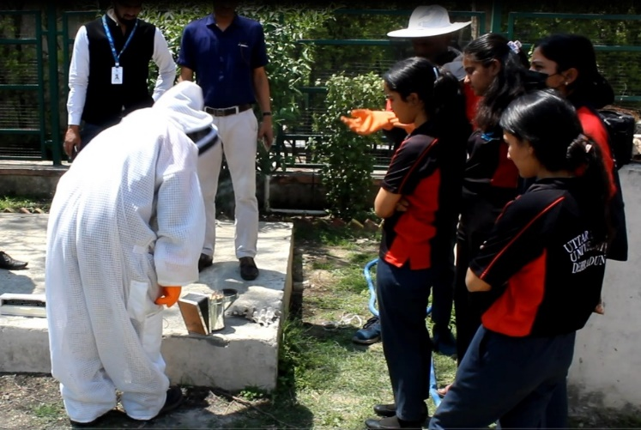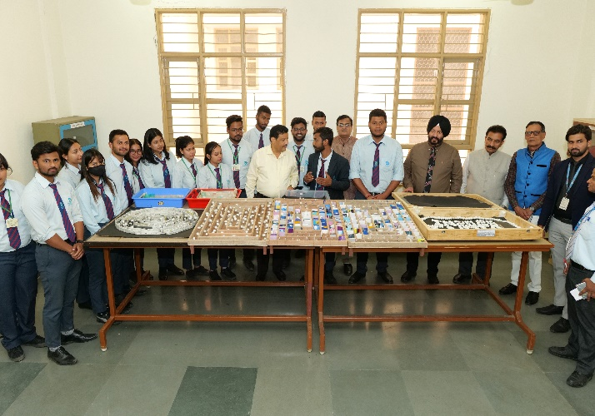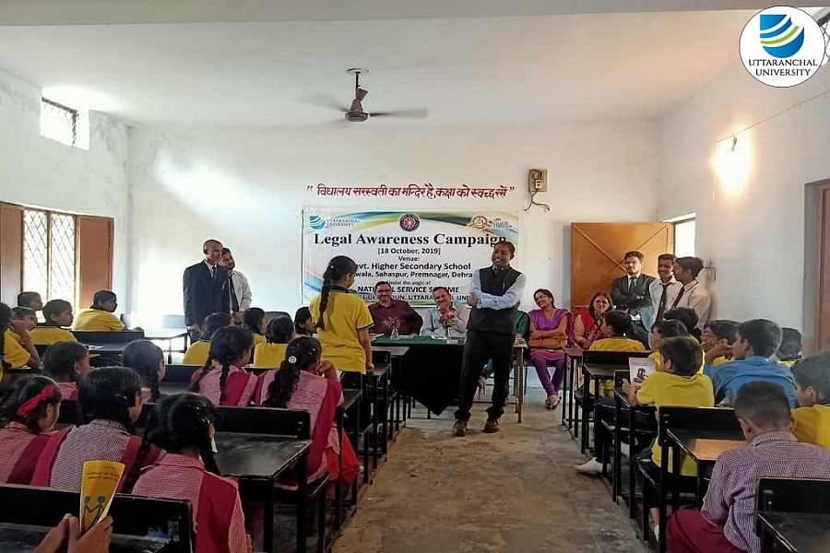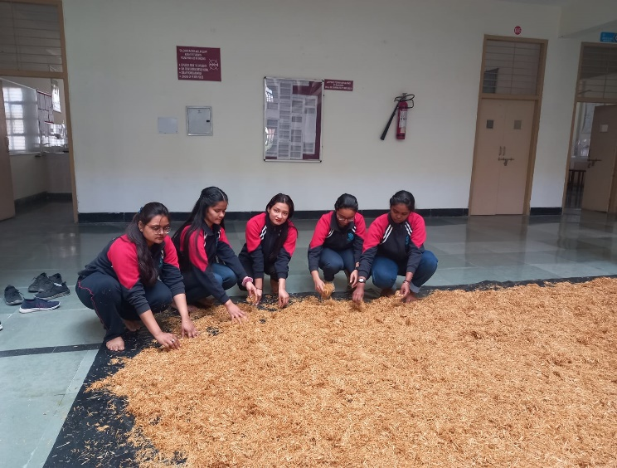

**Education outreach activities beyond campus**

Uttaranchal University in alignment with its vision and mission of serving the country and human community at large organises various awareness campaigns and donation drives with the human resource available within its ambit. To expand and elevate the knowledge through practice, the university indulges in a plethora of social activities to benefit the local population.

**Objectives of the practice:**

* To impart skills and knowledge through free education and study material to the financially downtrodden children.
* To make them aware about the basic concepts of hygiene and cleanliness habits, hygiene and sanitation.
* To create awareness through various campaigns on pressing issues and develop potential erroneous beliefs on drugs.
* To impart practical knowledge of basic legal rights even to the common man of the nation and enable them to face the challenges in real life situations.
* To imbibe social responsibility and patriotism amongst the students and motivate the students to adopt the culture of sacrifice in life by making them donate voluntarily things and services for the welfare of the society.

**Adoption of a school**

Uttaranchal University has donated land to run a **High school in Banjarawala Basti, Selaqui**, in the name of Pandit Sureshanand Joshi Saraswati Vidya Mandir, which is a pioneering initiative. Besides donating land, the school has been adopted and continuous support is extended and the university facilitates the requisite infrastructure and teaching resource for the betterment of the children, who are at the bottom of the pyramid to have a similar opportunities to grow as those of the others. Through this philanthropic activity the university extends a holistic support in its construction, library, and purchase of goods for the school and pays the salaries of the teachers thereby strengthening the educational system at its grass root level.

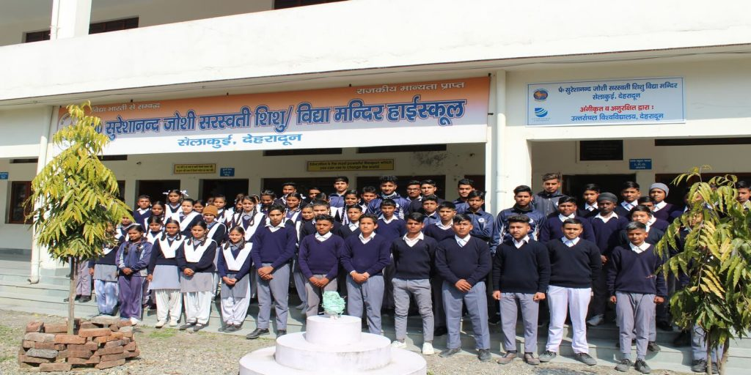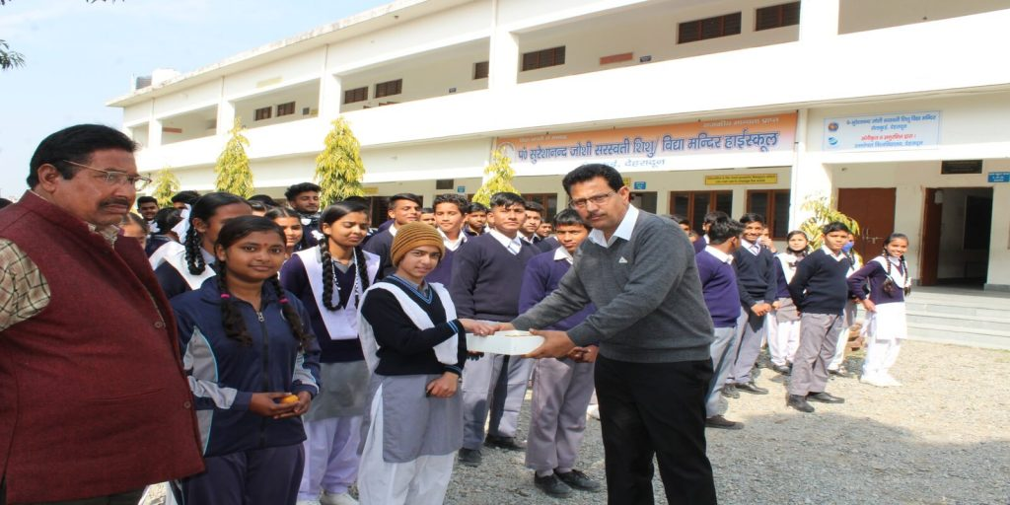

**Free education:**

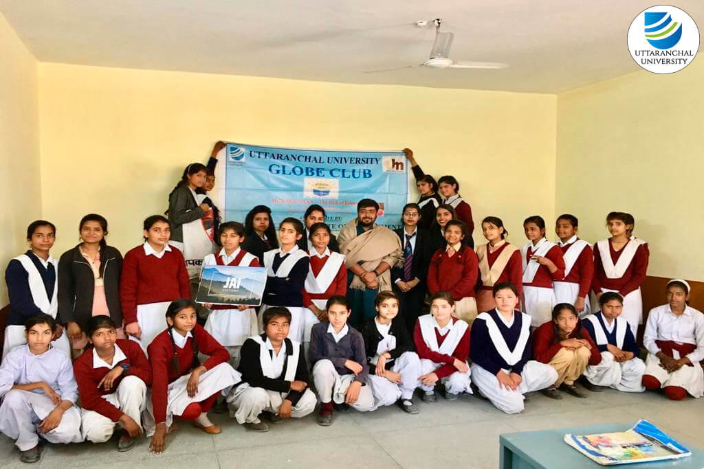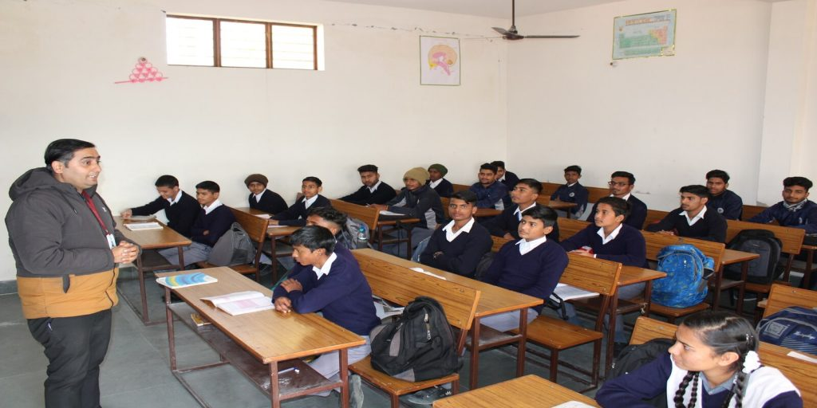Gift of education is considered to be the most precious gift that a human being can offer. The ‘Globe Club’ of the university conducts ‘Shiksha Daan’ activity in ‘Akhil Bhartiya Mahila Ashram’ Besides adopting a school, the students of Uttaranchal University volunteer themselves to educate and provide equal opportunity to the economically backward and needy children residing in the slum areas in and around the city of Dehradun. The activity is conducted on first three Saturdays of every month on a regular basis , with a view to create awareness among the less privileged children on issues r elated to health, environmental issues, education etc.

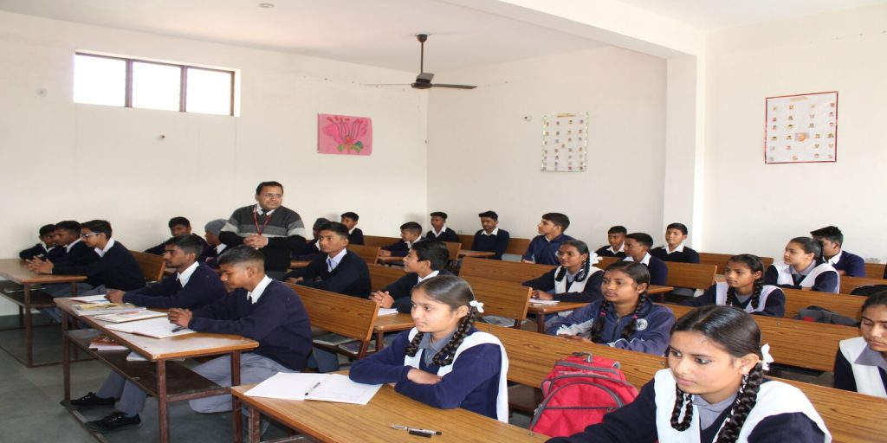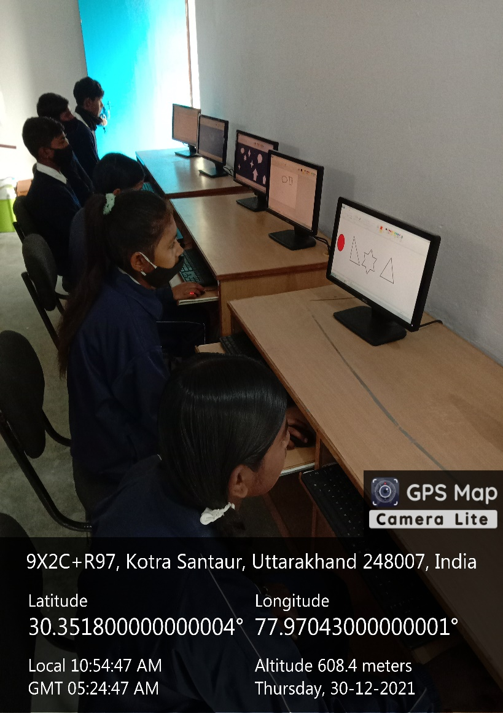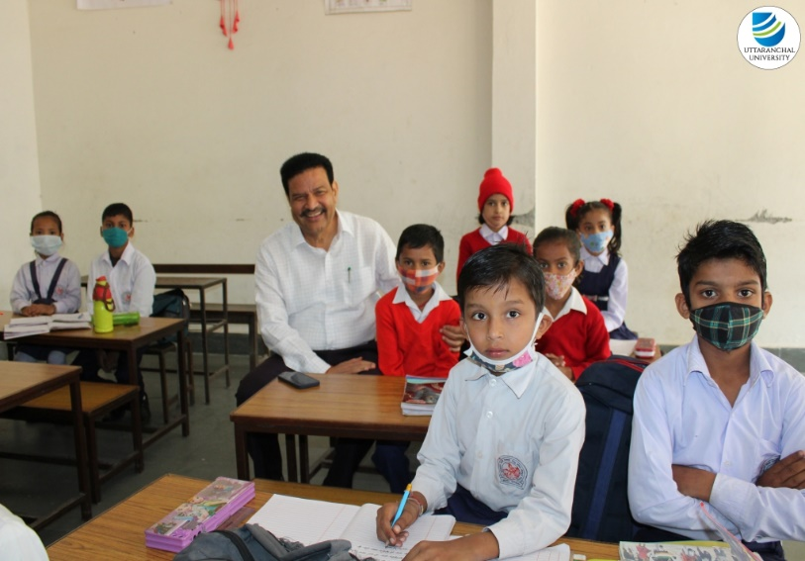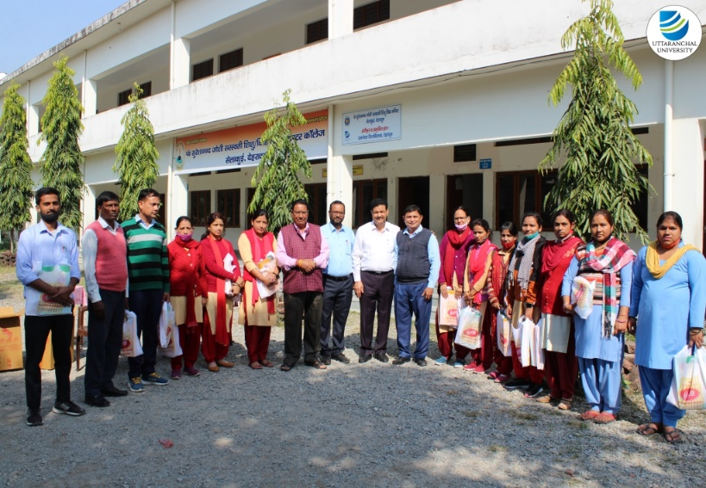



Uttaranchal University is dedicated to promoting gender equality and eliminating social exclusion within its academic environment, aligning with the United Nations Sustainable Development Goal 5, which focuses on empowering women and girls.

To systematically enhance women’s access to education, Uttaranchal University has implemented several key initiatives aimed at fostering an inclusive academic atmosphere.

* **Centralized Dedicated Admissions Committee:** The university has formed a centralized admissions committee that places significant importance on ensuring easy access for female students, especially those from underprivileged and rural backgrounds.
* **University ERP System:** A dedicated University ERP System has been established to follow up with prospective female candidates. This system, along with personalized interactions via call centres and admissions counsellors, has resulted in high percentages of female applicants and admissions across various academic programs.
* **Robust Admission Process:** The admissions process at Uttaranchal University prioritizes identifying prospective students, with a particular emphasis on women. This proactive approach is reflected in the university’s high admission rates for female students.
* **Gender Representation:** The central admissions committee includes a substantial representation of women in leadership roles, highlighting the importance of female perspectives in shaping access measures.
* **Mainstreaming Gender Equality:** Gender equality is integrated into all aspects of Uttaranchal University's development processes, programs, projects, and actions, promoting comprehensive gender inclusion and empowerment.
* **Creating a Supportive Socio-Cultural Environment:** The university has worked diligently to establish a welcoming atmosphere that encourages female students to apply, gain admission, and successfully complete their studies.

|  |  |  |  |  |
| --- | --- | --- | --- | --- |
| **Description** | **UG** | **PG** | **Ph.D.** | **Total** |
| **Total Number of Female Application Received** | 8878 | 3363 | 1211 | 13452 |
| **Total Number of Female Admission** | 1537 | 467 | 137 | 2141 |

**Women’s access schemes**

* **Academic support and other financial resources:** scholarships are available for female students facing financial difficulties or lack of financial support from their families.
* **Equal Opportunity:** The university is committed to providing all students with equitable access to education, mentorship programs, social services, technology, accommodations, transportation, and other essential resources.
* **Mentoring Initiatives:** Female students are encouraged to engage in mentoring programs that connect them with female faculty and industry professionals, providing valuable guidance and support for their academic and career growth.
* **Flexible Ph.D. programs:** Married female Ph.D. students have the option to take a break from their research during pregnancy and resume their studies with the next batch in the following year.
* **Childcare facility:** To support student parents, the university provides on-campus childcare services, enabling female students to manage their academic responsibilities alongside family obligations.
* **Gender Sensitization Initiative:** Uttaranchal University is dedicated to implementing a comprehensive Gender Sensitization Initiative that fosters gender equity through a variety of activities. These include workshops for students and staff, ongoing awareness campaigns, faculty advocacy for fair representation in leadership roles, ensuring gender balance in team projects, establishing a network of gender equality advisors for research and coursework, and promoting gender parity within the student code of conduct.
* **Academic Support Services:** Tailored academic counselling and support services are available, focusing on the unique challenges faced by women in higher education. Workshops on study skills, time management, and exam preparation are also offered.



**3231 female students are provided with Financial Support under university Scholarship program, which is 33.85% of total student population. A sum of**

**26.497397 million INR.**

**is invested in female student education support.**

**3121**

**Female Students Scholarship**

**support**

**Student Mentorship Program**

**275** female faculty members have been appointed as mentors for female students at the university to provide mentorship support with a **mentor to mentee ratio of 1:23**.

**Women's application in underrepresented subjects**

Uttaranchal University is committed to increasing female representation in fields where women are traditionally underrepresented. To achieve this, the **university actively encourages women to apply to these programs through targeted outreach initiatives and collaborations**. The university partners with other educational institutions, community groups, government bodies, and NGOs to participate in regional and national campaigns promoting women's education in STEM fields, business, and other male-dominated disciplines. Additionally, the university **organizes awareness programs, workshops, women health camps and career counselling sessions aimed at young women**, **highlighting opportunities and career paths in these fields**. By fostering an inclusive environment and offering scholarships, mentorship, and support networks, the university is dedicated to empowering women to pursue academic and professional success in all disciplines.

**Interactive Session with rural women organized by the Women Cell of School of Liberal Arts:**

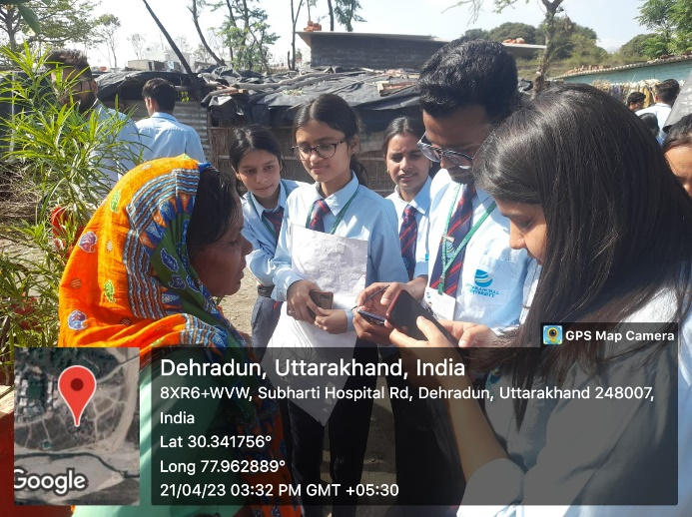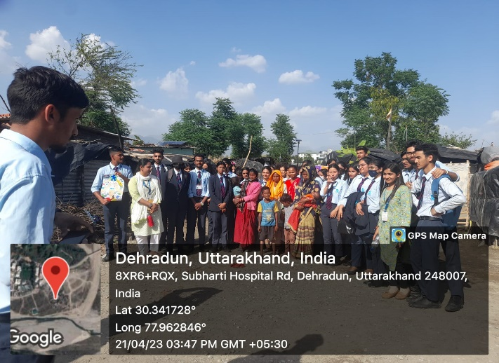

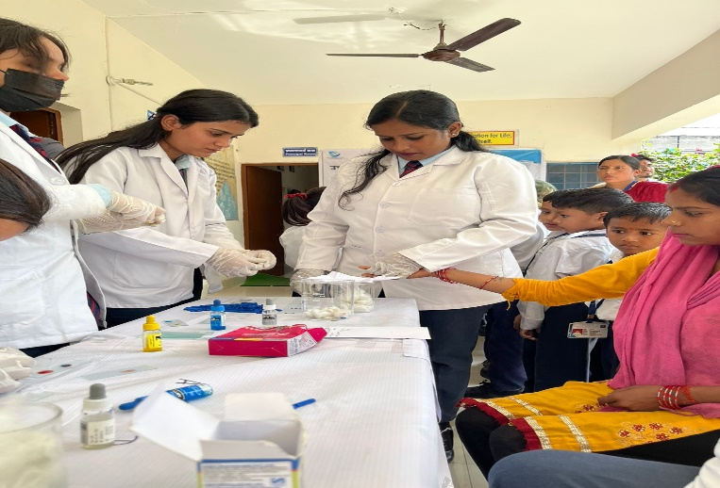**Women Health Check-up Camps:**

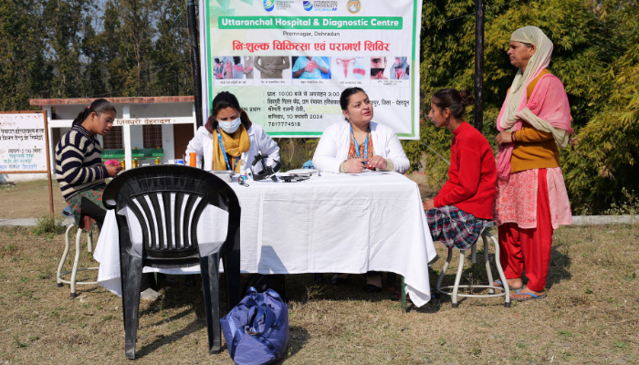

**Empowering Women: Recognising Excellence through Uttaranchal Naari Shakti Samman**

The "**Uttaranchal Naari Shakti Samman**" Honors women in Uttarakhand, India who have demonstrated exceptional achievements in their respective fields, serving as unparalleled examples in advancing women's empowerment.

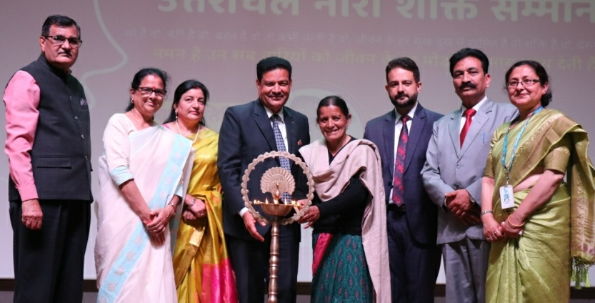

**Honoured Padma Shri awardee Basanti Devi known for generating women consciousness, halting of blind cutting of trees in the forests and preserving the existence of Kausi River, Pithoragarh, Uttarakhand, India.**

**Honoured International Bodybuilder, Pratibha Thapliyal**

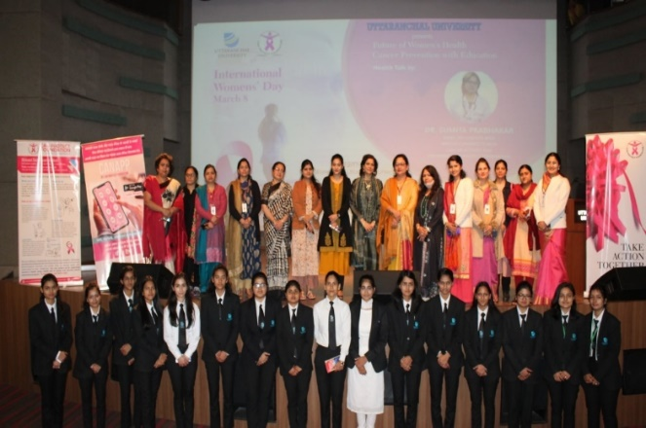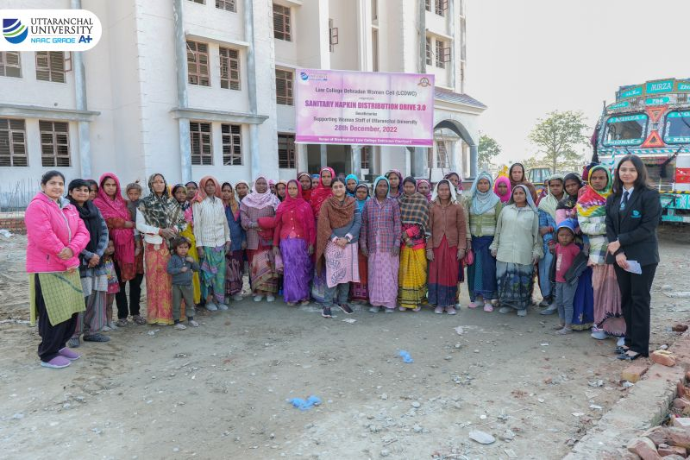

**Health & Hygiene Awareness Camp**

**Future of Women’s Health Breast and Cervical Cancer Awareness**



**Activities & Initiatives for women**

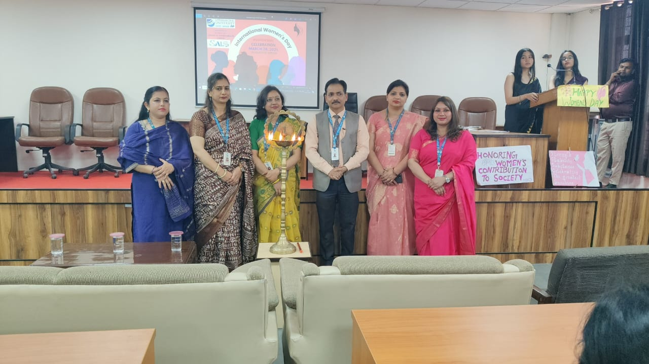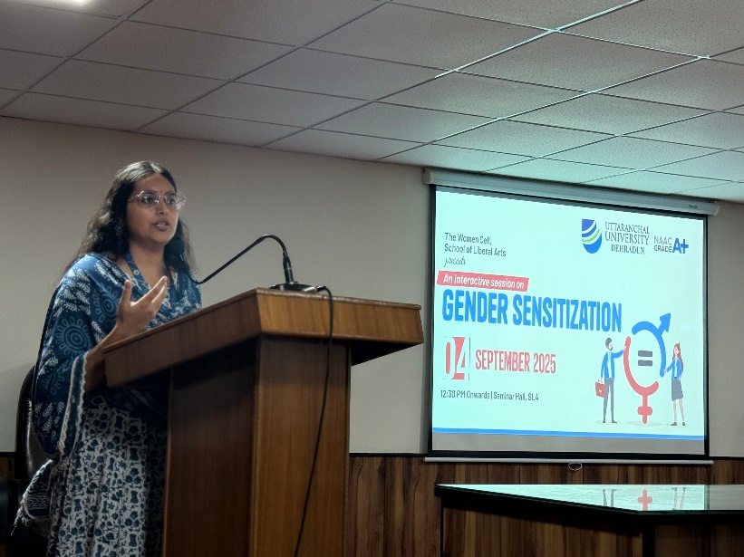

**Our regional and national campaign partners for the promotion of women's education in STEM fields**









**Graduating compared to men's, and schemes in place to close any gap**

Based on the provided data, here is an analysis of the female graduation rates for the two academic years and suggestions for improving gender parity in graduation rates at the university:

**Analysis of Female Graduation Rates**

|  |  |  |  |
| --- | --- | --- | --- |
| **Year** | **Female Graduates** | **Total Graduates** | **Female Graduation Rate** |
| 2022-23 | 683 | 1589 | 42.98% |
| 2023-24 | 1000 | 2391 | 41.82% |
| 2024-25 | 1253 | 3063 | 40.90% |

**Trend Observation:**

Over the three academic years, the number of female graduates increased significantly from 683 in 2022–23 to 1253 in 2024–25, indicating steady progress in women’s participation in higher education.

Despite the rise in absolute numbers, the female graduation rate (as a percentage of total graduates) has shown a gradual decline from 42.98% to 40.90%, suggesting that the total number of male graduates has grown at a faster pace.

**Schemes to Increase Female Graduation Rates at Uttaranchal University**

* Scholarships or grants for female students, especially in fields where they are underrepresented. This financial support could encourage more women to enrol and stay through to graduation.
* Mentorship program that connects female students with female faculty members.
* Offer additional academic support programs geared towards female students, especially in traditionally male-dominated fields like STEM.
* Introduce flexible learning options, such as evening or weekend classes, to support female students who may have family responsibilities or part-time jobs.
* Run campaigns to raise awareness about the importance of female education and provide resources such as counselling and support groups.
* Regularly track and report on gender disparities in graduation rates and academic performance.

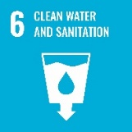

**SDG6: CLEAN WATER AND SANITATION**

**Water consumption per person**

Uttaranchal University actively monitors and manages its water consumption across the campus by recording usage daily. **This includes measuring the volume of water consumed, treated, reused, and recycled to evaluate overall efficiency**. Water usage for drinking, cleaning, washing, and cooking forms a key part of these assessments. **Each building is equipped with water meters, and a designated team records daily consumption**. The data is then reported to the maintenance team for further analysis. Additionally, the university reviews weekly water usage reports to identify patterns and implement corrective measures where necessary.

The university also practices rainwater harvesting, collecting between 5,000 and 15,000 liters of rainwater in underground tanks as part of its stormwater management efforts. This harvested water is processed through a **Water Treatment Plant (WTP)** and stored in clean water tanks for future use. The quality of water treated in the WTP is regularly tested by a consultant laboratory to ensure compliance with the **Bureau of Indian Standards (BIS)**. Water meters help track the consumption and extraction of both treated rainwater and groundwater, with the latter being filtered through **Reverse Osmosis (RO) systems before use**.

**Total Volume of Water Used at Uttaranchal University**

****The average **daily water consumption** at Uttaranchal University is approximately **717262 liters**, serving a **campus population of 14638**. This results in an **average per capita water consumption of 49 liters per day**. Overall water usage has increased this year due to the **growing number of students, staff, and construction workers involved in ongoing campus expansion projects**.

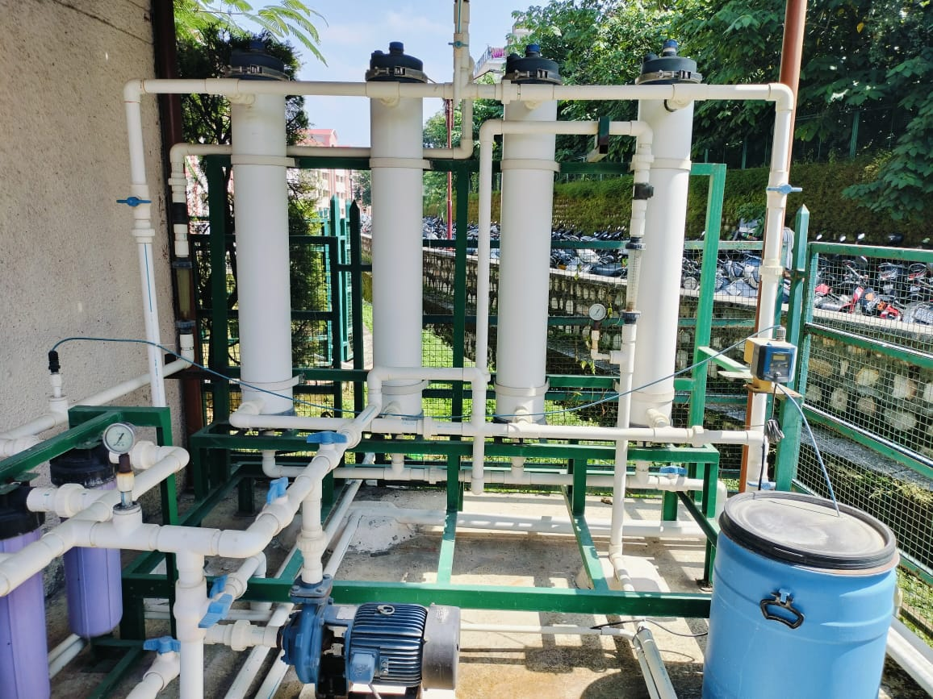

**600 Kilo liters of water per day**

**is being filtered by Water Treatment Plant for the direct consumption of a university community.**

**Water Treatment Plant (WTP)**





**148**

**Reverse Osmosis (RO) water cooling and drinking stations for clean and safe drinking water.**



**93%**

**6%**

**1%**

**Students Staff Visitors**

**Water Utilization Population Wise**

**6.3.1 Wastewater treatment**

Uttaranchal University is committed to the **conservation of natural resources, with water management being a key focus**. The water used on our campus is sourced from the rivers and streams in the surrounding region. Recognizing the importance of **sustainable practices, the university places a strong emphasis on wastewater treatment as part of its broader environmental efforts. This ensures that we reduce our ecological footprint while maintaining access to essential water resources**.

Our goal is to halt the degradation and shrinkage of water as a valuable resource. To achieve this, we take meticulous precautions to conserve water at every step on campus. We follow a dynamic process to prevent polluted water from entering the campus water system by adopting multiple approaches.

Each year, around **50 lakh liters of wastewater** is collected in separate tanks on campus. This collected water is passed through a comprehensive filtration process in our Water Treatment Plant (WTP). **The wastewater treated is then repurposed for horticultural and agricultural activities, particularly during the lean months**.

Additionally, two **Biological Sewage Treatment Plant (Bio STP) with a 150 KLD capacity & 450 KLD capacity** is installed on campus to recycle wastewater. The **Bio-Digester tank is a specialized structure designed with partitions and an internal flow system that incorporates a bacterial matrix to treat human waste**. The system includes an inlet for waste and an outlet for clean effluent water. **After treatment, the sewage water is tested to ensure it meets BIS standards and is then used for agricultural and horticultural purposes, further supporting the university's commitment to sustainability**.

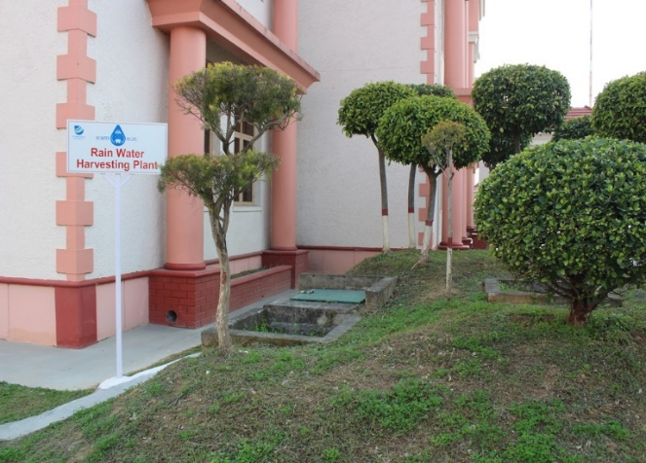

**Rainwater Collection Tank**

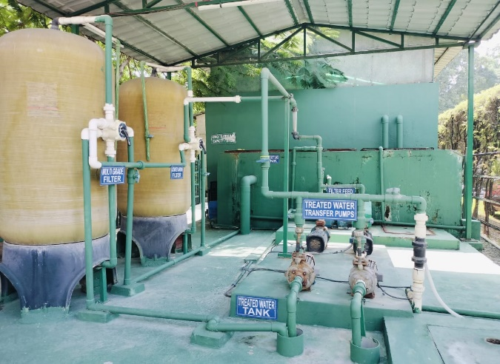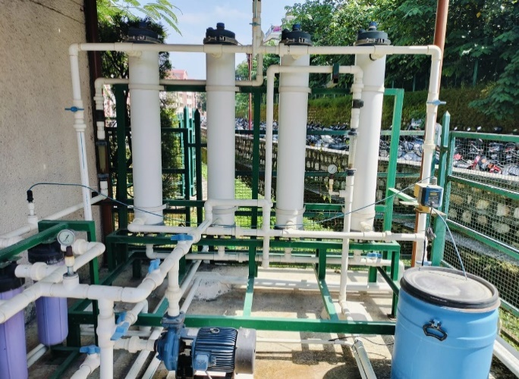

**Water Treatment Plant**

**Biological Sewage Treatment Plant (150 KLD)**

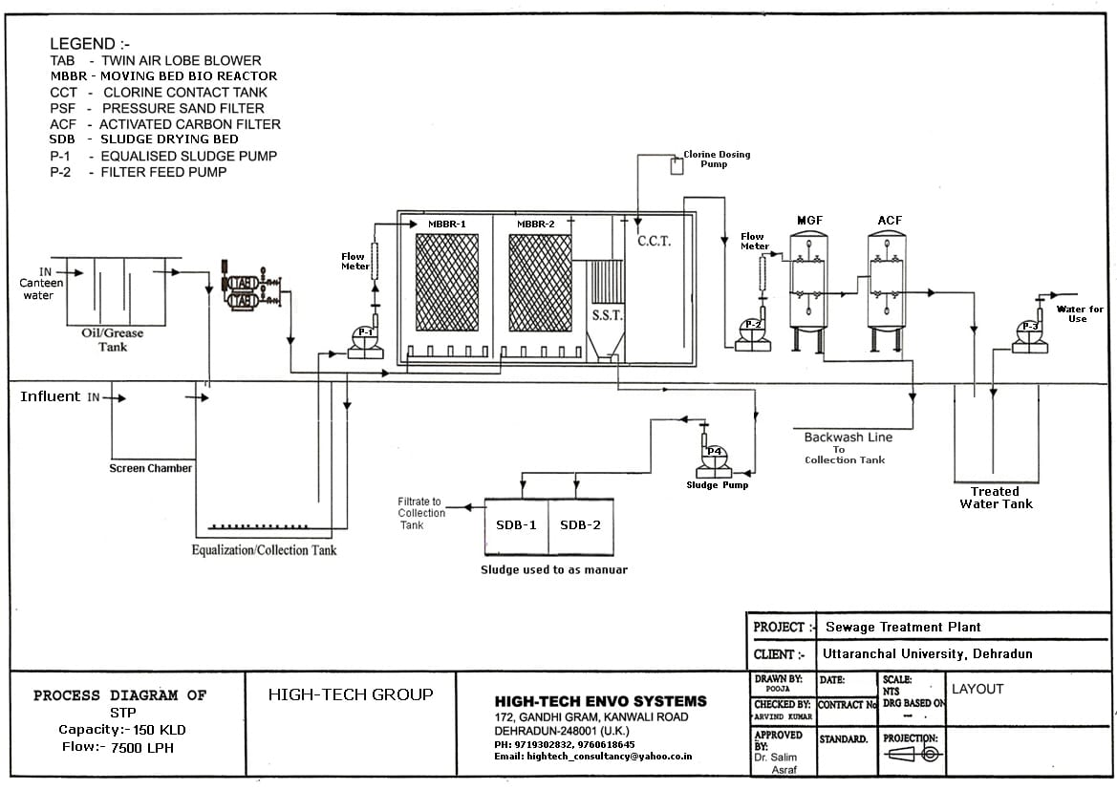

**Layout of one of the Wastewater treatment facilities at Uttaranchal University**

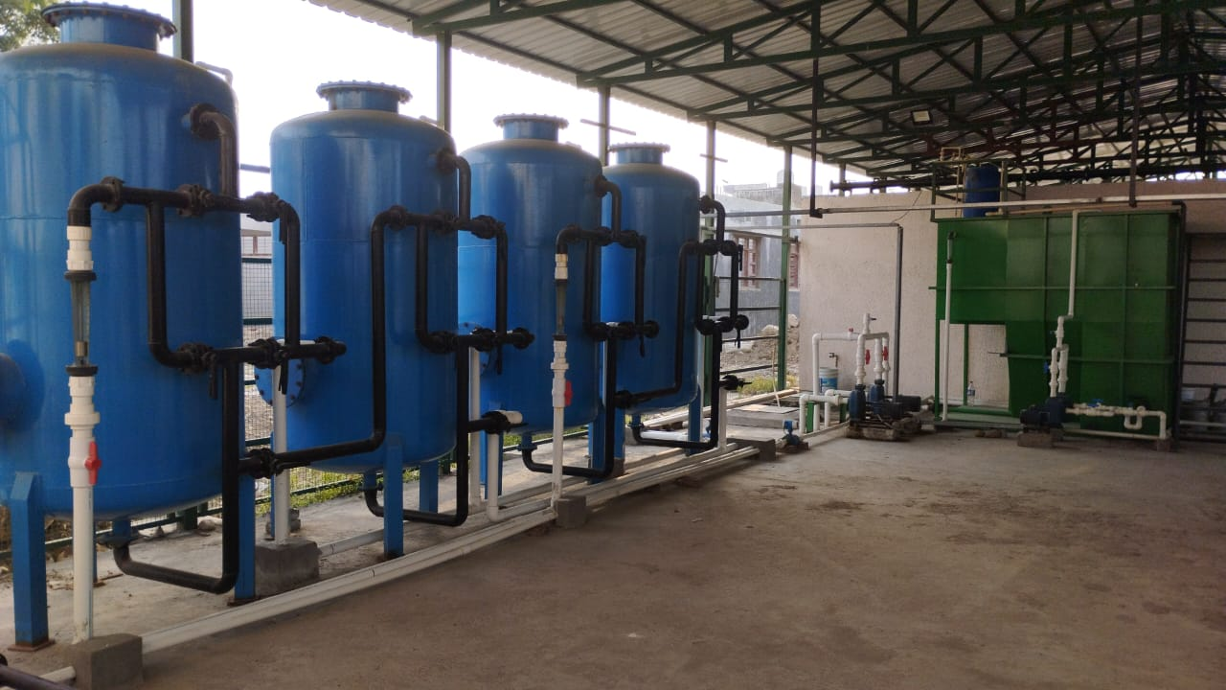

**Biological Sewage Treatment Plant (Capacity 450 Kilo Liters Per Day)**

**Water Conservation Trends Adopted by University**

* Proper facilities for rainwater harvesting are provided in each building, with maintenance conducted every six months.
* **Auto water level sensor systems are installed at every major collection and pumping system** to avoid water spillage.
* **Maintenance logbooks for the water supply system**, RO units, and water coolers are maintained to control leaks and reduce loss due to high retention rates from RO systems.
* A team of skilled and semi-skilled personnel are dedicated to the water supply maintenance team.
* **Smart Water Saving Systems (SWSS) with adequate water flow control rates are installed in labs to minimize water loss**.
* Horticultural practices include **sprinkling and drip irrigation rather than flood irrigation, adhering to water conservation principles**.

**Uttaranchal University collaborates for waste management, promoting environmental sustainability as below:**

* **Liquid Waste Management:** Uttaranchal University effectively manages liquid waste on its campus through the implementation of the **Sewage Treatment Plants (STP)**.
* **Uttarakhand Pollution Control Board:** The **MoU between Uttaranchal University and Uttarakhand Pollution Control Board** signifies a cooperative relationship. This collaboration likely involves joint efforts to address environmental issues and ensure compliance with pollution control regulations.
* **E-Waste Recyclers India:** The association with E-Waste Recyclers India, likely involves implementing proper **e-waste recycling practices and raising awareness about the importance of responsible disposal of electronic devices**.
* **Bharat Oil & Waste Management Ltd.:** Uttaranchal University **has a partnership with this organization**, which holds Hazardous Waste Collection Certificate. This collaboration likely focuses on the proper collection, handling, and disposal of hazardous waste.
* **Degradable Waste Management:** For the management of degradable waste, the **University has set up a vermicompost unit**. This unit facilitates the decomposition of organic waste, such as food scraps and garden waste, into nutrient-rich compost. **This compost is then utilized for gardening and landscaping purposes within the campus**.
* **Medical Pollution Control Committee for Biomedical Waste Management:** Uttaranchal University has a tie-up with this committee to address the management of biomedical waste generated in facilities.

**Preventing water system pollution**

At our university, we are committed to preserving a pristine, clean, and sustainable campus ecosystem through strategic initiatives. These initiatives include effective water management and the responsible handling of liquid, solid, and e-waste. We have adopted environmentally friendly practices to tackle water-related challenges, such as rainwater harvesting, grey and black water management, recycling and reusing treated water and the implementation of cost-effective, eco-friendly potable water solutions.

Additionally, we prioritize raising awareness about water conservation and management across the campus community. To prevent water pollution and protect the local ecosystem, we are dedicated to fostering a culture of environmental responsibility among our staff and students through the promotion of sustainable practices.

At our university, several strategies have been implemented to prevent water pollution and maintain a sustainable campus environment:

* Proper drainage and water supply networks are established with a standardized layout to ensure efficient water flow and minimize contamination.
* An advanced plumbing and drainage network system connects the hostels to biogas plants, facilitating environmentally friendly waste management.
* A wireless water level controller using Modbus communication has been installed to enable automatic valve control at the inlets of overhead storage tanks, optimizing water usage.
* We maintain an effective solid waste management system to prevent leachate from contaminating groundwater resources.
* Four Sewage Treatment Plants (STPs) have been set up to treat greywater, ensuring water reuse and preventing pollution.
* Regular monitoring of treated/recycled water and the performance of STPs is conducted to ensure optimal operation and compliance with environmental standards.

**Open Well Recharge**

Open well water recharge system in our university exemplifies our commitment to sustainability. By capturing and filtering rainwater, the system replenishes groundwater, reduces flooding, and promotes eco-friendly water management. This initiative not only conserves water resources but also serves as an educational model for sustainable practices within our academic community.

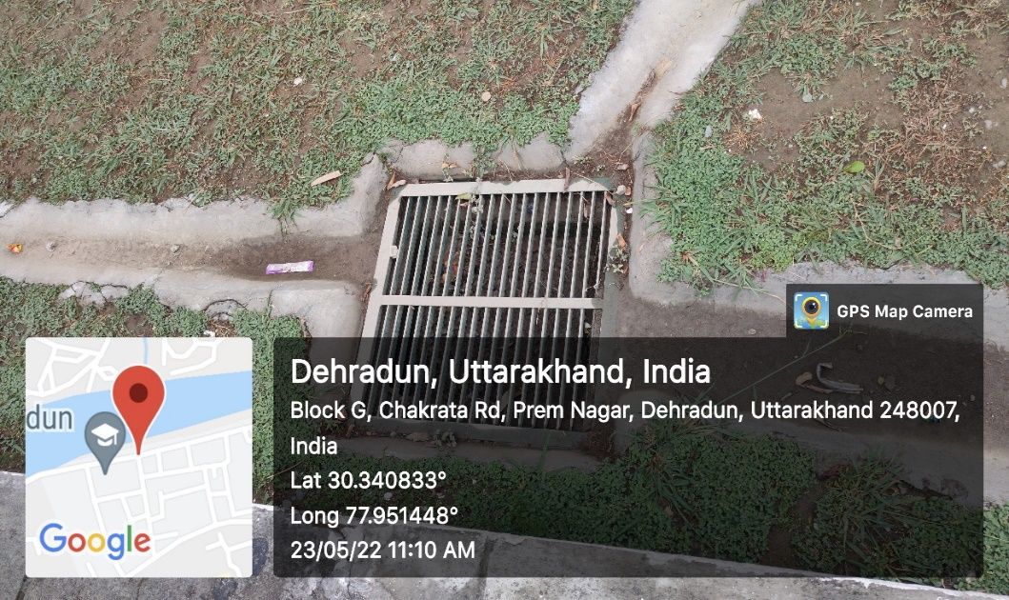

**Borewell**

Uttaranchal University has borewells incorporated in different academic and residential blocks of the campus. These borewells are of different capacities to fulfill the day-to-day water needs.

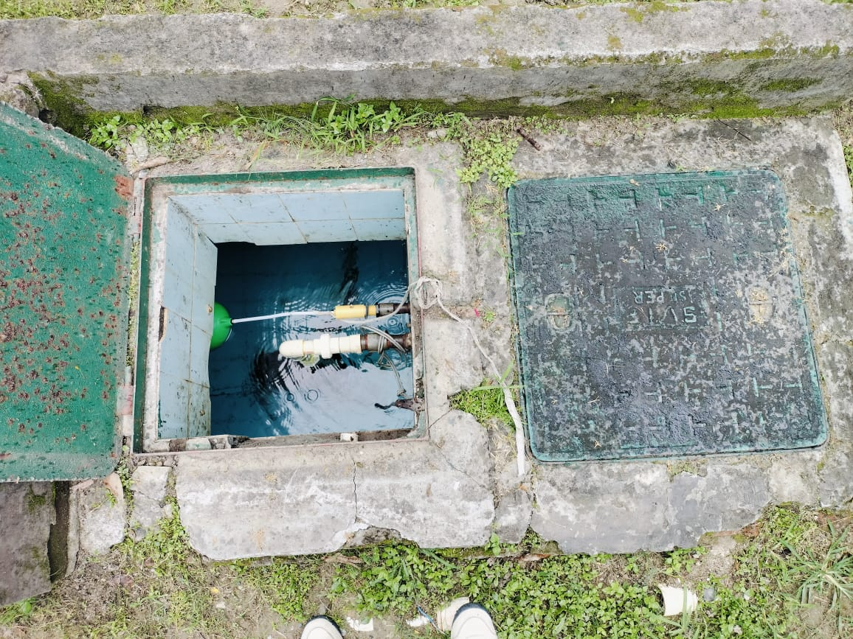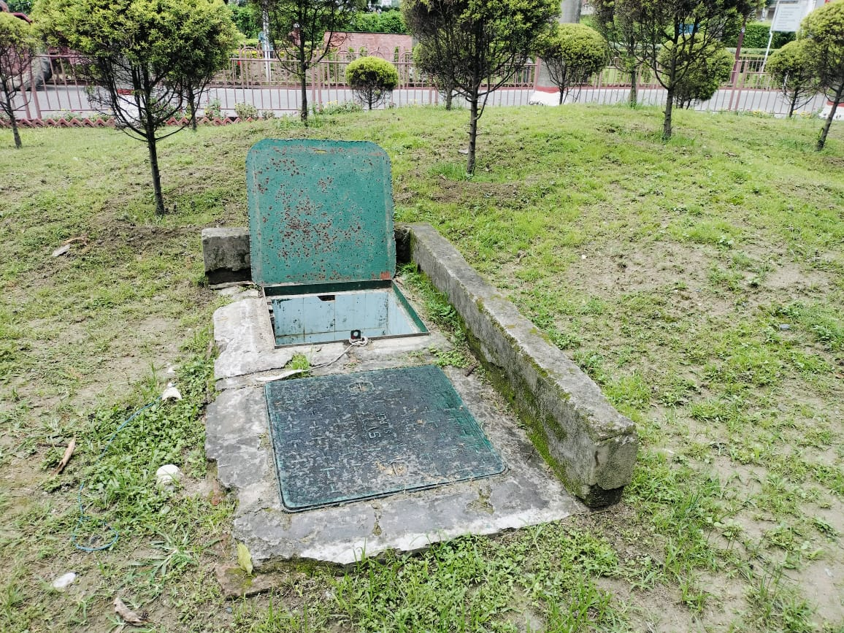

**Construction of Tanks and Bunds**

The University is equipped with overhead tanks, underground tanks, large bunds, and several small tanks on all rooftops. The combined capacity of these tanks meets the daily water needs of students in both residential and academic blocks. Additionally, the larger tanks and bunds provide a reliable water supply during emergencies or periods of water scarcity.

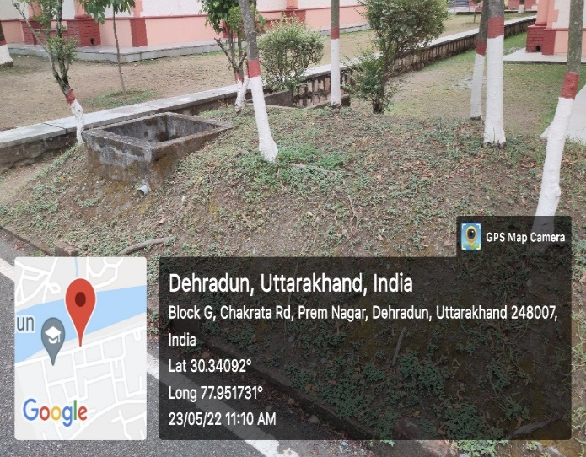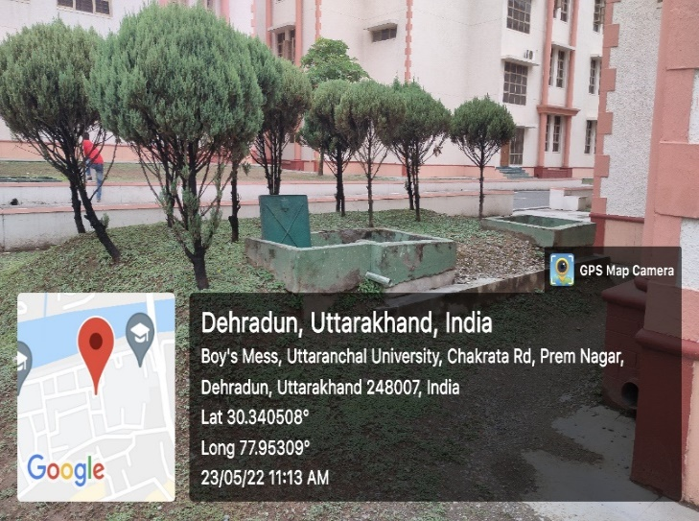

**Waste Water Recycling**

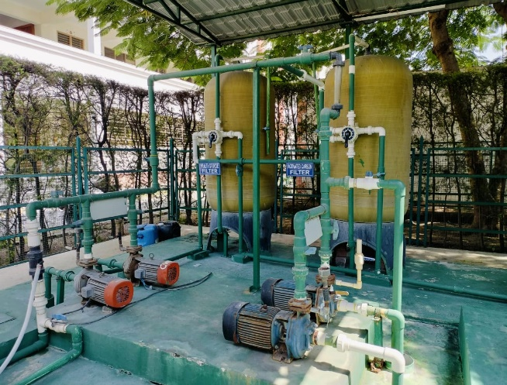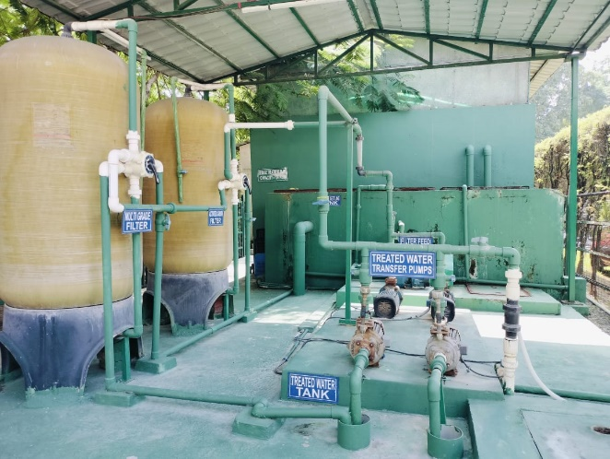Waste water recycling, also referred to as water reclamation or water reuse, involves treating and repurposing wastewater for different applications rather than releasing it into the environment. This approach aids in conserving water resources, minimizing pollution, and addressing water scarcity challenges. Uttaranchal University has implemented a comprehensive plan and established a facility for wastewater recycling.

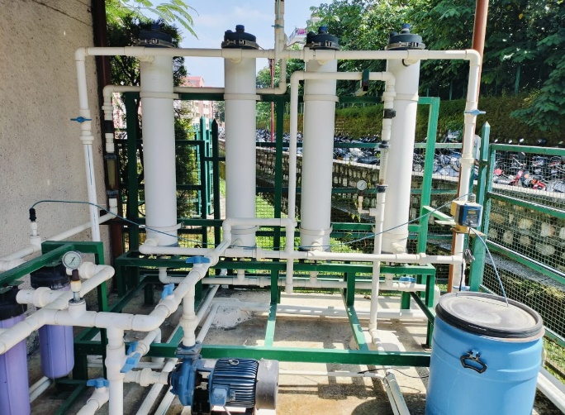

**50 lakh Liters of wastewater treated every Year**

**Water Treatment Plant**

**6.3.3 Free drinking water provided**

Uttaranchal University is dedicated to ensuring the provision of safe, accessible, and sustainable drinking water to support the health and well-being of its students, faculty, and staff. The university's campus comprises 11 departments, serving 10,707 students and 942 faculty and staff members. As a fully residential campus, it includes 14 hostels for both male and female students, as well as 82 staff quarters housing approximately 300 faculty and staff members.

**Water Sources:** The university has installed 123 Reverse Osmosis (RO) water cooling and drinking stations across all floors in the academic buildings, administrative block, hostels, and staff quarters to provide clean and safe drinking water.

**Water Quality Testing:** Regular water quality testing is conducted to ensure that the drinking water meets safety standards.

**Maintenance and Cleaning:** Uttaranchal University prioritizes the regular maintenance and cleaning of all drinking water sources to prevent bacterial growth and ensure hygiene.

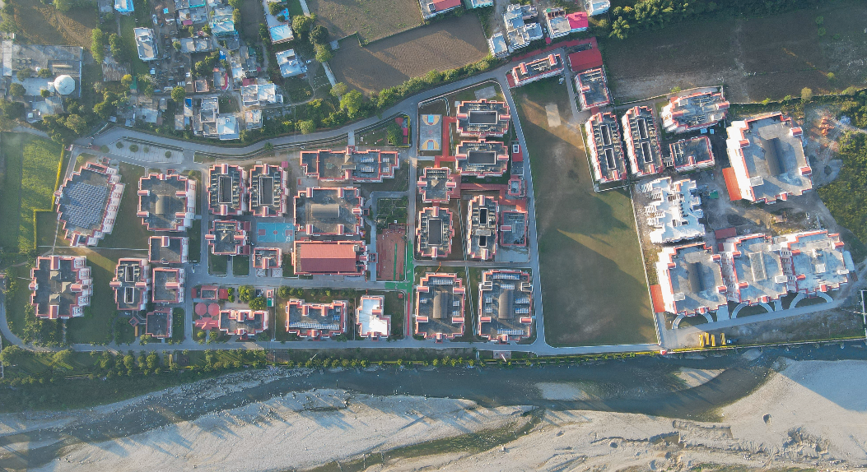

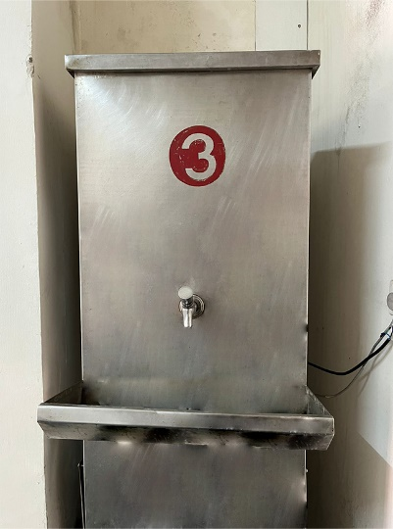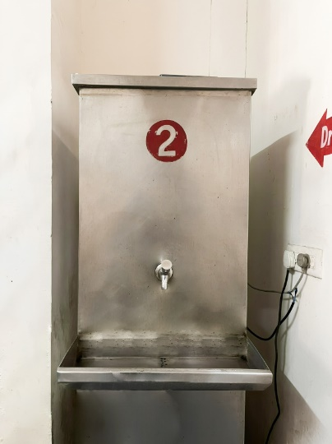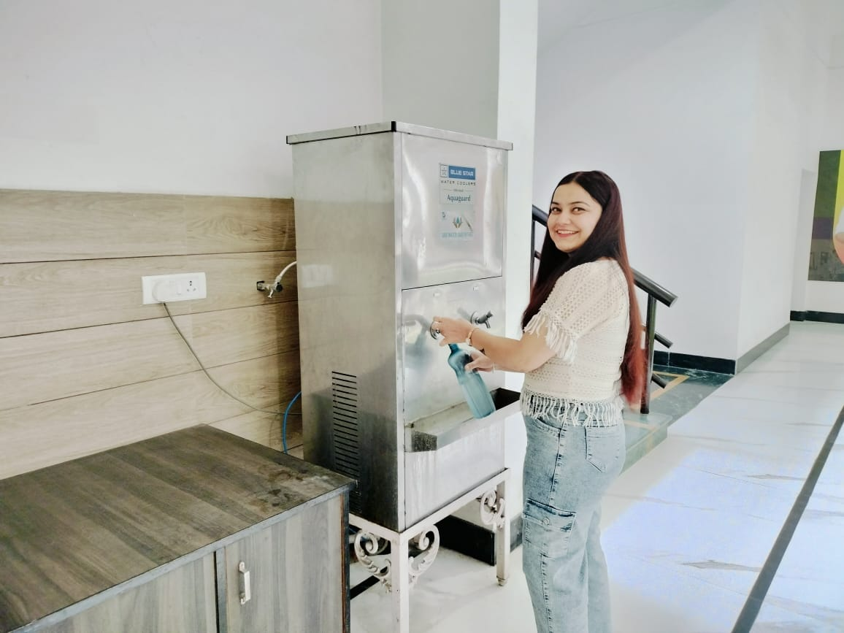

**6.3.4 Water-conscious building standards**

Uttaranchal University is committed to adopting water-conscious building standards that promote sustainability and efficient water use across its campus. These initiatives are an integral part of the university's efforts to foster environmental responsibility and contribute to long-term water conservation.

**Sustainable Infrastructure Design:** The university prioritizes water-efficient infrastructure in the planning and construction of its buildings. All new buildings are designed with sustainable water management systems, ensuring minimal water waste and reduced environmental impact. This includes the integration of water-saving fixtures like low-flow faucets, dual-flush toilets, and water-efficient cooling systems.

**Rainwater Harvesting:** To further its commitment to sustainable water management, the university has implemented rainwater harvesting systems across the campus. These systems capture and store rainwater, which is then used for landscaping, irrigation, and replenishing groundwater reserves. By utilizing rainwater for non-potable purposes, the university reduces its dependence on treated water sources.

**Landscaping Practices:** The university promotes water-efficient landscaping practices, using drought-resistant plants and native species that require minimal irrigation. In addition, automated irrigation systems are used to optimize water use, ensuring that water is only applied where and when needed.

**Awareness and Training:** To foster a culture of water conservation, the university regularly conducts awareness programs and workshops for students, faculty, and staff. These sessions emphasize the importance of water conservation, educate the community about sustainable practices, and encourage active participation in water-saving efforts on campus.

By integrating these water-conscious building standards, Uttaranchal University demonstrates its commitment to environmental sustainability while ensuring the responsible use and conservation of water resources for future generations.

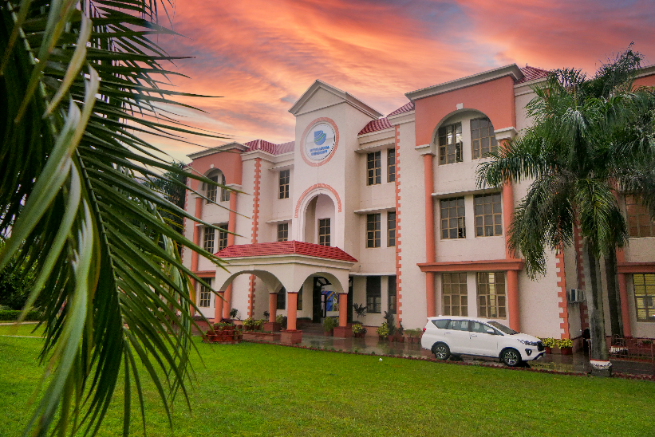

**Rainwater Collection Tank**

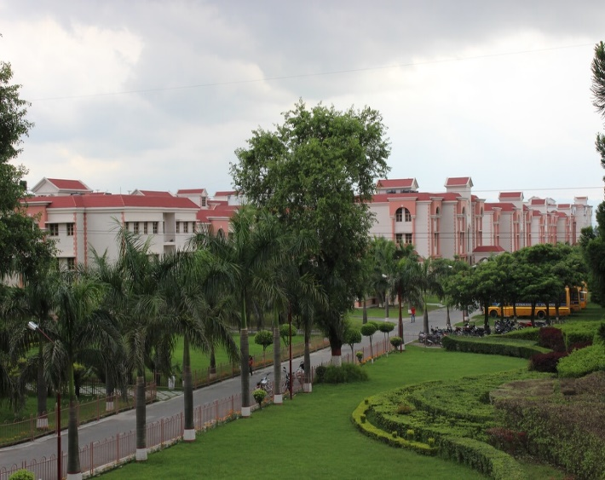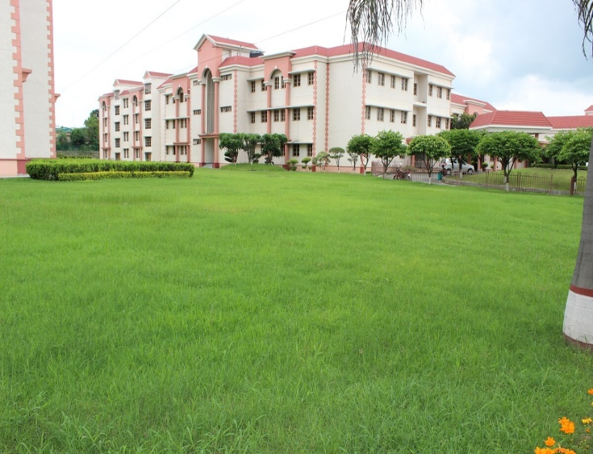

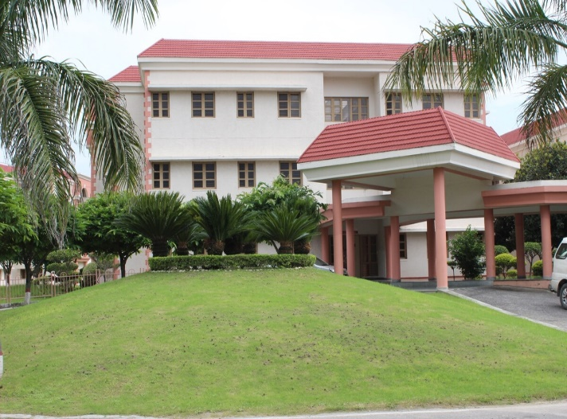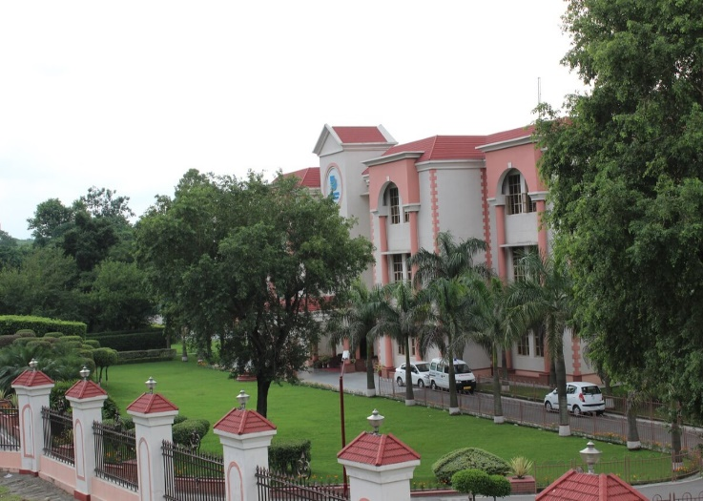

**Landscaping Practices**

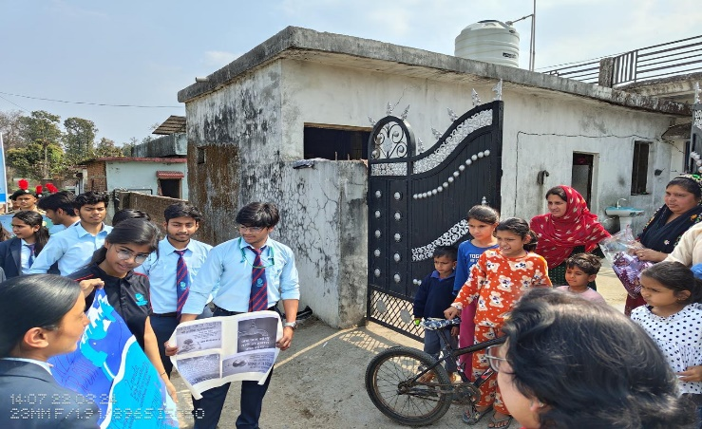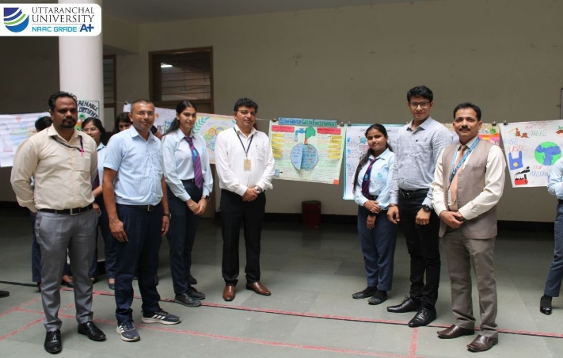

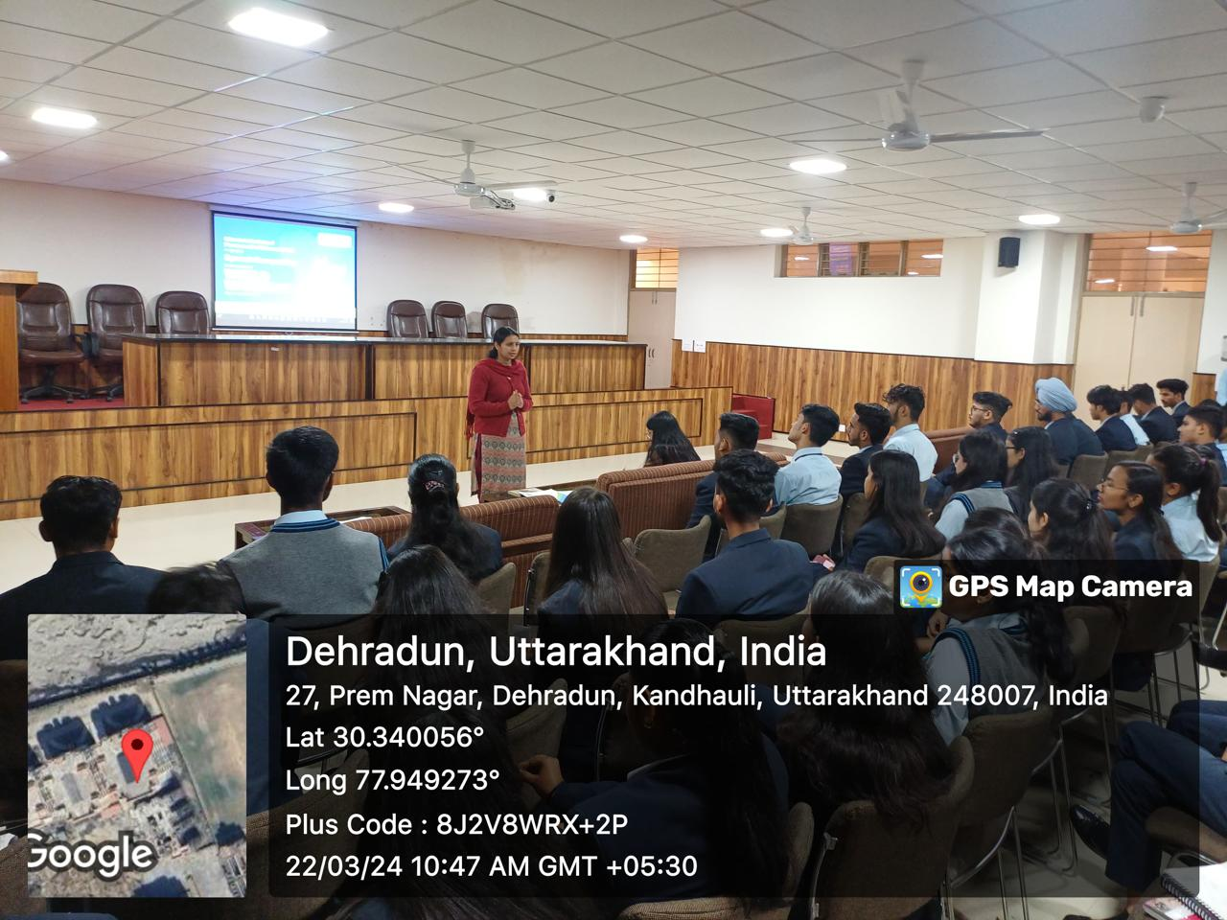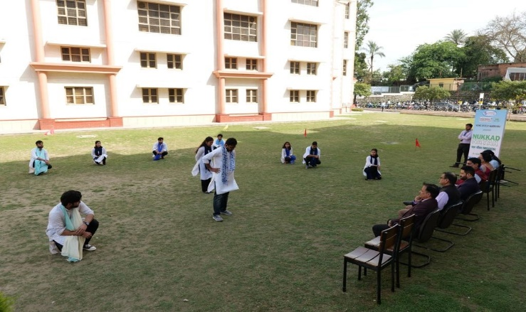

**Awareness & Training**



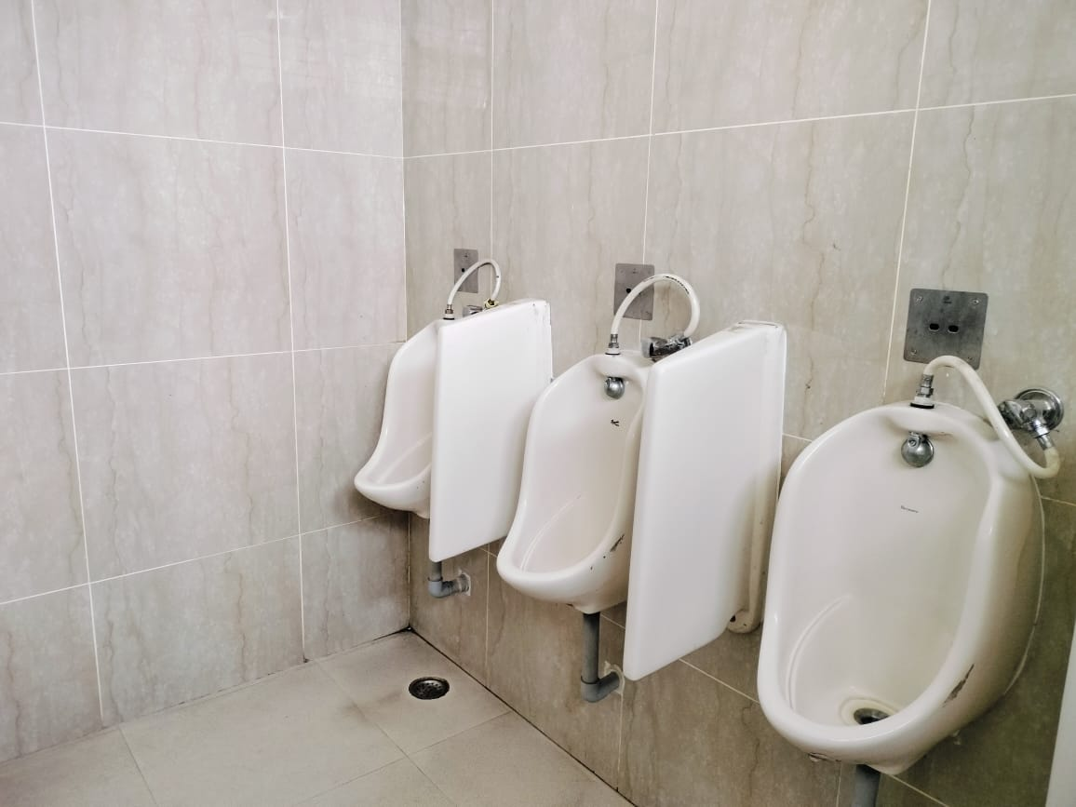

**6.3.5 Water-conscious planting**

**Smart sensor based hand washing stations & urinals**

**6.3.5 Water-conscious planting**

Uttaranchal University is home to a rich diversity of plant species, with 87 herbs, 65 shrubs, and 67 trees, totaling 219 species across the campus. This green initiative plays a vital role in water and environmental conservation efforts. The carefully selected plant species help improve air quality, reduce soil erosion, and contribute to maintaining the campus' natural ecosystem. Additionally, these plants, particularly the drought-resistant varieties, aid in minimizing water usage by requiring less irrigation. This green cover not only enhances the beauty of the campus but also supports biodiversity, creating a sustainable and eco-friendly environment for the university community.

The university campus is home to native plant species and drought-tolerant varieties that are well-suited to the local climate. These plants are naturally adapted to thrive with minimal water, making them ideal for water conservation efforts on campus.

* **Maintenance:** The university employs a proactive approach to landscape management, ensuring regular pruning, weeding, and upkeep of the campus greenery. This not only keeps the plants healthy but also optimizes their ability to use water efficiently, contributing to overall water conservation.
* **Educational Initiatives:** Faculty and staff actively incorporate the campus landscapes into educational programs, using them as hands-on tools to teach students and the surrounding community about water-efficient landscaping practices and the broader significance of sustainability in environmental stewardship.

Uttaranchal University boasts a diverse and vibrant array of flora, with over 200 species of plants, including herbs, shrubs, and trees. The campus is thoughtfully landscaped with native and drought-tolerant species that contribute to water conservation and environmental sustainability. This rich biodiversity not only enhances the aesthetic appeal of the campus but also serves as a natural habitat for local wildlife, fostering a harmonious balance between nature and academic life.

******List of University Flora**











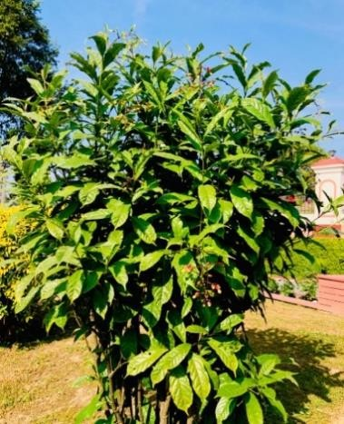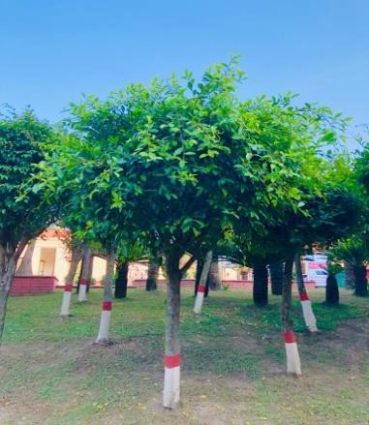

**6.4.1 Water re-use policy**

**6.4.2 Water re-use measurement**

The reuse of treated wastewater at Uttaranchal University is focused on reducing reliance on external freshwater resources. We are dedicated to monitoring water consumption, including the reuse of treated water, across the campus by tracking daily water usage.

Water meters have been installed in all buildings to measure the amount of reused water. These meters are monitored daily by our dedicated staff, and the data is reported to the relevant department, which analyzes the weekly consumption of treated water. Regular monitoring of the water meters helps detect overuse, allowing corrective actions to be taken to minimize water consumption.

* We ensure that treated wastewater is efficiently utilized for various purposes, including irrigation, sprinkling, and flushing in common toilets.
* Through our wastewater treatment plants, Uttaranchal University successfully reuses approximately 60% of the water, which is then used for various campus needs. This approach is essential for promoting water reduction and reuse within our institution.

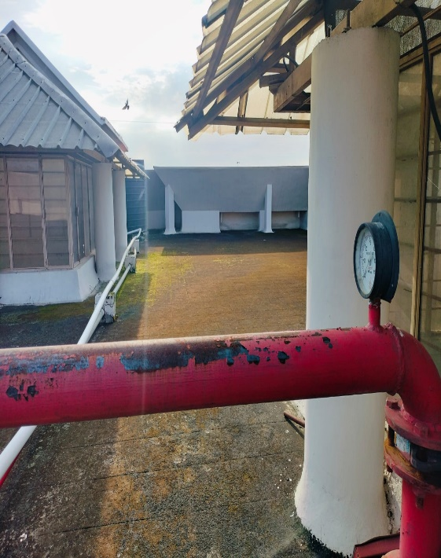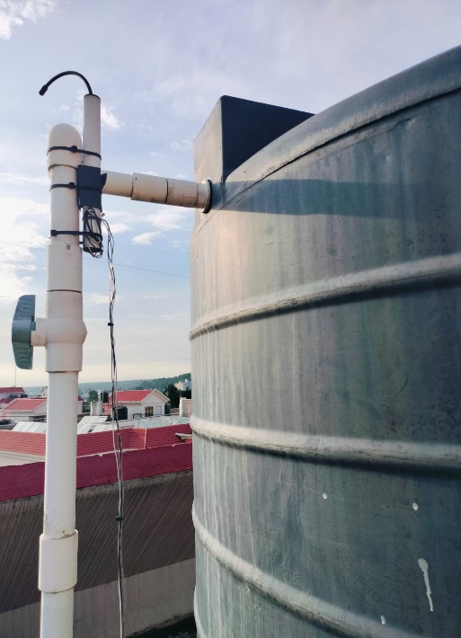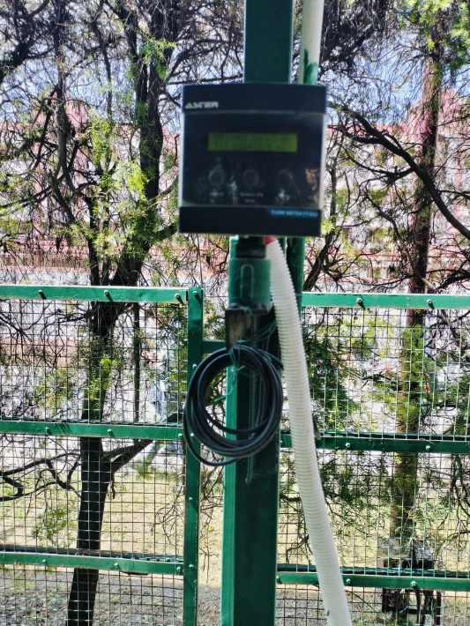

**Mechanical Flow Meter**

**Smart Sensor Water Level Sensor**

**with Alarming System**

**Smart Sensor Based Flow meter**

**6.5 Water in the community**

**6.5.1 Water management educational opportunities**

Uttaranchal University is committed to advancing the United Nations Sustainable Development Goals (SDGs) by focusing on four critical areas of societal importance: water, food, healthcare, and sustainable energy. In support of these goals, the university offers diverse academic programs related to Environment and Energy management, from undergraduate to doctoral levels. These programs are designed to address the multifaceted aspects of water resources, emphasizing conservation, sustainable practices, and innovative solutions for water management. By equipping students with the knowledge and skills needed to tackle global water challenges, Uttaranchal University plays a pivotal role in shaping a more sustainable future. Some of the Course related to SDG-6 are given below

**Courses Related to SDG Goal 6 – Clean Water and Sanitation**

**Environmental Science**

**Environmental, Urban and Occupational Health**

**Water Resource Engineering**

**Environmental Chemistry & Microbiology Of Water**



**Environmental Health & Rural Sanitation Engineering**

**Water Supply Systems**

**Water Resources Systems Management**

**Industrial Wastewater Management**

**Advanced Water and Wastewater Treatment**

**Sustainable Development Goals**

**Smart Sensor Based Flow meter**

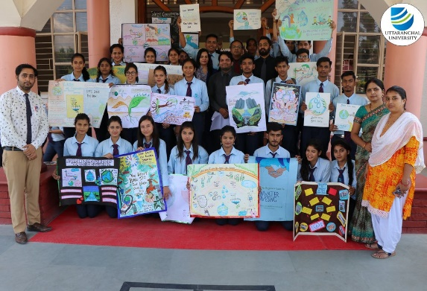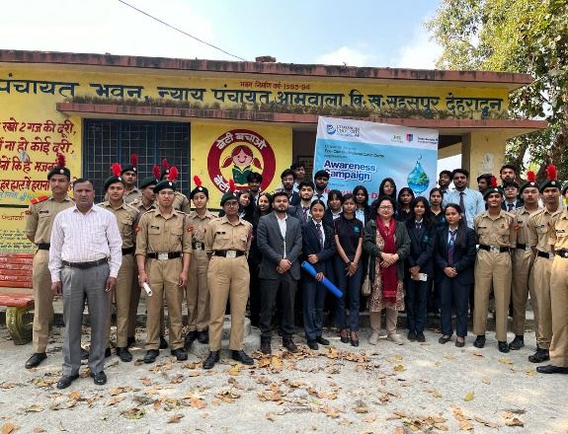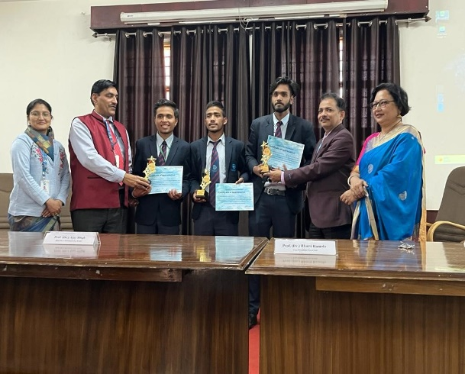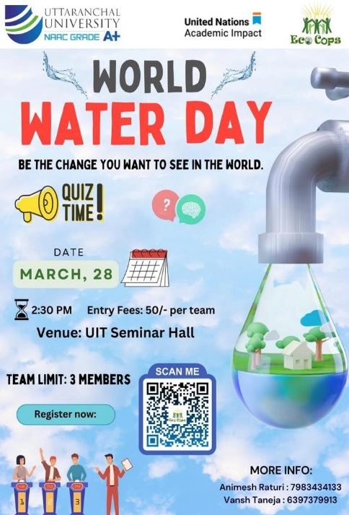

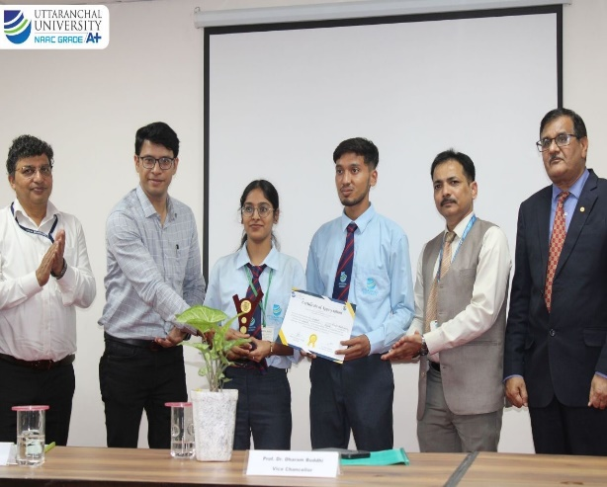

**Awareness Campaign & Training Programs**

**SDG- 6**



**6.5.2 Promoting conscious water usage**

As part of its commitment to sustainability and environmental stewardship, Uttaranchal University actively promotes conscious water usage across its campus. This initiative involves a combination of innovative techniques and devices designed to minimize water consumption, prevent wastage, and ensure long-term resource conservation. The following approaches highlight how the university is fostering responsible water usage among students, staff, and faculty.

**Water-Efficient Fixtures and Devices**

To reduce water consumption across the campus, Uttaranchal University has installed water-efficient fixtures in various facilities:

* **Low-flow faucets and aerators:** These reduce the volume of water used in sinks without compromising functionality, cutting water usage by up to 50%.
* **Dual-flush toilets:** Designed to use minimal water for flushing, these toilets provide different flush volumes for liquid and solid waste, significantly lowering water use in restrooms.
* **Sensor-based taps:** These automatic taps activate water flow only when hands are detected, eliminating the possibility of taps being left on unintentionally.
* **Water-efficient showers:** Installed in dormitories and sports facilities, these reduce water flow while maintaining effective pressure, contributing to significant savings in water consumption.

**Details of devices and techniques used for promotion of conscious water usage**

|  |  |  |
| --- | --- | --- |
| **S. No** | **Description** | **Number** |
| 1 | **Sensor based smart urinals** | 345 |
| 2 | **Low-flow faucets and aerators** | 2717 |
| 3 | **Sensor-based taps** | 1289 |
| 4 | **Sensor Based Flow meters** | 115 |
| 6 | **Sensor Based Water level Alarming System** | 112 |

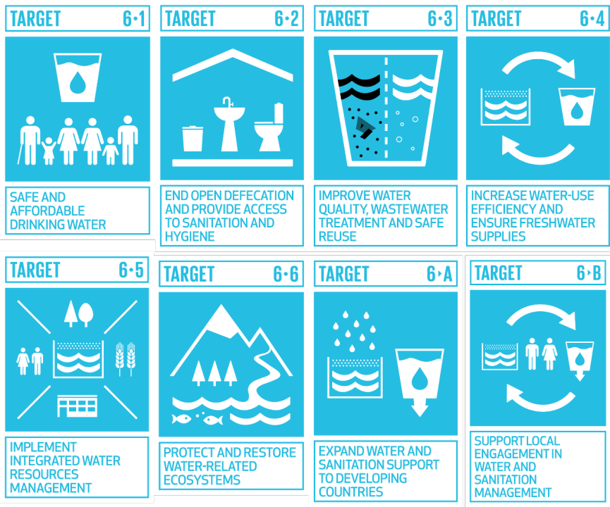

**6.5.3 Off-campus water conservation support**

Uttaranchal University actively supports water conservation efforts beyond its campus, engaging with communities at local, regional, national, and international levels to promote sustainable practices. The university contributes to these efforts through the following initiatives:

* Implementing practical projects to showcase effective water management techniques.
* Partnering with institutions and organizations to conduct research on water conservation and management.
* Raising awareness and educating the community on the importance of water conservation.
* Offering expert advice and solutions for water conservation to external organizations and communities.
* Engaging local communities in initiatives aimed at conserving water resources.
* Forming strategic alliances with stakeholders to drive water conservation efforts.
* Assessing water quality and providing transparent reports to ensure sustainability.

**Villages adopted by Uttaranchal University for Community Outreach and Student Sensitization w.r.t. Sustainable Village Development**

**Name of village 1: Majhaun**

**Panchayat Name: Aamwala**

**Block name: Sahaspur**

**District: Dehradun**

**State: Uttarakhand**

**Name of village 2: Chauki**

**Panchayat Name: Chauki**

**Block name: Sahaspur**

**District: Dehradun**

**State: Uttarakhand**

**Name of village 3: Hariyawala Kalan**

**Panchayat Name: Haria Wala Kalan**

**Block name: Sahaspur**

**District: Dehradun**

**State: Uttarakhand**

**Name of village 4: Kotra Santaur**

**Panchayat Name: Kotda Santaur**

**Block name: Sahaspur**

**District: Dehradun**

**State: Uttarakhand**

**Name of village 5: Kolhupani**

**Panchayat Name: Kotda Santaur**

**Block name: Sahaspur**

**District: Dehradun**

**State: Uttarakhand**

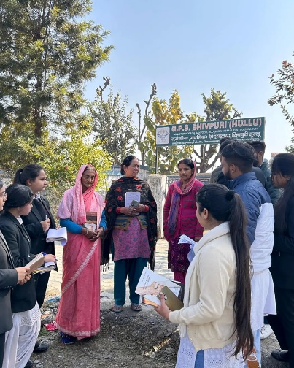

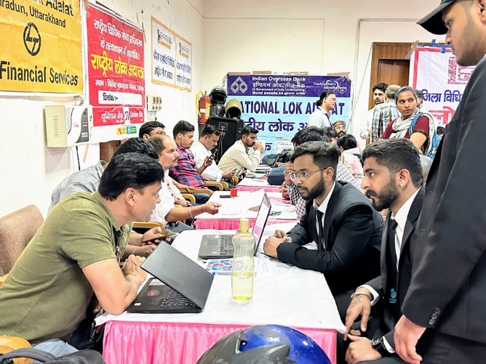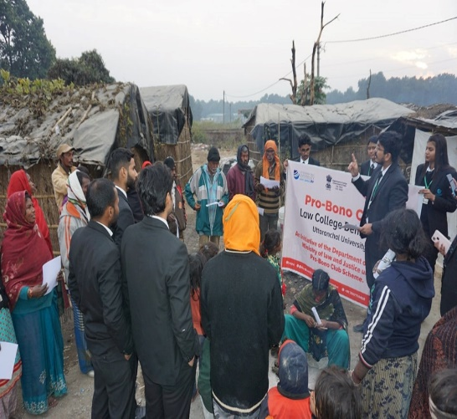

**Outreach Campaigns**

* Host street plays focusing on the water crisis and traditional water conservation methods.
* Host demonstrations on how to set up low-cost rainwater harvesting systems at homes, schools, and community centers.
* Distribute educational pamphlets on simple methods to reduce water wastage in daily activities.
* Organize river clean-up drives with student volunteers and local community members.
* Conduct awareness rallies and use posters to discourage the dumping of waste into water bodies.
* Conduct women-centric workshops on water-saving practices in daily chores like cooking, cleaning, and washing.
* Educate villagers about the dangers of groundwater depletion and simple techniques to recharge groundwater.
* Host regular meetings where villagers can discuss water concerns and develop solutions.

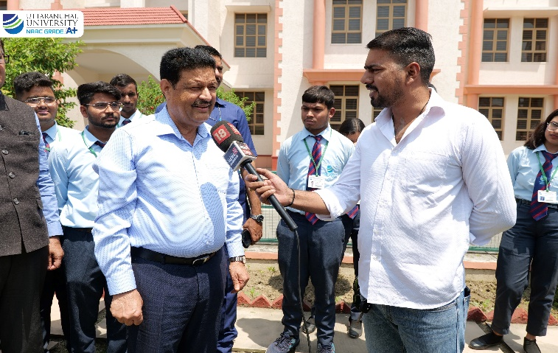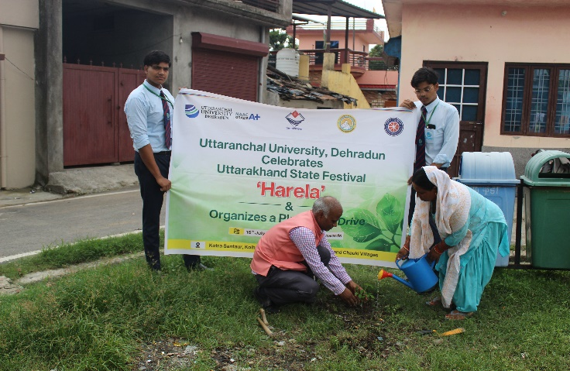

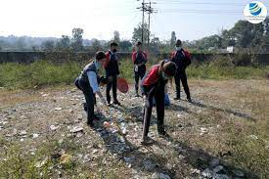

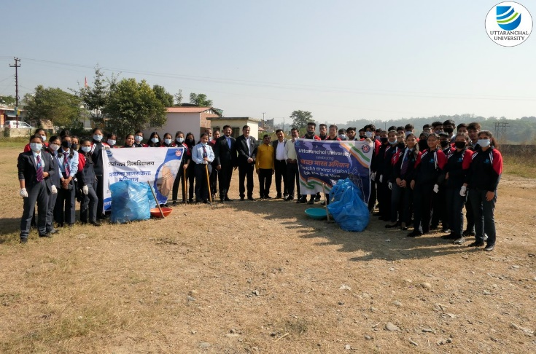

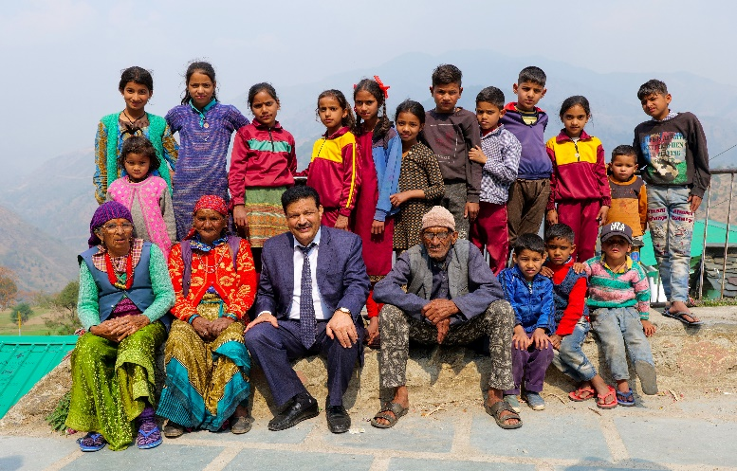

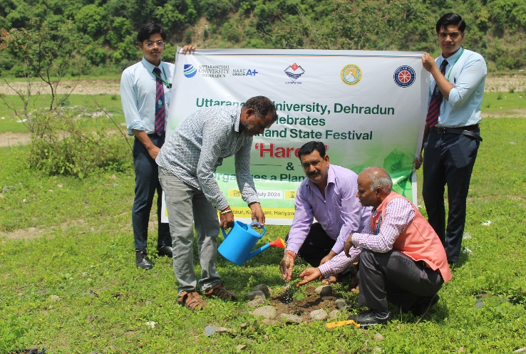

**6.5.4 Sustainable water extraction on campus**

At Uttaranchal University, sustainable water extraction practices are prioritized to ensure efficient use of water resources while maintaining environmental balance. These efforts are aligned with the university's commitment to sustainability and contribute to the responsible management of water on campus. Key initiatives include:

* Rainwater harvesting systems are installed across campus buildings to collect and store rainwater in underground tanks.
* Borewells on campus are equipped with water meters to monitor extraction rates, preventing over-extraction.
* Energy-efficient pumps are installed for extracting groundwater, lowering electricity consumption.
* Regular testing of water quality is conducted to monitor parameters such as pH, hardness, and contamination levels.
* 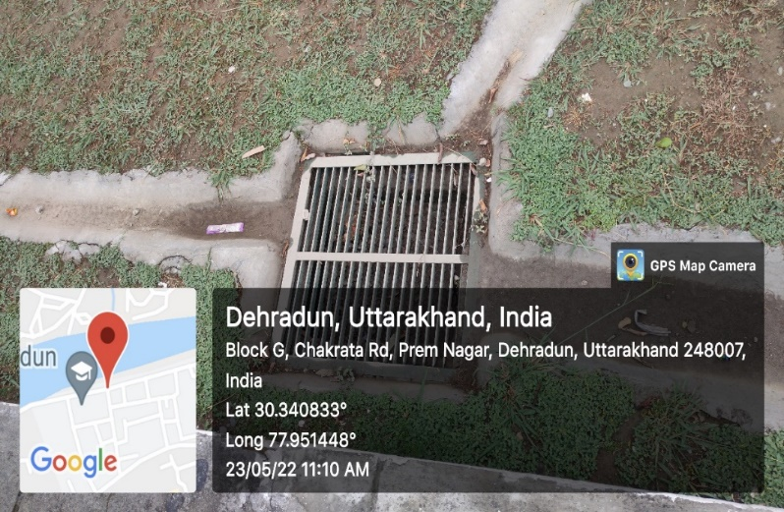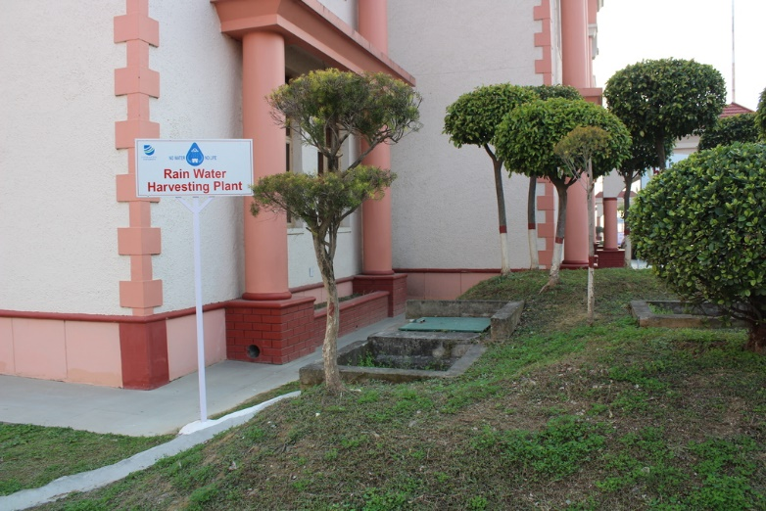Wastewater from residential and academic buildings is treated in the university’s on-campus treatment plants.

**Rain Water Harvesting**

**6.5.5 Cooperation on water security**

Uttaranchal University collaborates with governments at local, regional, national, and global levels, as well as with other universities, to address challenges related to water security. These partnerships aim to improve water availability, quality, and management through research, policy development, and the implementation of sustainable solutions. Such cooperation fosters advancements in water resource management, benefiting both academia and industry.

Uttaranchal University has signed Memorandums of Understanding (MoUs) with various national and international academic institutions and industry partners to enhance these efforts. Below are key ways in which Uttaranchal University collaborates on water security with governments and universities:

* Research and development on sustainable water management practices.
* Policy support in addressing water-related challenges.
* Joint initiatives to improve water availability and quality.
* Knowledge sharing and capacity building for sustainable water resource management.

**Some of Our prominent collaborations for Sustanable practices**

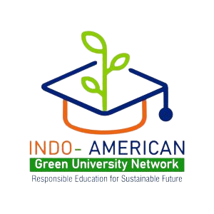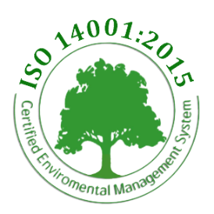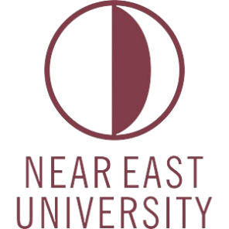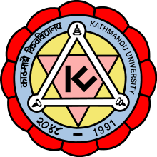

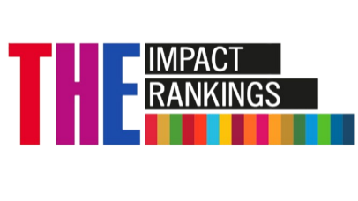

* Energy Efficiency Policy outlined by Uttaranchal University reflects a commendable commitment to promoting sustainability and reducing the institution's carbon footprint.
* By integrating various energy-efficient measures, such as conducting energy audits, installing solar power plants, implementing LED lighting systems, and utilizing bio-gas plants, the university demonstrates a proactive approach toward energy conservation.
* Additionally, the policy's emphasis on awareness and training, as evidenced by organizing training programs and webinars, indicates a comprehensive strategy to educate the university community about energy efficiency and renewable energy technologies.
* The involvement of industry experts and professionals in these programs further enriches the learning experience.
* Moreover, the policy's periodic review every three years ensures its relevance and effectiveness over time, allowing for necessary adjustments and improvements.
* Uttaranchal University is deeply committed to sustainability, evidenced by a comprehensive plan to upgrade existing buildings for higher energy efficiency.
* The strategies, including energy audits and advanced technologies, reflect a holistic approach to reduce energy consumption.
* Integrating solar panels, energy-efficient windows, water conservation, and occupant awareness aligns with Sustainable Development Goals, particularly SDG 5.
* Visual representations highlight successful implementations, showcasing the university's dedication to sustainability and fostering an environmentally responsible culture among occupants.
* Uttaranchal University's initiatives towards Carbon Management and reducing CO₂ emissions are commendable and reflect a proactive approach towards mitigating climate change.
* The university's commitment to controlling energy performance and transitioning towards a net-zero future is demonstrated through various measures, such as the installation of rooftop solar PV plants, solar water heaters, and EV charging points.
* The solar power generation plant, generating 286,072 KWh and saving 286 metric tons of CO₂ emissions, showcases the university's dedication to clean energy solutions.
* Additionally, the installation of 12 solar water heaters with a capacity of 24,000 litres per day significantly reduces carbon emissions by 393 metric tons.
* Uttaranchal University's Energy Efficiency Plan (SDG 7.2.4) takes a holistic approach to energy management.
* Regular energy audits are conducted to assess and optimize energy consumption.
* LED lighting and HVAC optimization are implemented for energy conservation.
* Renewable energy integration showcases a commitment to sustainable energy use.
* Occupancy sensors and energy-efficient appliances help further conserve energy.
* Awareness campaigns and workshops promote energy conservation among the university community.
* Collaborations with experts demonstrate a commitment to community involvement and education.
* Practical renewable energy solutions, including solar panels, solar water heaters, and EV charging points, emphasize the university's dedication to sustainability.
* Uttaranchal University's Environmental Policy, established in 2021, demonstrates commitment to environmental sustainability.
* The policy is set for review in 2024 to ensure continued relevance and effectiveness.
* The university has divested from coal and oil industries, reducing carbon-intensive investments.
* A 208 KWp Grid Connected Solar Photovoltaic Power Plant has been installed to decrease the carbon footprint.
* 24,000 lpd solar water heating systems contribute to energy efficiency and carbon reduction.
* The University saves 286 metric tons and 393 metric tons of CO₂ emissions through these initiatives.
* Educational initiatives, workshops, and guest lectures engage stakeholders in sustainable energy practices.
* The university advocates for responsible investment strategies and promotes a low-carbon economy.
* These efforts align with the university’s Environmental Policy objectives to combat climate change.
* Uttaranchal University's Environmental Policy, established in 2021, demonstrates commitment to environmental sustainability.
* The policy is scheduled for review in 2024 to ensure its continued relevance and effectiveness.
* The University has divested from coal and oil industries, reducing carbon-intensive investments.
* A 208 KWp Grid Connected Solar Photovoltaic Power Plant has been installed to decrease the carbon footprint.
* 24,000 lpd solar water heating systems are in place to enhance energy efficiency and reduce carbon emissions.
* These initiatives save 286 metric tons and 393 metric tons of CO₂ emissions, respectively.
* Educational initiatives, workshops, and guest lectures engage stakeholders in sustainable energy practices.
* The university advocates for responsible investment strategies to promote a low-carbon economy.

**All efforts align with the university’s Environmental Policy objectives to combat climate change.**

1. **Strong commitment to community engagement through various initiatives promoting energy efficiency and environmental awareness.**

* **Clean Energy Programmes:** Includes workshops, seminars, and conferences.
* Serves as a platform for disseminating knowledge on affordable and clean energy.

1. **5th International Conference on Clean Energy Systems and Technology:**

* Brings together diverse stakeholders.
* Fosters interdisciplinary discussions on sustainable practices.

1. **Swachh Bharat Abhiyan and Earth Day celebrations:**

* Highlight the university's dedication to community welfare.
* Activities extend beyond service provision to impactful awareness campaigns.

1. **Plantation drives and education camps:** Further exemplify the institution's commitment to environmental conservation.

**Promotion of sustainable energy practices through various initiatives are as below:**

1. National Energy Conservation Day events and Zero Emission Day celebrations.
2. Workshops on green audit concepts to educate the community.
3. Collaborations with HESCO Dehradun for energy conservation efforts.
4. Seven-day educational camp focusing on energy conservation, tree plantation, and waste management.
5. Global platforms like the 5th International Conference on Clean Energy and "Synergetic Innovations for Sustainable Development".
6. Faculty Development Program on electric vehicles to promote renewable energy awareness.

**Commitment to sustainability extends beyond campus boundaries.**

1. Commitment to advancing energy efficiency and clean energy through impactful initiatives.
2. Collaboration with Skill Council for Green Jobs and Arbutus Pvt. Ltd. for a 60-hour online training program on solar PV systems, upskilling professionals.
3. Technology transfers: Patented solutions for Thermal Storage Blanket and multilayer shading devices benefiting local industries.
4. Strategic partnerships through MoUs with HESCO Dehradun, National Power Training Institute, Punjab, and Industries Association of Uttarakhand for eco-sustainability.
5. Promotion of research among faculty and students on renewable energy topics.
6. International courses on biomass-based renewable energy and faculty development programs on electric vehicles.

**Pivotal role in advancing clean energy practices in collaboration with local industries.**

1. Active engagement with government bodies on clean energy and energy-efficient technology policy development.
2. The Vice Chancellor got invited by the Uttarakhand State Council for Science and Technology for a brainstorming session on the Science, Technology, and Innovation (STI) Policy for Uttarakhand.
3. Recognition at the national level: Ministry of New and Renewable Energy, Government of India, invites the Vice Chancellor as a panelist for a workshop on Solar Thermal Technologies.
4. Keynote lecture by Vice Chancellor on "Renewable Energy: Call for Global Action" showcasing the university’s commitment to renewable energy.

**Proactive role in shaping policies and fostering collaborations to advance clean energy adoption in India.**

1. Uttaranchal University is committed to promoting a low-carbon economy and technological innovation through its dedicated start-up and entrepreneurship cell.
2. The university nurtures entrepreneurship, with a special focus on energy and environmental sectors, by organizing seminars and workshops that inspire innovation.
3. Its goals include fostering cross-disciplinary ideas, improving employability, and establishing collaborations with government agencies and industries.

**SDG8: DECENT WORK AND ECONOMIC GROWTH**

**8.2 Employment practice**

**8.2.1 Employment practice living wage**

|  |  |  |  |  |
| --- | --- | --- | --- | --- |
| Minimum 6 years of Experience as Lab Technician Selection Grade | Rs. 9300-34800 + Rs. 5400 | Demonstrator | Foreman | Computer Instructor |

*\* Various other allowances as per norms*

**Salary Scale for Non-Teaching Staff – Clerical Grade/ Maintenance Staff**

|  |  |  |  |
| --- | --- | --- | --- |
| **Qualification** | **Recommended Scale of pay** | **Maintenance** | **Clerical Grade** |
| ITI / Diploma/B.Sc/ relevant equivalent degree | Rs.5200-20200 + Rs. 2200, | Plumber / Electrician/ Pump Operator Grade II | Clerical Grade II |
| Minimum 6 years of Experience | Rs. 5200-20200 + Rs. 2400 | Plumber / Electrician/ Pump Operator Grade I | Clerical Grade I |
| Minimum 8 years of Experience | Rs. 5200-20200 + Rs. 2800 | Plumber / Electrician/ Pump Operator (Selection Grade) | Clerical Grade (Selection Grade) |

*\* Various other allowances as per norms*

|  |  |  |
| --- | --- | --- |
| **Qualification** | **Recommended Scale of pay** | **Designation** |
| Graduate / Postgraduate with essential computer knowledge | 9300-34800 + Rs. 4200 | Assistant / Accountant Gr. II |
| M.Com / PG Diploma / Shorthand higher with a degree & 3 years relevant exp. Or Minimum 6 years of Experience as Assistant/Accountant Gr. II | 9300-34800 + Rs. 4600 | Assistant/Accountant Gr. I |
| Μ.Β.Α/M.C.A or Minimum 8 years of Experience as Assistant / Accountant Gr. I | 9300-34800 + Rs. 4800 | Assistant Section Officer / Assistant Purchase Officer / Assistant Stores Officer / Assistant PRO / Assistant Accounts officer / Assistant Superintendent / Assistant Manager |
| Minimum 6 years of Experience as Asst. Section Officer/Asst. Purchase Officer/ Asst Stores Officer / APRO / Asst Accounts officer | 15600-39100 +Rs 6000 | Section Officer / Purchase Officer / Stores Officer / PRO / Accounts officer/ Superintendent / Manager |
| Minimum 8 years of Experience as Superintendent | 15600-39100 +Rs 7000 | Asst. Registrar |
| Minimum 6 years of Experience as Asst. Registrar | 15600-39100 +Rs 8000 | Joint Registrar/Dy. Registrar |
| As per University Grant Commission, Government of India norms | 37400-67000 | Registrar |

*\* Various other allowances as per norms*

* Candidates holding qualifications from Distance Education programs will be evaluated for appointments based on their performance in a skills test and interview. However, applicants from Open University programs will not be considered.
* All new hires will initially be appointed on a two-year contract. Upon completion of this period, the contract may be extended or transitioned into a permanent position, contingent upon a thorough review of the individual's performance.

**8.2.2 Employment practice unions**

Uttaranchal University is fully aligned with the new labor laws recently passed by the Indian legislature, which have significantly enhanced worker protections and introduced the concept of fixed-term employment. These laws have reshaped the employment landscape, allowing organizations the option to engage fixed-term employees, who can potentially transition into temporary or permanent roles, depending on organizational needs.

In keeping with these changes, Uttaranchal University remains committed to upholding the rights of its employees and setting a standard for fairness and transparency in the workplace. The university has established a robust and impartial grievance redressal mechanism for staff and employees, ensuring that grievances are resolved promptly and equitably. This process guarantees that every employee has a voice in shaping decisions that impact their work and well-being.

Protecting and advancing worker rights is a priority not just nationally but globally. Uttaranchal University recognizes the importance of fostering a work environment where all employees feel safe, respected, and valued. By adhering to both state and central government regulations, the university ensures that every employee has fair representation. This approach has multiple positive outcomes, including:

* Enhanced employee morale and productivity.
* Lower turnover rates.
* A stronger reputation as a fair and responsible employer.
* A reduced risk of legal disputes.

**8.2.3 Employment policy on discrimination**

Uttaranchal University is dedicated to fostering an inclusive academic and professional environment, where diversity is celebrated, and discrimination of any kind—whether based on gender, race, ethnicity, religion, nationality, or disability—is unequivocally prohibited. Our recruitment and selection practices are designed to reflect this core value, ensuring that every individual has equal access to opportunities based solely on merit, fostering a culture of respect and fairness.

**8.2.4 Employment policy modern slavery**

Uttaranchal University firmly opposes all forms of forced labour, modern slavery, human trafficking, and child labour. We actively support and adhere to both national laws and international conventions that prohibit such practices. The university is committed to raising awareness and promoting ethical standards to prevent these violations of human rights, fostering a culture of dignity, respect, and responsibility across our community.

**8.2.5 Employment practice equivalent rights outsourcing**

As a private institution, Uttaranchal University is committed to ensuring equal rights for all employees on its campus. The university mandates that all current and future contractors establish safe and conducive working conditions for their staff. This commitment includes adhering to all relevant labour rights outlined in Uttaranchal University’s Human Resource Policy and associated regulations.

Uttaranchal University fully upholds its Human Resource Policy and related guidelines when interacting with employees of contractors and those on temporary contracts. Furthermore, employees of contractors and those on temporary contracts have access to university amenities, including cafeterias and restrooms, fostering an inclusive environment for everyone working on campus.

**8.2.6 Employment policy pay scale equity**

At Uttaranchal University, we prioritize creating an equitable and inclusive academic environment, where government regulations, open dialogue, and gender equality are integral to our values. Our female faculty and staff are recognized not only for their exceptional contributions but also as essential leaders in driving the university’s innovation and advancement.

In alignment with the "Standard Pay Scale" prescribed by the Government of India, the university ensures that compensation practices are fair and transparent. We maintain a strict 1:1 salary ratio for men and women holding equivalent positions, reaffirming our commitment to eliminating gender-based disparities in pay.

**8.2.7 Tracking pay scale for gender equity**

Uttaranchal University is dedicated to building a culture of inclusivity and respect, where each employee's contributions are recognized and rewarded fairly, without bias or discrimination. This approach ensures that talent and effort are the true measures of value.

By embracing this philosophy, the university not only advances equality but also nurtures a more driven, innovative, and committed workforce, enhancing the overall success and well-being of both the employees and the institution.

|  |  |  |  |  |  |  |
| --- | --- | --- | --- | --- | --- | --- |
| **Category** | **Level** | **Employee Count** | | **Median Salary** | | **Difference** |
| **Male** | **Female** | **Male** | **Female** |
| Teaching | Assistant Professor | 219 | 185 | 45000 | 36344 | 8656 |
| Associate Professor | 19 | 17 | 70169.5 | 59914.2 | 10255.3 |
| Professor | 23 | 7 | 93587 | 105184 | -11597 |
| Non-Teaching Staff | Senior Administrative Staff | 12 | 1 | 88250 | 45000 | 43250 |
| Administrative Officers | 18 | 7 | 49203 | 24000 | 25203 |
| Staff | 339 | 75 | 15000 | 16000 | -1000 |
| Blue collar Staff | 28 | 87 | 8800 | 8800 | 0 |

**8.2.8 Employment practice appeal process**

Uttaranchal University employees are entitled to a range of fundamental rights that ensure dignity, fairness, and protection in the workplace. These include:

* The right to be treated with respect and decency.
* Protection from abuse, harassment, and all forms of discrimination.
* The right to work in a safe and healthy environment.
* Fair compensation and access to benefits.
* The freedom to organize and participate in collective bargaining.
* A fair and transparent process during disciplinary actions.
* The right to confidentiality and privacy.

**Reporting Concerns**

Employees who wish to raise concerns about their rights, or the rights of others, have several avenues for doing so. They may report issues to as per University Grievance Redressal of Employees Policy. Complaints must be submitted in writing and should include:

* The employee's name and contact information.
* A clear description of the concern.
* Any other relevant details.

Once submitted, the appropriate office will investigate the complaint and take the necessary steps to address it.

**8.3.1 Expenditure per employee**



**Total University Expenditure**

0000000000000000000

**Expenditure per employee**

000000000000000

**8.4 Proportion of students taking work placements**

At Uttaranchal University, we actively encourage students to pursue internships and work placements both within the university and with leading external organizations. These opportunities play a crucial role in enhancing their professional and practical skills.

By engaging in internships with top industries, students are challenged to apply their academic knowledge, fostering creativity and a scientific mindset. These experiences not only provide hands-on training and real-world exposure but also significantly improve their employability and entrepreneurial potential. Through these placements, students develop a deeper understanding of their field, preparing them for future career success.

|  |  |  |  |
| --- | --- | --- | --- |
| **Number of intern students with outside organizations (A)** | **Number of intern students with Uttaranchal University (B)** | **Total Number of Student Intern (A+B)** | **Total number of University Students** |
| **5862** | **49** | **5911** | **10707** |

**8.5 Proportion of employees on secure contracts**

At Uttaranchal University, **682 out of 1,037** employees are on secure contracts, while the remaining staff members are currently in their probationary period. This reflects the university's strong commitment to offering stable and reliable employment, which not only enhances the institution's competitiveness in the job market but also contributes to the social and economic well-being of the surrounding community.

This achievement highlights Uttaranchal University's dedication to fostering a positive and secure work environment. The high percentage of employees with secure contracts is a key factor in maintaining a productive and supportive workplace.

The university ensures this stability through several measures:

* Long-term job security by transitioning staff into permanent roles.
* Competitive pay and benefits that attract and retain talented professionals.
* A supportive work culture that promotes inclusivity, growth, and collaboration.

These efforts collectively strengthen the university’s reputation as an employer of choice while contributing to the overall success of its academic and administrative operations.

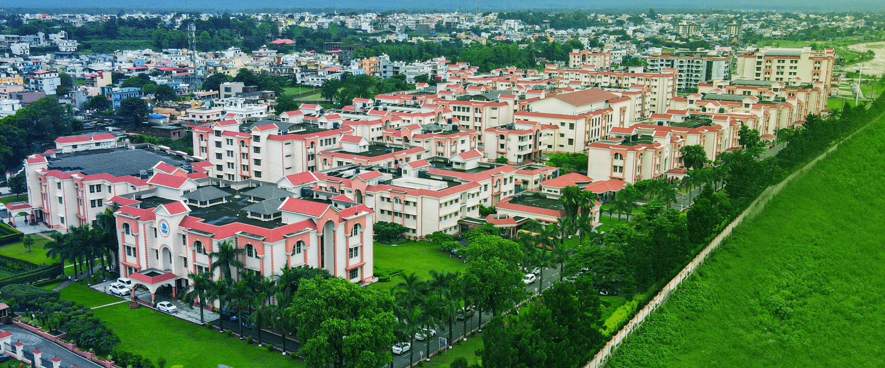

GOAL 9

GOAL 10

GOAL 11



**SDG12: RESPONSIBLE CONSUMPTION AND PRODUCTION**

**12.2 Operational measures**

**12.2.1 Ethical sourcing policy**

Our university has entered into an agreement with a certified catering supplier to ensure the provision of food and ingredients that adhere strictly to the principles of "Sustainable Food Procurement Practices- Guidelines." This contract mandates that the supplier sources only high-quality, certified food products, with a focus on local, traceable agricultural goods endorsed by government or approved authorities. It prohibits the use of incomplete packaging, unverified brands, and strictly bans the use of genetically modified ingredients or any primary processing involving genetically modified organisms. By prioritizing local, sustainable sourcing, the university aims to support regional agriculture while promoting healthier, eco-friendly food options for our campus community.



**12.2.3 Policy waste disposal - hazardous materials**

Uttaranchal University has implemented a comprehensive 'Waste Disposal and Hazardous Materials Management Policy' to ensure the responsible handling of waste on campus. The policy outlines a systematic approach to managing laboratory waste, including effluents, chemicals, and empty containers, which are safely disposed of on an annual basis. Biomedical waste generated by the university's hospital and laboratories is collected weekly by a certified third-party agency. Additionally, the university has established multiple MOUs with specialized waste disposal agencies to enhance the efficiency and effectiveness of its campus-wide waste management practices.

Our MOUs:

* **Bio-Medical Waste**- Medical Pollution Control Committee - Validity
* **Uttarakhand Pollution Control Board**- Provisional Consent Order (CCA)
* **E Waste**- Greenlink Recyclers Private Limited
* **Hazardous waste collection certificate** – Bharat Oil & Waste Management Limited

**12.2.5 Policy for minimisation of plastic use**

**12.2.6 Policy for minimisation of disposable items**

**12.2.7 Disposable policy: extensions to services**

Uttaranchal University is committed to minimizing the use of plastic and disposable items across its campus as part of its sustainability efforts. The university actively discourages single-use plastics, promoting the use of reusable and eco-friendly alternatives such as cloth bags, refillable bottles, and biodegradable materials. In line with this commitment, the university's Policy on Minimization of Plastic Use and Disposable Items the use of durable, reusable items, and when necessary, biodegradable or compostable options. Furthermore, these sustainability standards extend beyond internal operations, ensuring that all outsourced services, including catering and supply chain partners, comply with the university’s plastic reduction goals. Vendors and suppliers are expected to adhere to sustainable practices, minimizing plastic packaging and favouring environmentally- friendly materials, thus reinforcing the university’s dedication to reducing its environmental footprint.

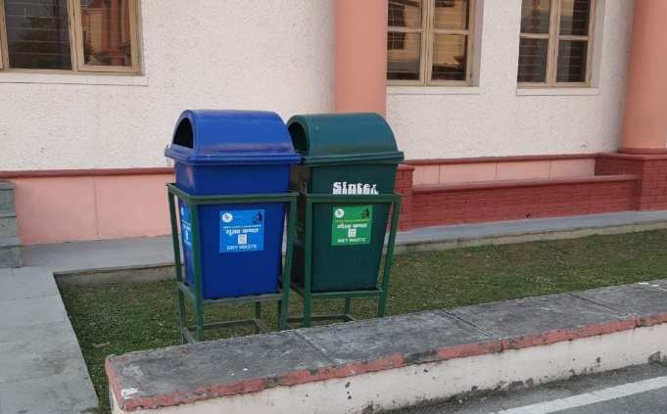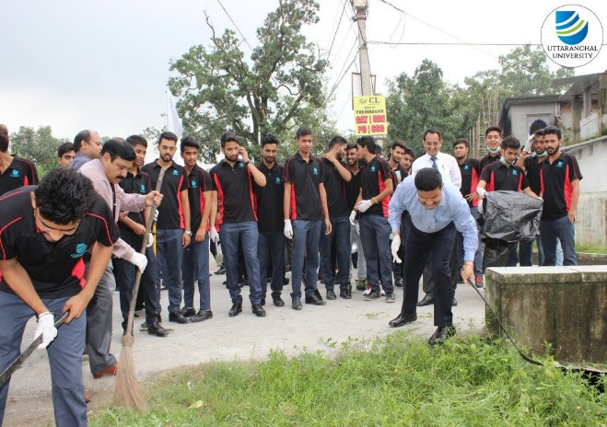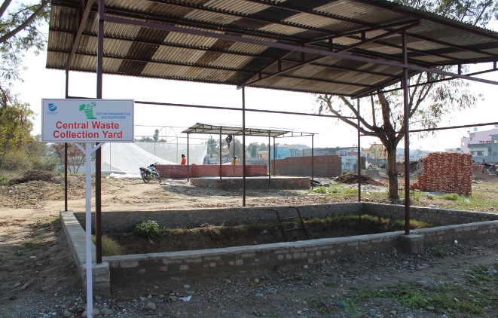

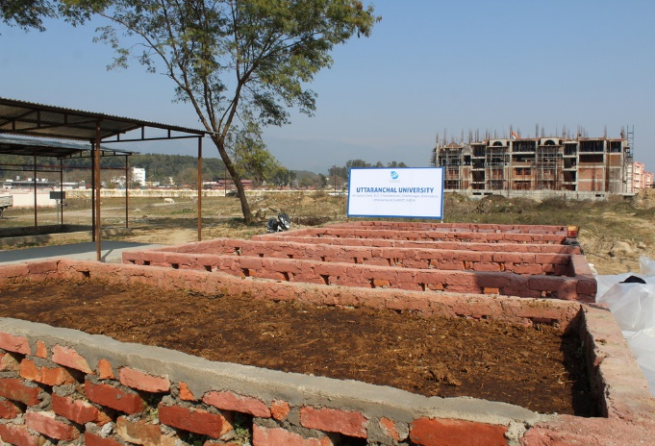

**12.2.8 Minimisation policies extended to suppliers**

At Uttaranchal University, ethical sourcing is integral to our sustainable supply chain management. Our minimization policies are not only applied within the university but also extend to our suppliers, ensuring that all procured goods and services meet high ethical and sustainability standards. Ethical sourcing involves a commitment to procuring commodities in a way that ensures safe and fair working conditions for producers and workers involved in the supply chain. The university carefully selects suppliers who align with these values, ensuring that products, particularly food items, are sourced responsibly. Food traceability is essential in this process, providing transparency about the origins and production methods of food products. By leveraging modern technology and regulatory frameworks, Uttaranchal University encourages the entire supply chain to adopt sustainable practices, fostering a culture of ethical responsibility and environmental stewardship across all procurement activities.

**12.3 Proportion of recycled waste**

**12.3.1 Waste tracking**

At Uttaranchal University, waste tracking is a vital part of our commitment to sustainability and effective waste management. Through systematic waste audits and monitoring processes, the university tracks various waste streams, including recyclables, compostables, hazardous materials, and non-recyclable waste. This data-driven approach helps measure waste generation across campus facilities, enabling us to identify trends and areas for improvement. By tracking key metrics such as recycling rates, waste diversion rates, and overall waste reduction, the university ensures transparency and accountability in its waste management efforts. This ongoing process allows us to refine our strategies, minimize waste sent to landfills, and align with our sustainability goals.

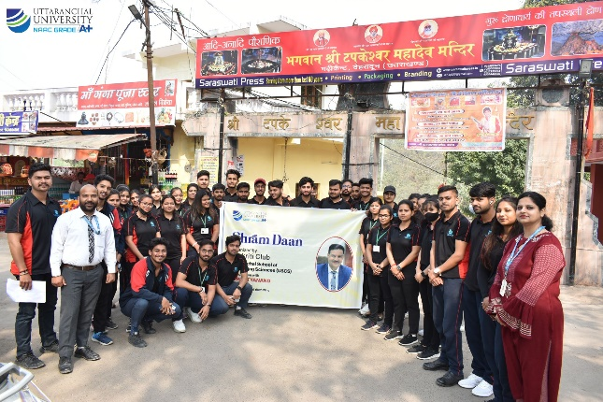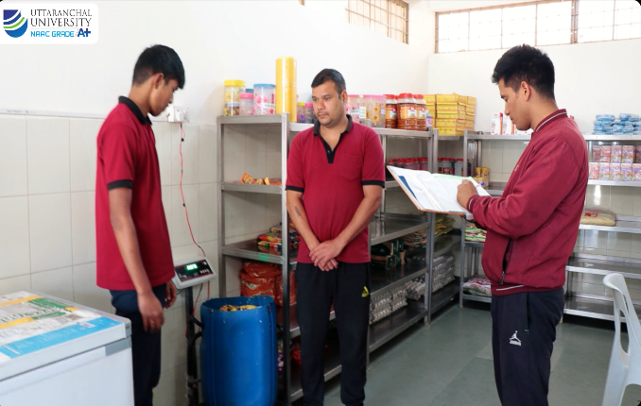

**12.4.1 Publication of a sustainability report**

Uttaranchal University is dedicated to transparency and accountability in its sustainability efforts, demonstrated through the annual publication of its Sustainability Report. This comprehensive document provides a detailed overview of the university’s environmental initiatives, including energy and water conservation, waste management, plastic reduction, and carbon footprint reduction efforts. The report highlights progress towards sustainability goals, tracks key performance indicators such as waste diversion rates and resource usage, and outlines new initiatives aimed at further minimizing the university’s environmental impact. By making the Sustainability Report publicly available, the university fosters community engagement, encourages stakeholder collaboration, and reinforces its commitment to creating a greener and more sustainable campus.

**13.2 Low-carbon energy use**

**13.2.1 Low carbon energy tracking**

**Measuring the Amount of Low Carbon Energy Used at Uttaranchal University**

As part of our commitment to sustainability and reducing our carbon footprint, the university has initiated an evaluation of the energy sources utilized across all campuses. This report provides an overview of the current usage of low carbon energy, the progress made towards achieving sustainability targets, and the steps required **to increase our reliance on low carbon energy in the future.**

**Current Energy Sources**

The university sources its energy from a combination of fossil fuels, low carbon energy, and renewable sources. Low carbon energy refers to sources that produce significantly lower emissions compared to traditional fossil fuels. These include:

**Renewable Energy:** Uttaranchal University strives hard to reduce the consumption of energy and has also adopted a range of alternate sources of energy. One measure in this aspect is its effort to tap the solar energy to minimise carbon emission. Currently, there is 208 KWh roof top PV Solar plant installed in the university campus for generation of electricity and also connected with grid. On an average 23000 units per month is generated through solar production. All the hostels have been installed with ‘Solar Heating water system’.

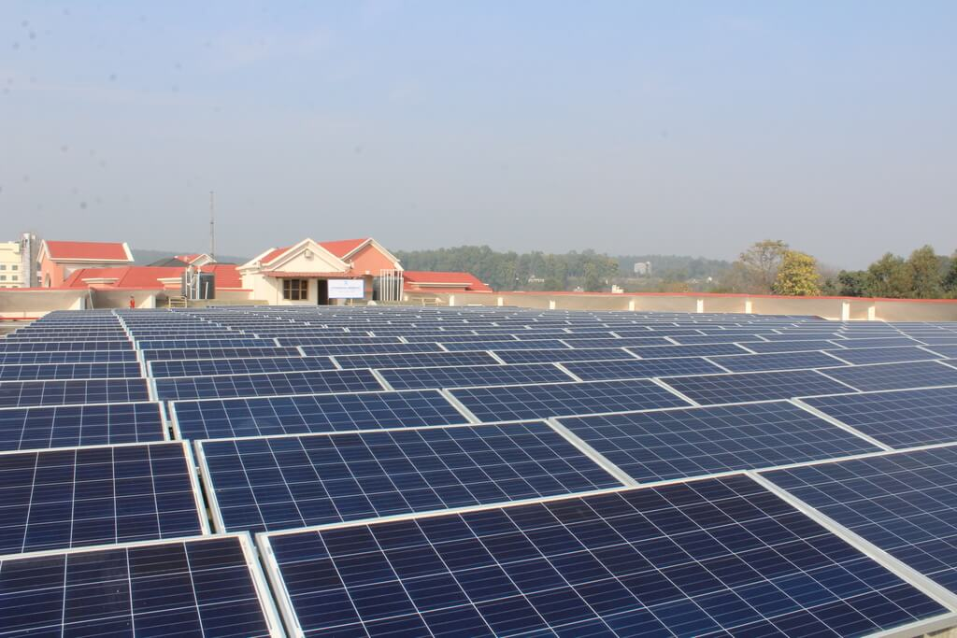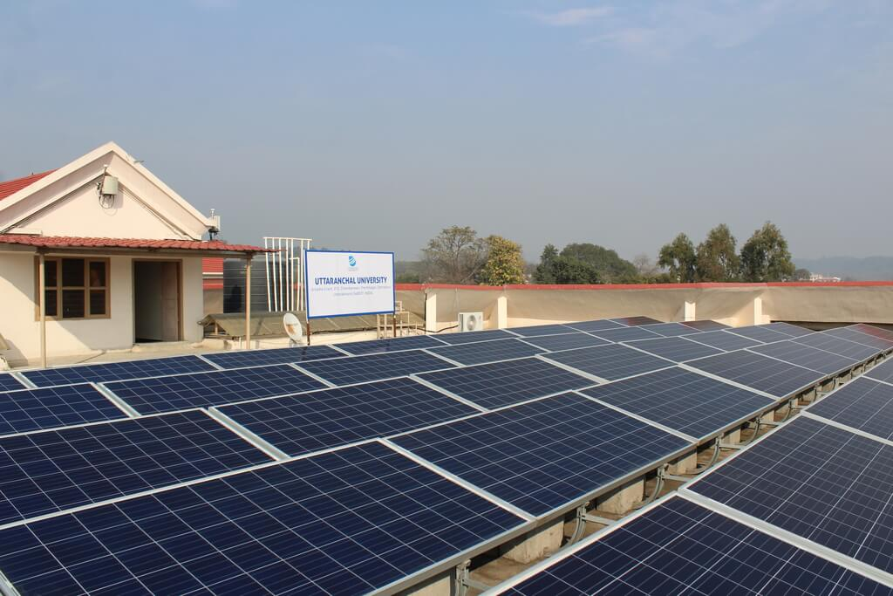

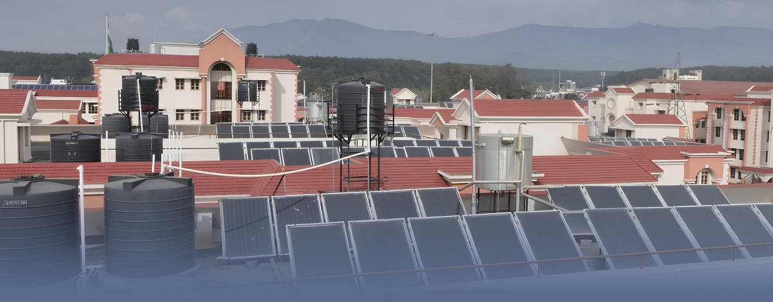

**Purchased Green Electricity:** Our university is committed to sustainability and reducing its carbon footprint by sourcing energy from low-emission sources. A significant portion of the electricity consumed at the university is purchased from Uttarakhand Power Corporation Limited (UPCL), which plays a crucial role in the state’s energy distribution. Notably, most of the electricity generated in Uttarakhand comes from hydropower, making it a relatively clean and low-carbon source of energy.

Our university purchases electricity from UPCL, which manages the distribution of power generated across the state. UPCL’s energy portfolio primarily includes hydropower, making it a low-carbon electricity provider. By sourcing electricity from UPCL, the university is indirectly benefiting from Uttarakhand’s hydropower capacity, contributing to the reduction of its overall carbon emissions.

Uttarakhand is endowed with abundant water resources, which have been harnessed for hydropower generation. The state's mountainous terrain and rivers, including the Ganges and Yamuna, provide ideal conditions for hydropower plants. As a result, hydropower contributes a significant percentage of Uttarakhand’s electricity generation, making it a sustainable and renewable energy source.



Tehri Dam - on the Bhagirathi River in New Tehri, Tehri Garhwal district in Uttarakhand, India. It is the tallest dam in India and the 13th-tallest dam in the world.

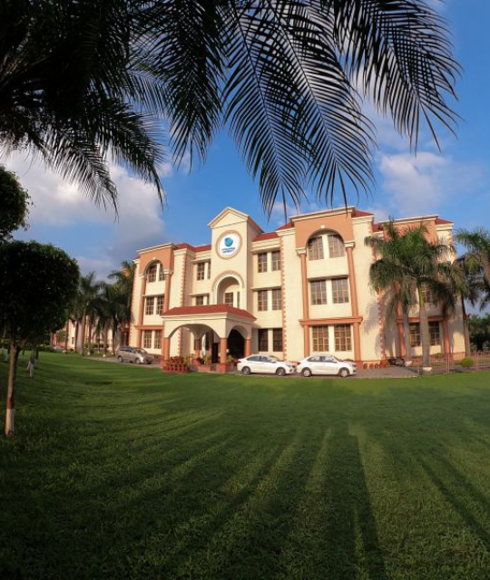

**Energy-efficient Infrastructure:** Buildings equipped with energy-efficient lighting, heating, and cooling systems that minimize carbon output.

Our university is proud to be ISO 50001:2018 certified, demonstrating our commitment to energy management and sustainability. This internationally recognized certification reflects our dedication to continuously improving energy performance, reducing greenhouse gas emissions, and promoting efficient energy use across campus. By adhering to the ISO 50001:2018 standards, the university has implemented a systematic approach to monitoring and optimizing energy consumption, aligning with global best practices. This certification not only underscores our efforts in minimizing environmental impact but also enhances operational efficiency, supporting our broader sustainability goals and commitment to a low-carbon future.



**Energy Usage Breakdown:** The energy consumption data from the past year reflects the following distribution of low carbon energy:

* **Solar Energy:** 12.81% of the total energy consumed is generated by solar panels installed on the campus rooftops and parking structures.
* **Green Electricity:** 80.56% of the university’s energy is sourced from green electricity suppliers who provide hydropower.

**Total Low Carbon Energy Usage**

The **total amount of low carbon energy usage across the university amounts to approximately 93.37%** of the university's total energy consumption. This includes both the on-site generation of solar energy and purchased green electricity. Based on recent calculations, **the energy generated from diesel generators constitutes approximately 6.63%** of the university's total energy usage with the operation efficiency of 40% of diesel generator sets. This usage is primarily during power outages or in areas where grid power is unreliable.

**13.3.1 Local education programmes on climate**

Uttaranchal University is committed to serving both its internal and external communities, with a special focus on the state of Uttarakhand. To foster awareness of Environmental Health, Safety, and Sustainability, the university organizes a variety of educational sessions throughout the year. These sessions, held weekly and monthly at the university or in schools across Uttarakhand, provide students with essential knowledge in these areas and help them build critical 21st-century skills. In line with the university's commitment to knowledge-sharing, learning resources are made available on its sustainability page for students to access freely for continued learning and skill development. Additionally, the university conducts local education programs and campaigns to raise awareness about the risks and impacts of climate change, including strategies for mitigation, adaptation, impact reduction, and early warning systems—addressing the unique challenges faced by Uttarakhand.

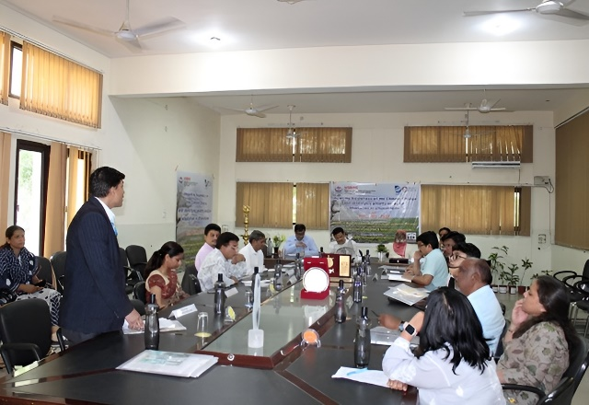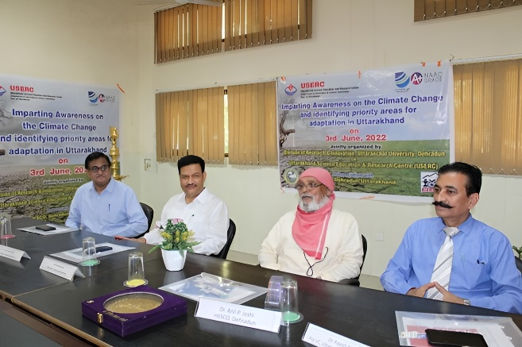

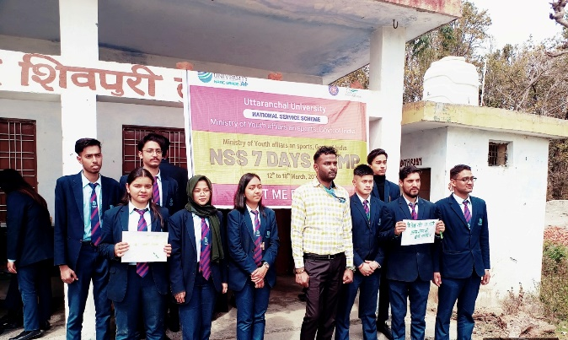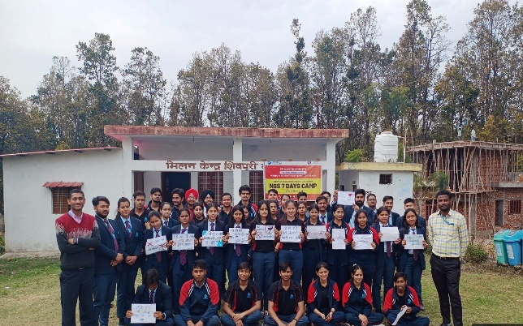

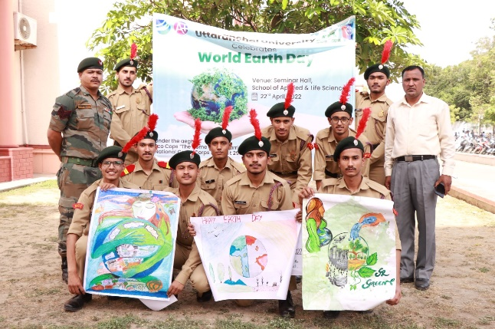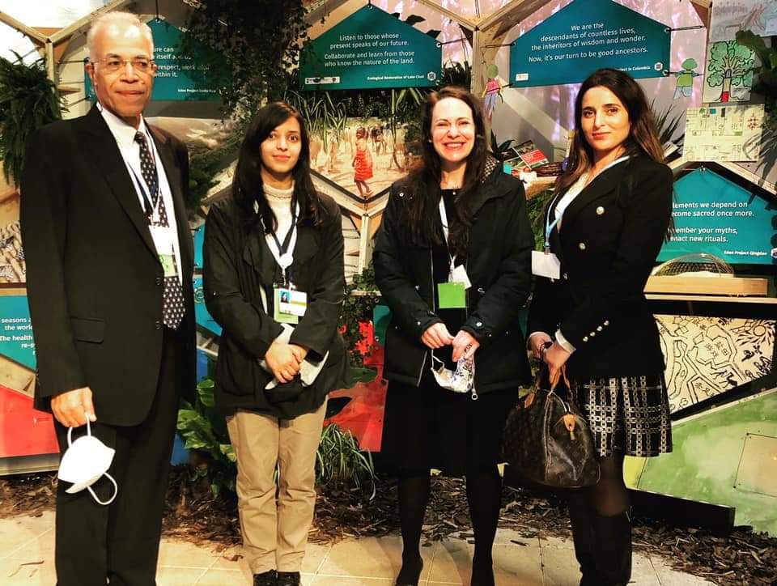

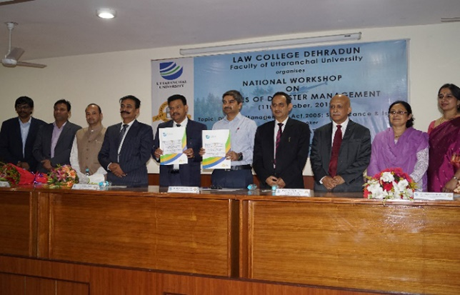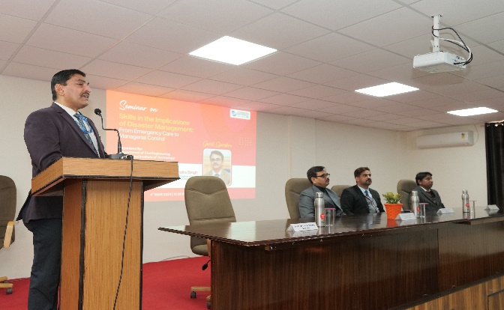

**13.3.2 Climate Action Plan, shared**

Our university's Climate Action Plan demonstrates our strong commitment to leading by example in addressing climate change, both on campus and throughout Uttarakhand. By actively reducing emissions, involving the local community, and supporting state-level sustainability initiatives, we strive to become a model of climate resilience and environmental stewardship. This plan not only tackles global climate issues but also fosters the sustainable development of Uttarakhand's unique ecosystem, empowering future generations to create a greener and more resilient future for all.

**13.3.3 Co-operative planning for climate change disasters**

Uttaranchal University is committed to co-operative planning for addressing climate change and its associated disasters. In line with this commitment, the university organized a workshop titled “Imparting Awareness on Climate Change and Identifying Priority Areas for Adaptation in Uttarakhand” on 3rd June 2022 at the HESCO campus in Dehradun. The event was graced by Padma Bhushan Dr. Anil Joshi, who emphasized the need to align economy and ecology for achieving the Sustainable Development Goals (SDGs). He highlighted the pressing issues of unemployment and the industrial revolution, urging the university to equip youth with sustainability skills.

Recognizing the urgent need for proactive measures, this initiative is part of a broader awareness campaign in Uttarakhand, designed to engage communities, businesses, and policymakers. The focus is not just on raising awareness about the challenges posed by climate change but also on identifying key priority areas for adaptation strategies, tailored specifically to Uttarakhand's unique ecological and socio-economic landscape. By fostering a collaborative environment among communities, experts, and decision-makers, this effort seeks to develop targeted solutions, build resilience, and ensure a sustainable future for both the people and environment of Uttarakhand.

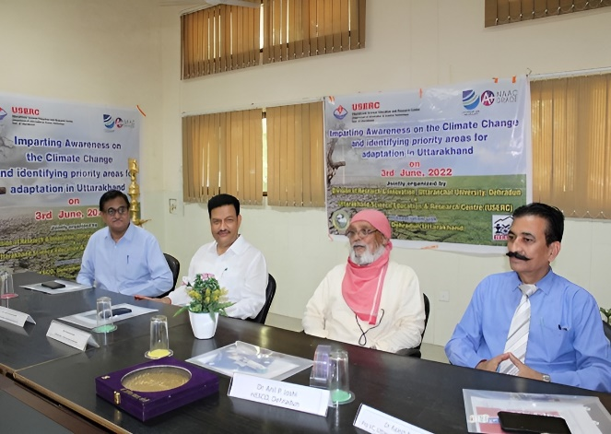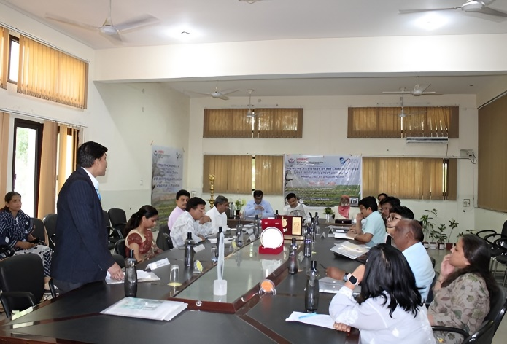

**13.3.4 Inform and support government**

Our university actively informs and supports local and regional governments in addressing climate change-related disasters and risks through early warning and monitoring systems. Regular research findings from our faculty and staff are shared with local communities and state officials to enhance preparedness and response strategies. To date, our researchers have published approximately 41 articles focused on climate change, contributing valuable insights to disaster risk reduction efforts.

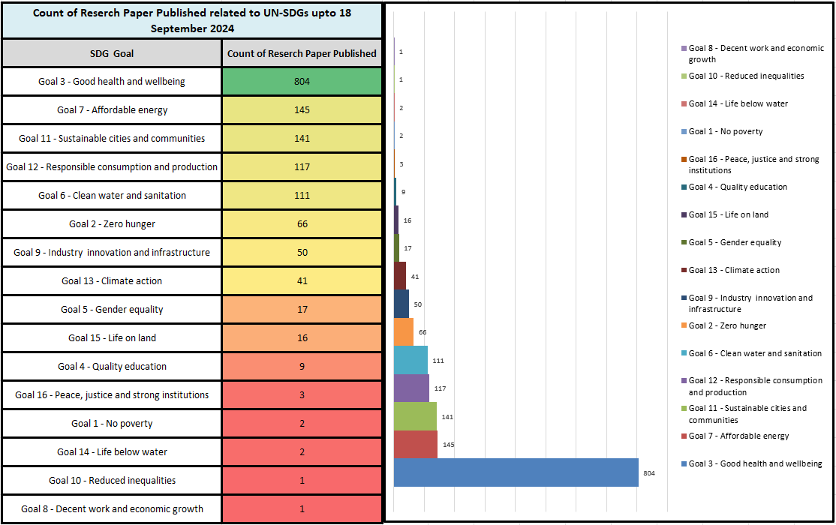

**13.3.5 Environmental education collaborate with NGO**

Our university is committed to fostering a sustainable future through strategic collaborations in environmental education. We are partnering with local NGOs, educational institutions, and various agencies to create a comprehensive framework for environmental awareness and action. These collaborations aim to enhance curriculum development, facilitate hands-on learning experiences, and promote community engagement in environmental initiatives. By leveraging the expertise and resources of our partners, we aspire to empower students and the wider community with the knowledge and skills necessary to address pressing environmental challenges. Together, we will cultivate a culture of sustainability that not only enriches academic life but also positively impacts our local and global ecosystems.

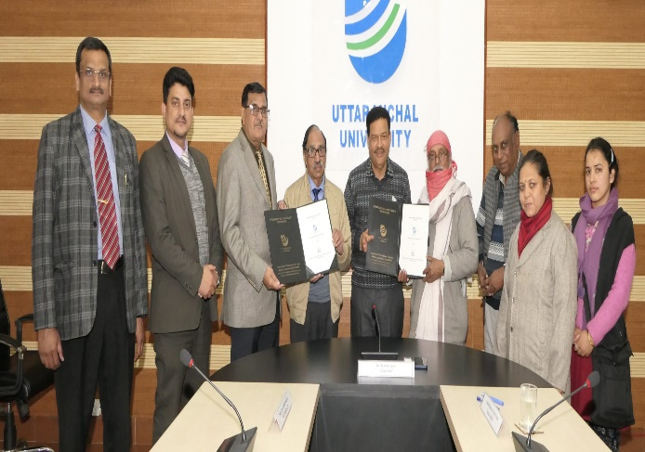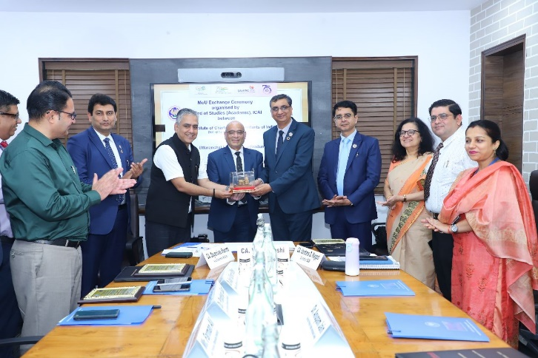

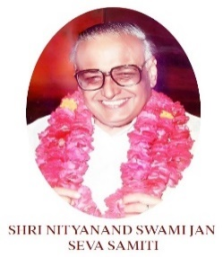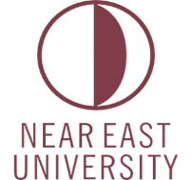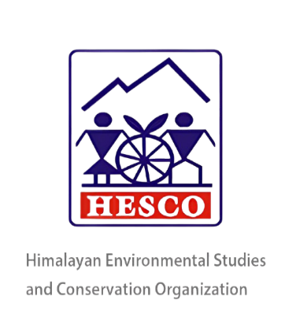

**Himalayan Environmental Studies and Conservation Organization**

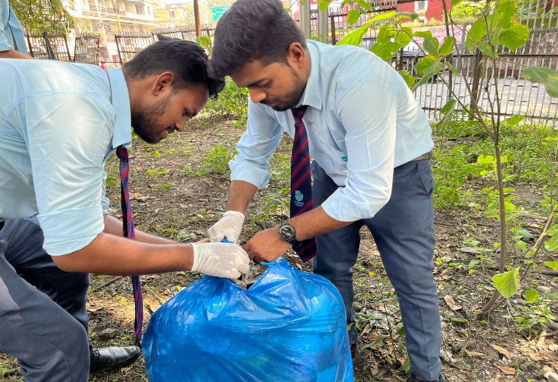

**13.4.1 Commitment to carbon neutral university**

Our university has set a target to achieve carbon neutrality by [insert year], in alignment with the Greenhouse Gas Protocol's Scope 1, 2, and 3 emissions. This commitment reflects our dedication to addressing climate change and minimizing our environmental footprint.

* Scope 1 includes direct emissions from sources that are owned or controlled by the university, such as fuel combustion for heating, vehicles, and campus operations.
* Scope 2 covers indirect emissions from the consumption of purchased electricity, steam, or heating and cooling.
* Scope 3 encompasses all other indirect emissions that occur as a result of the university’s activities, such as those from commuting, procurement, waste management, and the supply chain.

By addressing all three scopes, the university takes a holistic approach to reducing its carbon emissions across all areas of influence. Our action plan will focus on energy efficiency, transitioning to renewable energy sources, reducing travel emissions, and fostering sustainable procurement and waste management practices. Collaborations with local and state-level initiatives will further help us achieve this ambitious goal, making our campus a leader in sustainability and climate action.

***Overall, the University's Scope 1, 2 & 3 emissions were estimated to be 2584.87 Ton CO₂e in 2022-23.***

* Scope 1 emissions of **374.77 Ton CO₂e comprised 14%** of total Scope 1, 2 and 3 emissions in 2022-23. These emissions include the operation of owned or leased mobile sources that are within an organization's inventory boundary.
* Scope 2 emissions of **978.83 Ton CO₂e comprised 38%** of total Scope 1, 2 and 3 emissions in 2022-23. Scope 2 accounts for GHG emissions from the generation of purchased electricity consumed by the university. Purchased electricity is defined as electricity that is purchased or otherwise brought into the organizational boundary of the university.
* 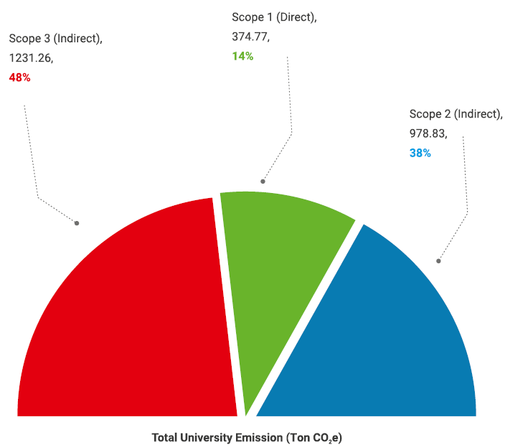Scope 3 emissions of **1231.26 Ton CO₂e comprised 48%** of total Scope 1, 2 and 3 emissions in 2022-23. Scope 3 is reporting category that allows for the treatment of all other indirect emissions. Scope 3 emissions are a consequence of the activities of the university but occur from sources not owned or controlled by the university.

University Carbon Footprint Report provides an updated summary of the University's Scope 1, 2 and 3 emissions with data collected and analysed throughout the period spanning from June 1, 2022, to May 31, 2023, adopting the internationally recognised U.S. EPA Centre for Corporate Climate Leadership - GHG Inventory Guidance & Greenhouse Gas (GHG) Protocol emissions accounting methods.

The Uttaranchal University sets out five goals to reduce emissions footprint:

* **GOAL 01:** Reduce Scope 1 & 2 emissions to 50% by 2035.
* **GOAL 02:** Measure our total emissions footprint and set targets for Scope 1, 2 & 3 emission reductions.
* **GOAL 03:** Ensure that sustainability is a part of the University educational programs by 2028.
* **GOAL 04:** Make sustainability a cornerstone of UU's research and societal impact.
* **GOAL 05:** Implement a sustainable and ethical investment policy.

Emissions are reported as CO₂e - carbon dioxide equivalent units. This enables the reporting of emissions from non-CO, sources which have different global warming potentials than CO2-

In general, we now have relatively complete emission estimates for the major Scope 1, Scope 2, and applicable Scope 3 categories; as well as for the other emissions the University has opted to report.

**13.4.2 Achieve by date**

Our university is committed to reducing Scope 1 and Scope 2 emissions by 50% by 2035. While Scope 3 emissions are not fully within our direct control, we are dedicated to implementing strategies to minimize them as much as possible. By focusing on emissions across all scopes, we aim to create a more sustainable campus and contribute to broader climate action efforts.

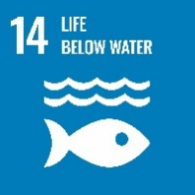**SDG14: LIFE BELOW WATER**

**14.2 Supporting aquatic ecosystems through education**

**14.2.1 Fresh-water ecosystems (community outreach)**

Uttaranchal University has established the Student Sustainability Club, led by students from the School of Applied and Life Sciences. The club collaborates with local farmers on activities such as sustainable irrigation practices, river clean-up drives, awareness on fisheries, and water resource management. The club’s mission is to educate, support, and empower farmers and local communities through curriculum-integrated outreach activities like internships and workshops, which also strengthen the bond between students and farmers to promote sustainable practices.

The B.Sc. (Hons) Agriculture, M.Tech. (Environment Engineering) program at Uttaranchal University includes subjects focused on protecting aquatic ecosystems and water conservation engineering. Courses like Environmental Studies and Disaster Management, Soil and Water Conservation Engineering, Introductory Agro-meteorology & Climate Change, Rainfed Agriculture and Watershed Management, and Renewable Energy and Green Technology contribute to this mission.

Similarly, the B.Sc. (Environmental Science), M.Sc. (Zoology) program offers a course on Water Resources, emphasizing water resource management and conservation. Various aspects of freshwater ecosystems, such as aquatic biodiversity and water pollution, are also integrated into the syllabus to provide a comprehensive understanding of water sustainability.

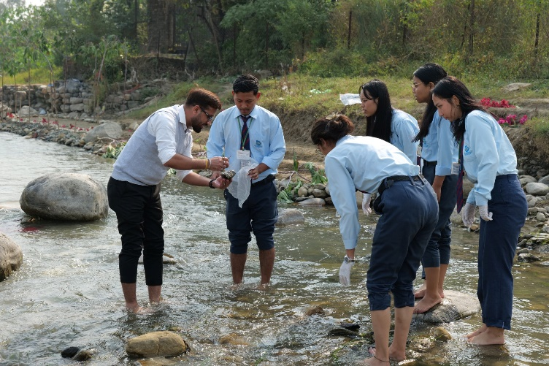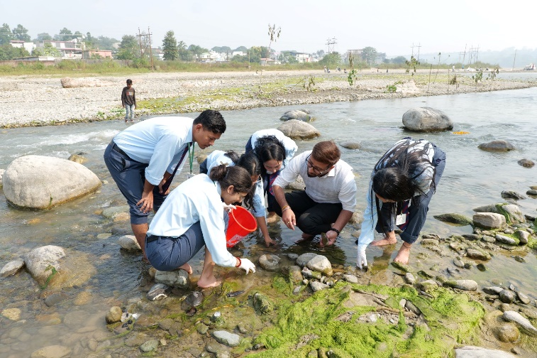

Uttaranchal University regularly organizes events and workshops on water management and irrigation practices for local farmers and communities. Through awareness campaigns, farmers learn to use water resources efficiently, while research scholars are encouraged to investigate and promote effective water management strategies.

Local farmers and other stakeholders are introduced to modern irrigation technologies and informed about government policies and subsidies related to sustainable practices. As a result, many farmers have successfully adopted improved water management techniques, leading to positive changes in their agricultural practices.

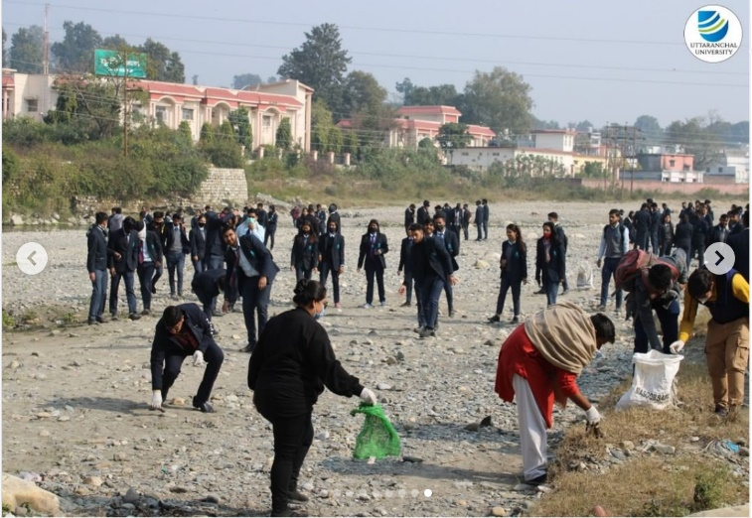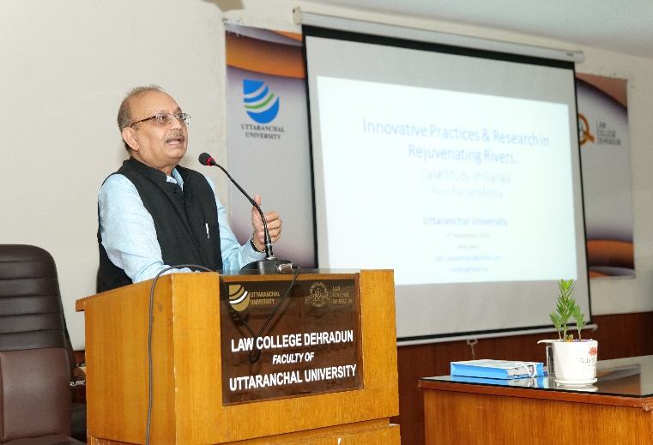

**14.2.2 Sustainable fisheries (community outreach)**

Uttaranchal University is dedicated to advancing sustainable practices in local and national communities, particularly in the areas of fisheries, aquaculture, and tourism. Through a diverse range of academic programs—including B.Sc. (Hons.) Agriculture, B.Sc. Life Sciences (CBZ), M.Tech. in Environmental Engineering and Energy Management & Sustainability, and M.Sc. programs in Environmental Science, Biotechnology, and Zoology—the university equips students with critical knowledge and practical skills in sustainability. These programs focus on environmentally responsible methods for managing natural resources, fostering sustainable aquaculture, and promoting eco-friendly tourism. By integrating these disciplines, Uttaranchal University aims to empower students to become leaders in sustainable development, thereby positively impacting both local communities in Uttarakhand and the broader national context.

**Community outreach**

Uttaranchal University actively encourages students to engage with local fishing communities to promote sustainable fishing practices. Through outreach activities, students help raise awareness about the benefits of sustainable fishing, the risks of overfishing, and the importance of regulated fishing practices, including appropriate mesh sizes and clean fishing environments.

Students conduct surveys and discussions with fishermen and fish vendors in nearby markets to understand their challenges, including threats to livelihoods. These interactions benefit the fishermen by supporting the adoption of improved fishing methods, while local communities gain from the broader impact of these sustainability-focused initiatives.

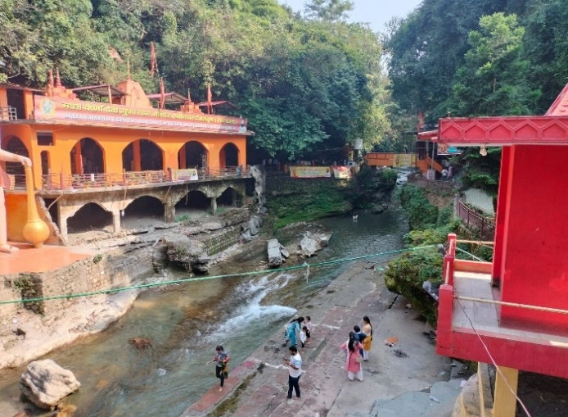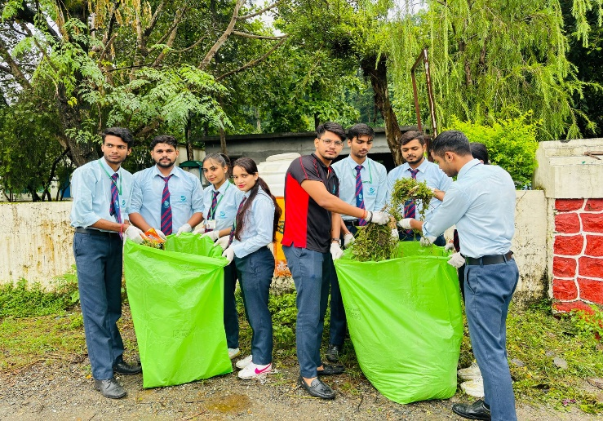

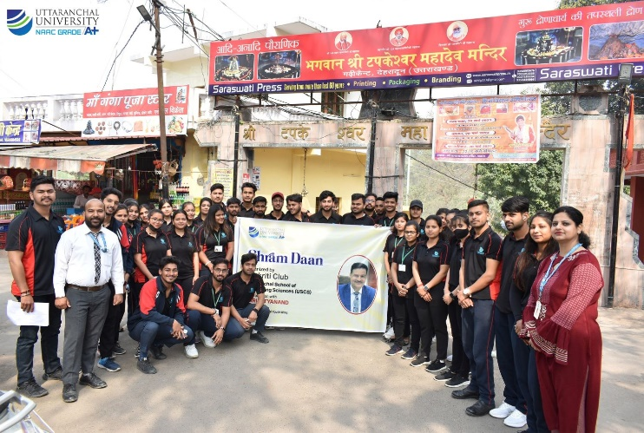

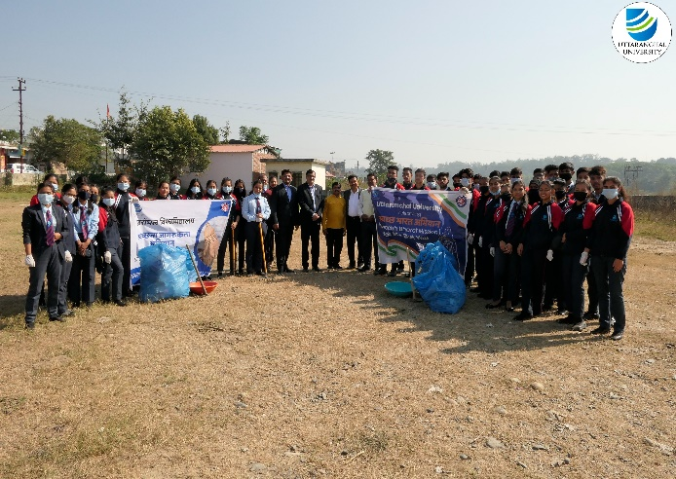

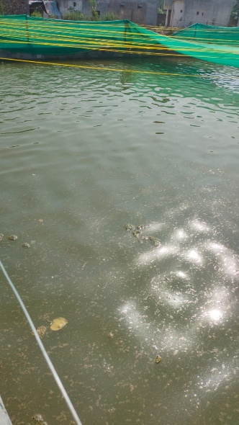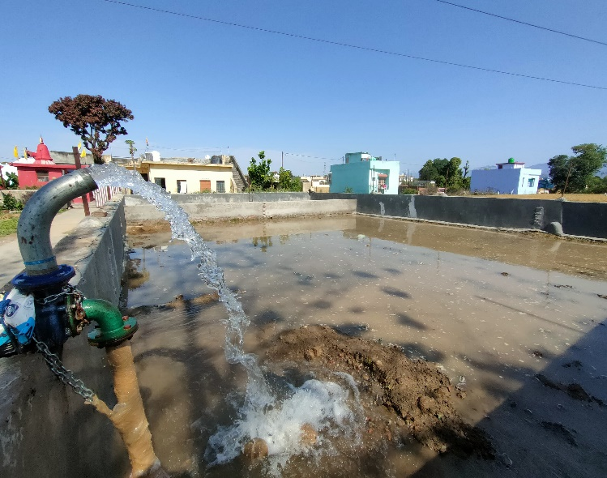

**14.2.3 Overfishing (community outreach)**

Our university, in partnership with students and faculty, is actively raising awareness on sustainable fisheries through a series of educational programs. These initiatives focus on the pressing issues of overfishing, as well as unreported and unregulated fishing practices. By fostering greater understanding and engagement, we aim to promote responsible fishing practices and contribute to the protection of marine ecosystems.

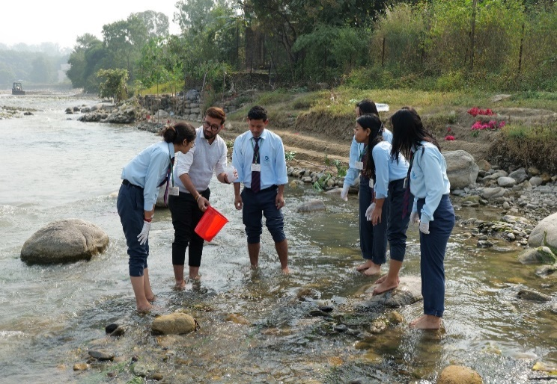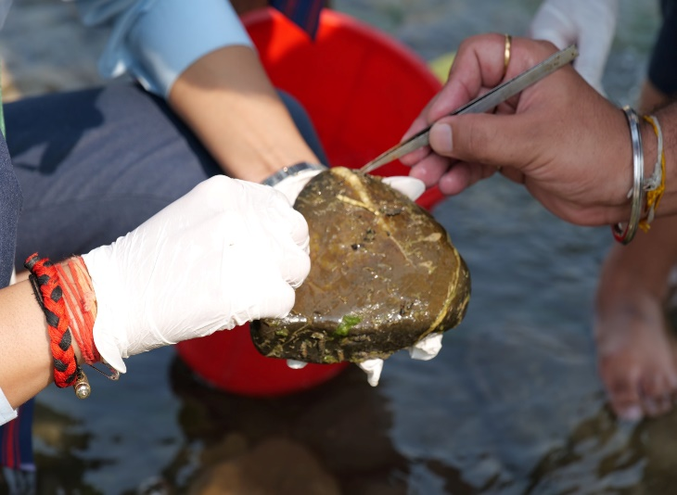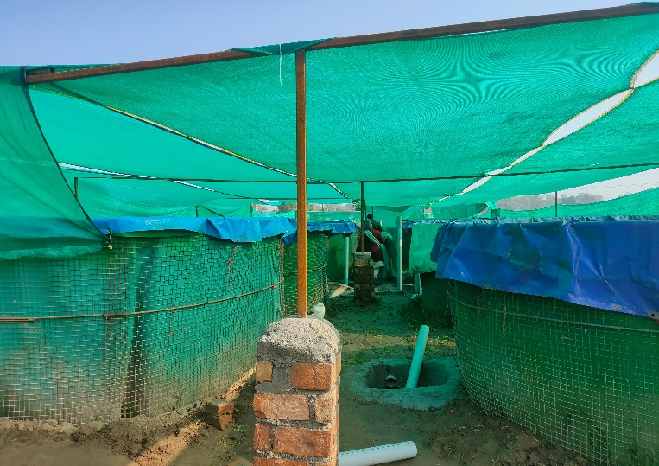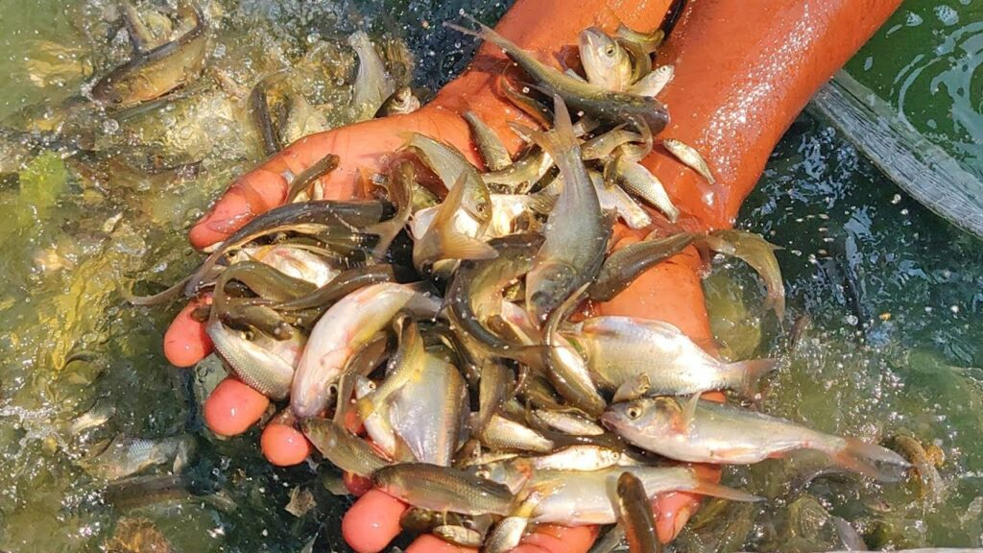

**14.3.1 Conservation and sustainable utilization of the oceans (events)**

Uttarakhand, known for its abundant rivers and as the birthplace of the sacred Ganga, is home to rich aquatic biodiversity. Uttaranchal University actively contributes to the conservation of this biodiversity through various awareness campaigns and research studies.

The current study focuses on assessing phytoplankton diversity and the physico-chemical characteristics of the Nun River from October 2023 to March 2024. Researchers identified 38 phytoplankton genera across seven classes, 21 orders, and 26 families. The major classes found include Bacillariophyceae (7 genera), Chlorophyceae (16), Cyanophyceae (10), Trebouxiophyceae (2), Tubulinea (1), Ulvophyceae (1), and Chrysophyceae (1).

Phytoplankton density was notably high at Site 1 in January, with Bacillariophyceae and Chlorophyceae as the dominant classes, exhibiting densities ranging from 42–262 Unit1-1 and 34–296 Unit1-1, respectively. The evenness index varied between 0.88 and 0.98, indicating uneven distribution of certain genera across sites. Based on the Shannon-Weiner index, we conclude that the water quality of the Nun River ranges from moderately polluted to clean, reflecting a balanced but fragile ecosystem.

This research highlights the need for ongoing monitoring and conservation efforts to preserve Uttarakhand’s aquatic ecosystems, which are vital to the region’s ecological health and cultural heritage.

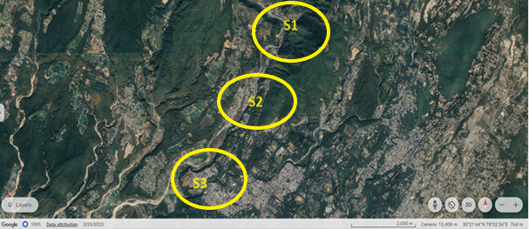

**Sites identified for sample collection Nun River from October 2023 to March 2024**



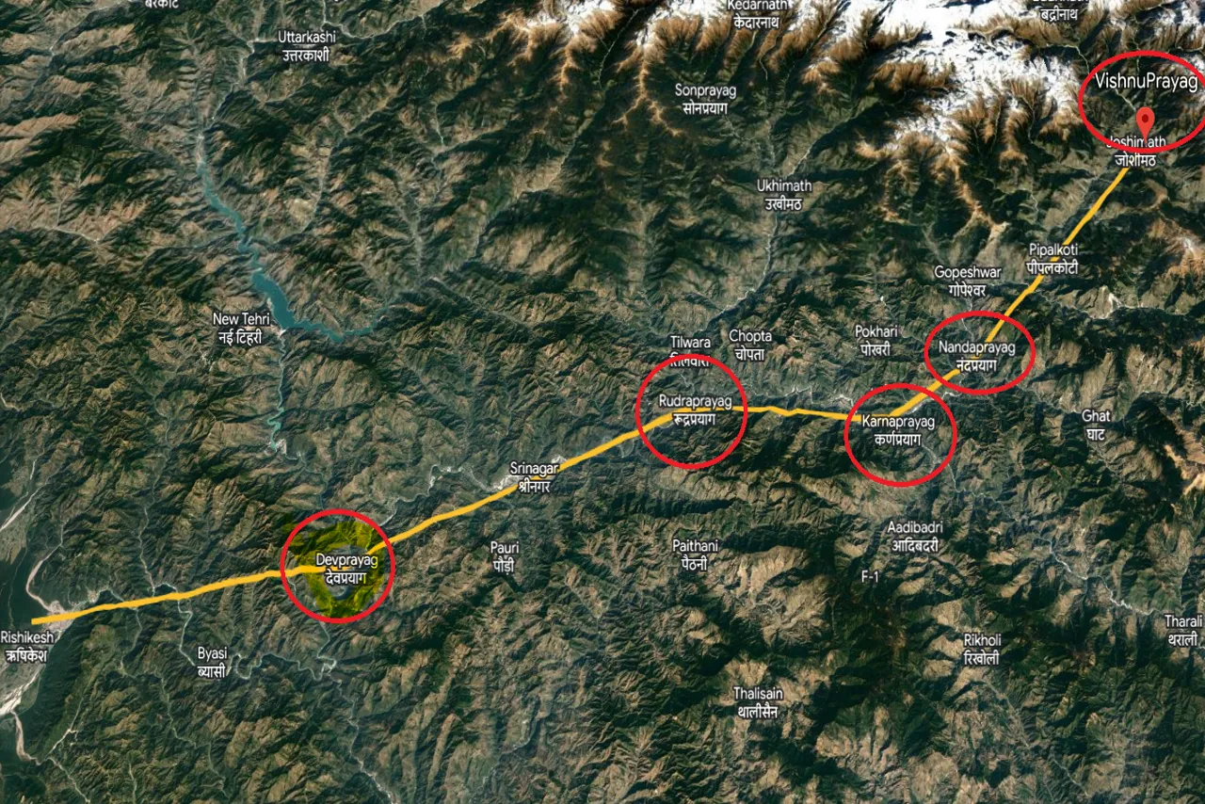

**The "Panch Prayag" of Uttarakhand refers to a group of five sacred river confluences in the Garhwal region, revered in Hindu mythology and regarded as significant pilgrimage sites. These sites, which are located along the Alaknanda River and its tributaries, hold a special place in the hearts of devotees, as they are believed to be powerful centers for spiritual cleansing and renewal. The Panch Prayag collectively represents the journey of the Alaknanda River as it flows down from the Himalayas to eventually meet the Ganges River, gathering spiritual energy from each confluence.**

Our university is deeply committed to the conservation of Uttarakhand’s rivers, with special focus on the culturally and ecologically significant river systems, including the revered Panch Prayag. Recognizing the role that rivers play in the spiritual and environmental health of the region, our initiatives align with the principles of sustainable development and community engagement. These efforts contribute to the university's broader mission of fostering environmental stewardship and developing innovative solutions to protect our natural resources.

**River Health Monitoring Program**

Our River Health Monitoring Program, led by faculty and actively involving students, conducts regular assessments of water quality, pollution levels, and biodiversity in the rivers of Uttarakhand. By leveraging advanced scientific methods and local knowledge, this initiative gathers essential data to inform conservation strategies and support policy-making. Results from these assessments are shared with local authorities to encourage actions that protect river ecosystems from degradation.

**Community-Driven Conservation**

We understand that local involvement is vital to successful conservation efforts. Through our community-driven programs, the university works directly with local residents, schools, and village councils to promote sustainable practices and awareness about river conservation. Workshops focus on sustainable water usage, pollution reduction, and waste management, while campaigns encourage eco-friendly habits that reduce human impact on the rivers, especially around sensitive areas like the Panch Prayag and nearby local sites.

**Student Engagement and Education**

Our River Cleanliness Program is central to engaging students in river conservation. Through this program, students participate in river clean-ups, conduct water testing, and participate in workshops on conservation techniques. This hands-on experience helps students develop a strong sense of responsibility towards the local environment. In addition, our curriculum integrates concepts like river ecology, sustainable water management, and waste reduction, equipping students with the knowledge to address environmental challenges.

**14.3.2 Food from aquatic ecosystems (policies)**

Our university has created "Food from Aquatic Ecosystems Policy" to promote the sustainable and ethical sourcing, consumption, and education of aquatic food products at the university. This policy aims to support the conservation of aquatic ecosystems, reduce environmental impact, and encourage responsible consumption aligned with the university's commitment to sustainability. By prioritizing sustainable practices, local resources, and educating the university community, the policy contributes to global conservation goals and enhances the university's role in fostering environmental stewardship.

**14.3.3 Maintain ecosystems and their biodiversity (direct work)**

Our university is actively engaged in the conservation of rivers and lakes in Uttarakhand, recognizing these water bodies as essential to both the local ecosystem and community. Through an ongoing awareness campaign, we focus on river cleanliness, preservation of riverbanks, and safeguarding water quality to ensure a thriving habitat for aquatic life. The campaign also educates the community on the importance of aquatic species, promoting identification and understanding of local biodiversity. By championing these initiatives, we aim to foster a sense of shared responsibility for preserving Uttarakhand’s aquatic ecosystems for future generations.

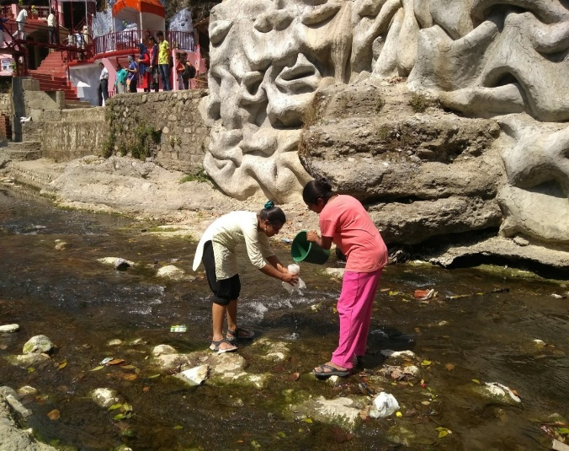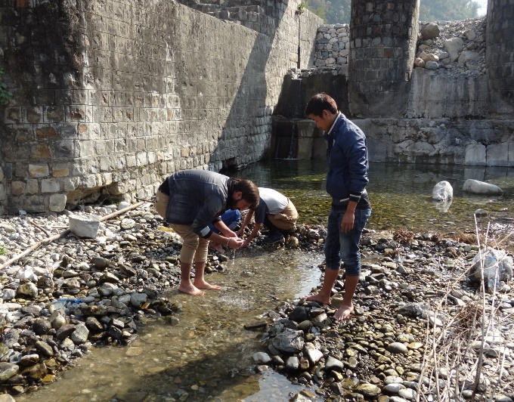

**Collection of samples of phytoplankton for water quality check from river Tons, Yamuna valley**

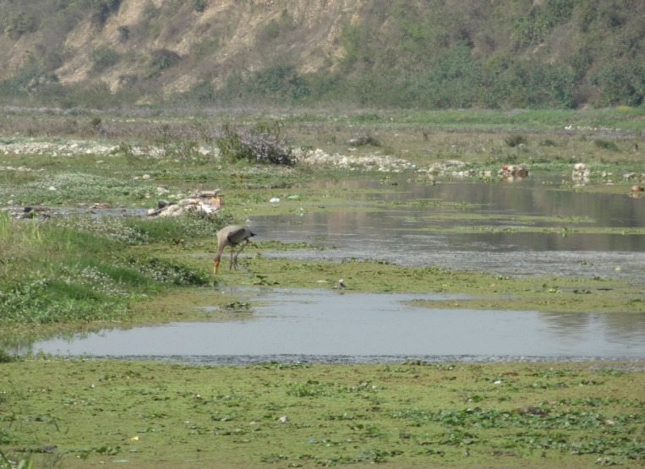

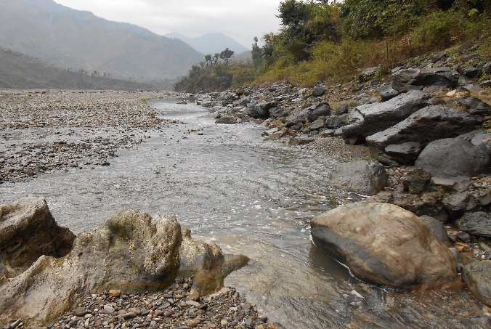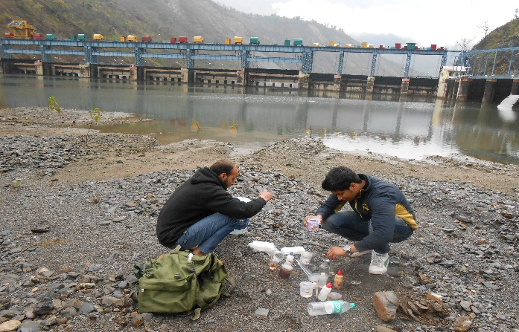**Avian diversity Study of Asan river near Dharmawala and Sahaspur Dehradun in Uttarakhand state, Northern India.**

**Phytoplankton and macroinvertebrate diversity study in the rivers**

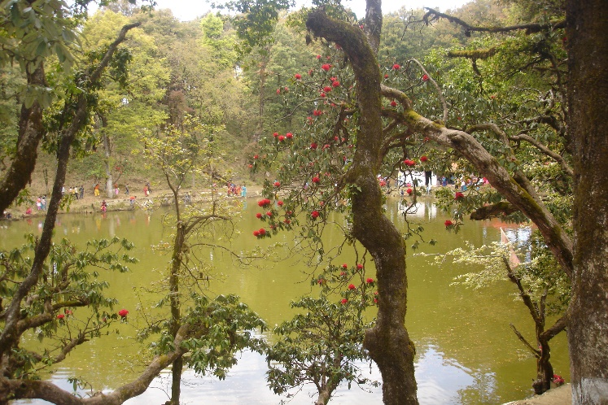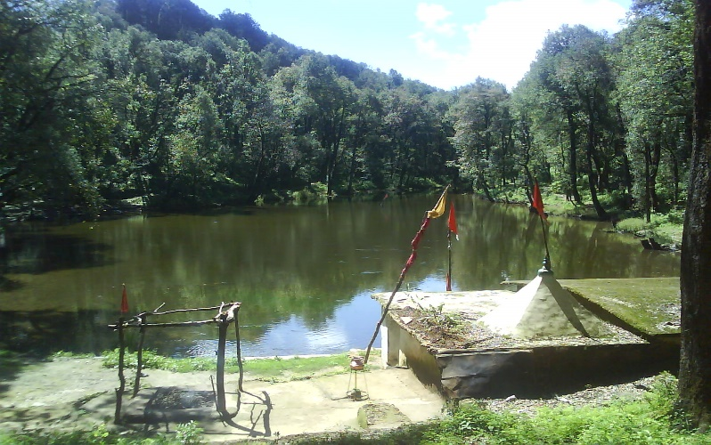

**Aquatic Diversity and water quality Study at Lake Nachiketa Tal, Uttarakhand state, Northern India.**

**14.3.4 Technologies towards aquatic ecosystem damage prevention (direct work)**

Our university is deeply committed to the conservation of Uttarakhand’s rivers and lakes, understanding that these water bodies are vital to both the local environment and the well-being of surrounding communities. Our ongoing awareness campaign focuses on promoting sustainable practices that protect these ecosystems and encourages active participation in river and lake conservation efforts. Key aspects of the campaign include educating the community about the importance of river cleanliness, preventing pollution, and maintaining the integrity of riverbanks to reduce erosion and protect adjacent habitats.

Additionally, we emphasize the significance of water quality preservation to ensure a healthy and sustainable environment for aquatic species. This involves monitoring and advocating for practices that reduce contaminants and safeguard the quality of water that flows through Uttarakhand’s rivers and lakes. A crucial element of our campaign is community education on local biodiversity, where we highlight the unique aquatic species that inhabit these waters. By teaching species identification and fostering an understanding of local aquatic ecosystems, we aim to build a connection between the community and the natural environment.

Our initiatives aim to instill a collective sense of responsibility towards Uttarakhand’s water bodies. By promoting conservation and engaging individuals in these vital efforts, we strive to protect and preserve these aquatic ecosystems for the benefit of future generations. Through this campaign, our university hopes to inspire lasting, positive environmental stewardship that extends beyond campus and into the broader community.

**Use of Technology for Research and Studies of water bodies and aquatic life by our university**

* Scanning Electron Microscope (SEM) & Energy Dispersive Spectroscopy (EDS) (EVO 18)
* Fourier-Transform Infra-Red (FTIR) Spectrometer (Thermoscientific Nicolet Summit LITE iD1)
* Geological Survey Studies of water bodies situate in Himalayan Region
* Use of GPS equipment for Precise measurements of water bodies
* Atomic absorption spectrometer (AAS)
* Digital water and Soil Analysis Kit
* Compound Microscope

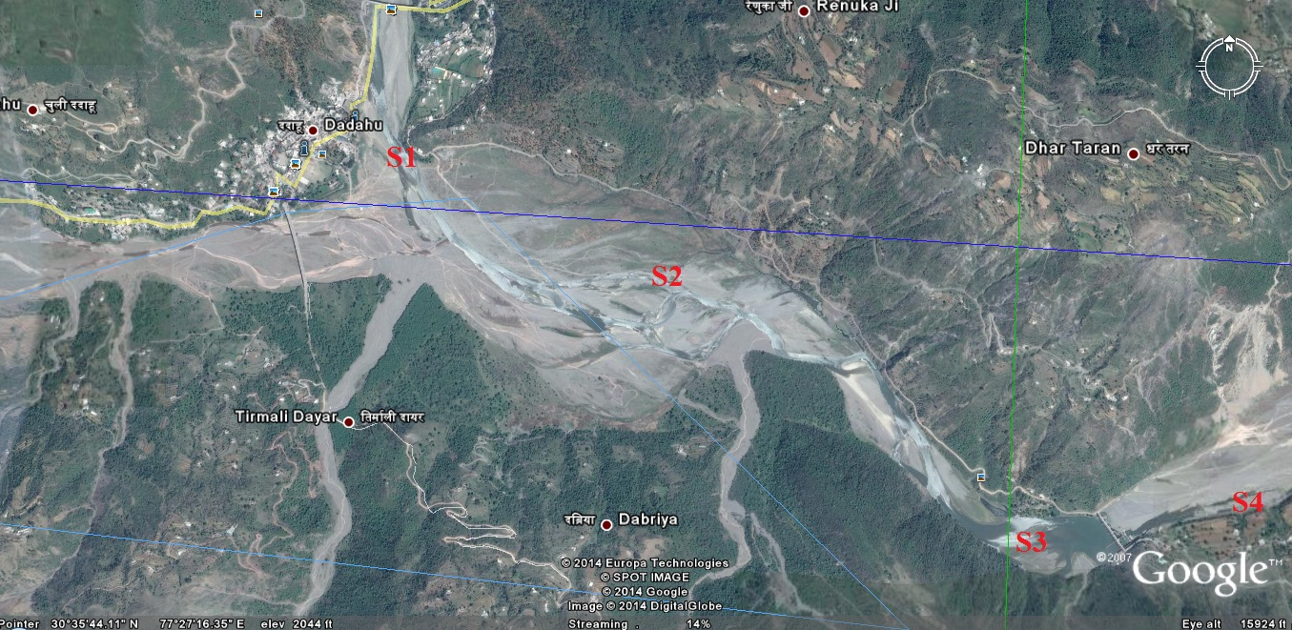

**River Girri flow path showing sampling sites in one of our research projects in Himalayan region for river conservation**

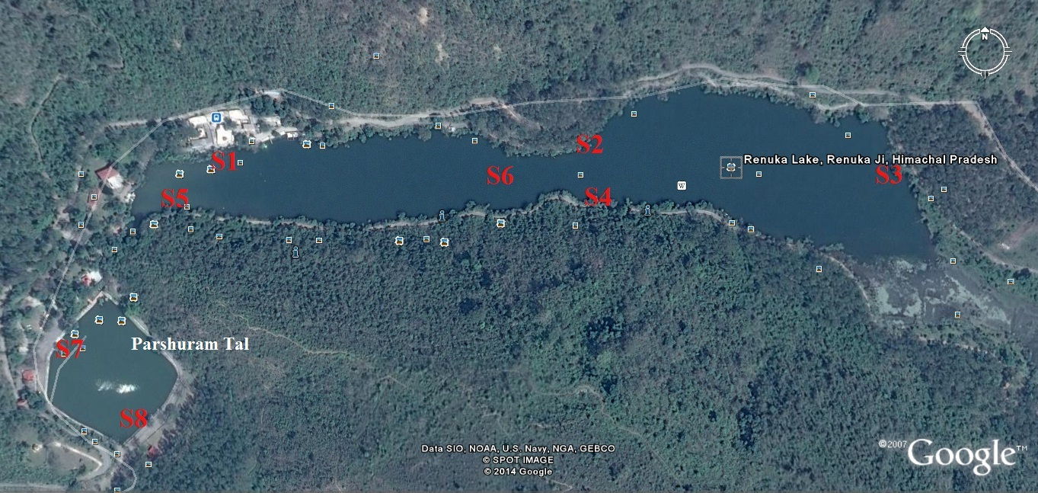

**Aquatic Life study project at Renuka Lake and Parshuram Tal, Himalayan region**

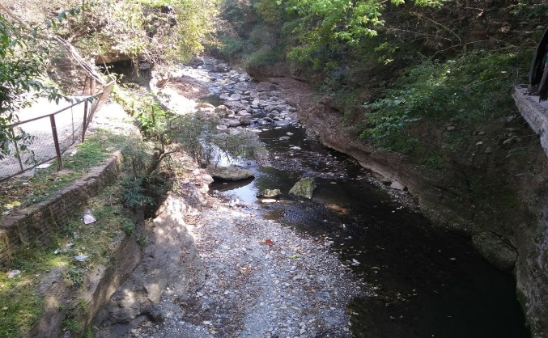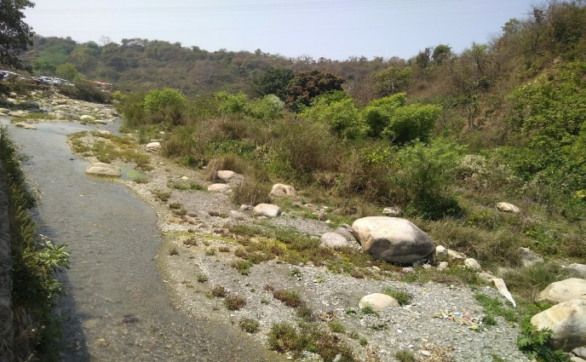

**River water pollutant study at Tons river- Research project**

**Some of the ongoing Research project and studies are given below:**

* The Ecology and Macroinvertebrates Of Nun River In Dehradun- A Research Study, Uttarakhand
* The Ecology and Fish Diversity Of River Nun-A Research Study, Dehradun (Uttarakhand)
* Length-Weight Relationship Of Fishes (Genus- Barilius) Of River Nun, Dehradun, Uttarakhand.
* Taxonomic Study Of Nymphalidae Of The Zsi, Dehradun (Uttarakhand)
* The Phytoplankton Diversity And Ecology Of The Nun River In Dehradun-A Research Study, Uttarakhand
* Investigation On The Diversity Of Freshwater Diatoms Of River Suswa, Dehradun (Uttarakhand)

**14.4.1 Water discharge guidelines and standards**

Uttaranchal University collects rainwater in disused quarries, treating it on-site through a dedicated water treatment plant. This treated water is then repurposed for use in toilets and other non-potable applications, reducing groundwater consumption and conserving rainwater.

The university carefully monitors water quality and discharge, adhering to BIS and WHO standards through routine assessments. The treated sewage water meets Bureau of Indian Standards (BIS) specifications and is utilized exclusively for horticulture.

There is no disposal of sewage or other liquid and solid waste in the wetland near the campus, preserving this sensitive ecosystem. Additionally, the university operates a bio-sewage treatment plant, recycling treated sewage water for irrigation, road sprinkling, and ground spraying. This process helps control harmful bacterial growth, safeguarding wildlife and aquatic ecosystems by ensuring that only treated water is released.

**14.4.2 Action plan to reducing plastic waste**

Uttaranchal University actively promotes the use of sustainable materials in daily operations and has implemented a strict "No Single-Use Plastic" policy. For events alternatives such as jute bags, steel utensils, and biodegradable disposal plates are encouraged across campus. This initiative has led to a noticeable reduction in plastic sales at nearby markets, helping to lower the campus’s carbon footprint and minimize plastic waste that might otherwise impact the local aquatic ecosystem.

In dining areas, steel tumblers are used by students and staff, while biodegradable disposal plates are introduced during special events. Jute bags have replaced plastic bags for campus activities, reinforcing the university's commitment to eco-friendly practices.

The university also employs an ERP system for academic and administrative tasks, significantly reducing paper use, improving efficiency, and lowering operational costs. Additionally, regular awareness programs are conducted to further reduce plastic usage and ultimately eliminate single-use plastics entirely.

**14.4.3** **Reducing marine Pollution (policy)**

Uttaranchal University has implemented a policy aimed at reducing marine pollution and organizes annual activities to prevent and minimize various forms of marine pollution.

**14.5.1 Minimizing alteration of aquatic ecosystems (plan)**

Uttaranchal University is committed to minimizing human-induced alterations to aquatic ecosystems through rigorous research, conservation initiatives, and community engagement. Our university prioritizes the health and sustainability of rivers, lakes, ponds, and wetlands by promoting practices that reduce pollution, protect biodiversity, and maintain water quality.

Through dedicated research, our faculty and students conduct comprehensive studies on major river systems—including the Ganga, Gomti, Tons, Asan, and Suswa rivers—focusing on critical areas such as fish diversity, water quality, toxicological impacts, phytoplankton, and macroinvertebrates. By regularly organizing sample collection camps and awareness campaigns, we actively involve local communities in understanding the impacts of pollutants and other factors that disrupt aquatic ecosystems.

This commitment reflects our belief in the importance of preserving these ecosystems for future generations and aligns with our broader mission to foster sustainable environmental practices.

**Some of the ongoing Research project and studies are given below:**

* The Ecology and Macroinvertebrates Of Nun River In Dehradun- A Research Study, Uttarakhand
* The Ecology and Fish Diversity Of River Nun-A Research Study, Dehradun (Uttarakhand)
* Length-Weight Relationship Of Fishes (Genus- Barilius) Of River Nun, Dehradun, Uttarakhand.
* Taxonomic Study Of Nymphalidae Of The Zsi, Dehradun (Uttarakhand)
* The Phytoplankton Diversity And Ecology Of The Nun River In Dehradun-A Research Study, Uttarakhand
* Investigation On The Diversity Of Freshwater Diatoms Of River Suswa, Dehradun (Uttarakhand)

**14.5.2 Monitoring the health of aquatic ecosystems.**

Each year, the university conducts a comprehensive water audit to assess campus water consumption, recycling efforts, and other key parameters related to sustainable water use. This audit forms part of our broader commitment to water conservation and resource management within our campus.

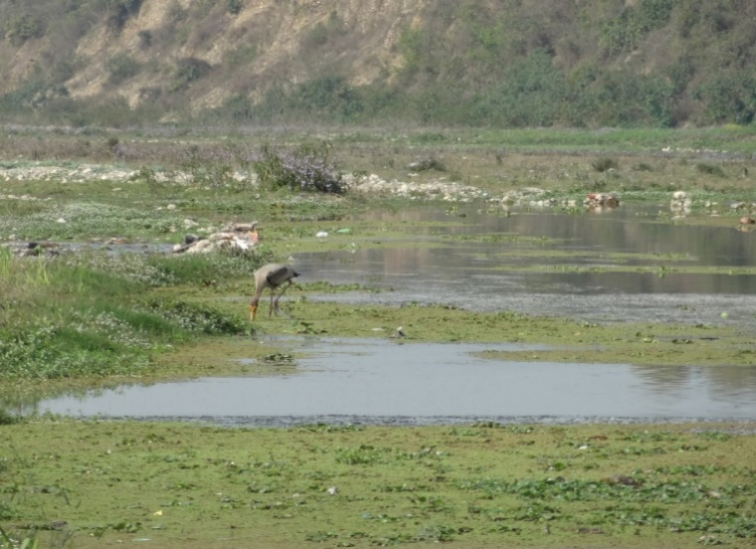Additionally, the university organizes a variety of research projects, river monitoring initiatives, experimental field camps, and awareness campaigns to evaluate and protect the health of aquatic ecosystems, with a particular focus on the Uttarakhand region. These efforts involve sampling and analysis of local water bodies—including rivers, lakes, ponds, and wetlands—to monitor water quality, assess biodiversity, and study the impacts of pollutants. Through these activities, our university fosters environmental stewardship and actively contributes to the preservation of aquatic ecosystems in Uttarakhand.

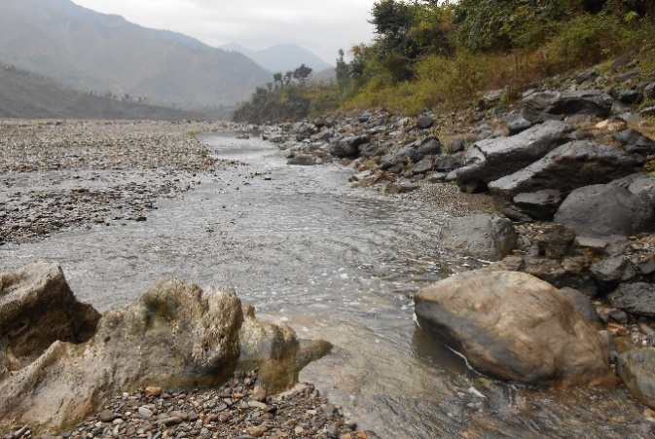



**14.5.3 Programmes towards good aquatic stewardship practices**

At our university, responsible aquatic stewardship means using water resources in a manner that is socially equitable, environmentally sustainable, and economically beneficial. This commitment is achieved through an inclusive process involving key stakeholders. Our university implements water filtration systems, which help foster responsible water usage, encourage mindfulness of water consumption, and ensure the integrity of our infrastructure by regularly checking that all pipes and faucets are secure and well-maintained. These measures help prevent water loss and waste, supporting our mission to protect and sustainably manage aquatic resources.





**Water Treatment Plant**

**Reverse Osmosis based water dispensing stations**

**Smart sensor based hand washing stations**

**Rainwater Collection Tank**

**14.5.4 Collaboration for shared aquatic ecosystems**

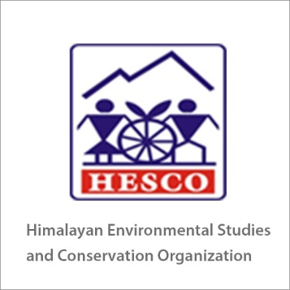



**14.5.5 Watershed management strategy**

At our university, watershed management is actively pursued to support sustainable water resources. We utilize natural quarry sites for water storage and implement rainwater harvesting techniques that contribute to groundwater recharge, making water available for reuse and upcycling.

Located in Dehradun district, our campus benefits from unique geographic and soil characteristics. The soils in Dehradun range from sandy loam to sandy clay loam, with a pH variation from 5.38 (acidic) to 7.88 (slightly alkaline), reflecting the diverse mineral content in the region. The district, covering an area of 3,088 square kilometers at an altitude of 640 meters, shares its western boundary with Himachal Pradesh’s Sirmur (Nahan) district, separated by the Tons and Yamuna rivers. Spanning between 29°58′ and 31°2′30″ N latitude and 77°34′45″ and 78°18′30″ E longitude, Dehradun's topography and soil characteristics are ideal for studying and implementing advanced water conservation and management practices.



**Biological Sewage Treatment Plant**

**Water Treatment Plant**

**Rainwater Collection Tank**



GOAL 15



**SDG16: PEACE, JUSTICE AND STRONG INSTITUTIONS**

**16.2.1 Elected representation**

Our university is dedicated to fostering an inclusive and participatory governance system by ensuring stakeholder representation on the governing body at the campus level. This initiative is designed to strengthen decision-making processes and ensure that the voices of all key stakeholders—students, faculty, staff, and the wider community—are represented in shaping the future of the university.

Through elected and appointed representatives, the governing body at the campus level includes a diverse range of perspectives. Faculty members contribute their expertise in academic matters, ensuring that decisions align with the university's educational mission and research goals. Student representatives, on the other hand, provide vital insights into the student experience, raising concerns about academic programs, campus life, and student services, thereby enhancing the overall quality of life on campus.

Administrative and support staff are also integral members of this body, offering operational knowledge that helps in making informed decisions about campus infrastructure, resource management, and day-to-day operations. Their involvement ensures that the university remains efficient and well-functioning, aligning its strategic goals with the practical needs of the campus community.

In addition, the university strives to engage with external stakeholders, such as local community leaders and industry partners, when appropriate. This allows the campus governing body to stay connected with the region’s socio-economic context and ensure that the university's initiatives contribute to local development and align with broader societal goals.

By integrating stakeholder representation into the governing body at the campus level, the university ensures that its governance is transparent, accountable, and reflective of the diverse interests of the campus community. This participatory approach strengthens the university's role as a collaborative institution where decisions are made collectively, fostering a sense of shared responsibility for the campus growth and development.

**Statutory Bodies of the university with Faculty Members and Administrative Staff Members**

1. Board of Governors
2. Board of Management
3. Academic Council
4. Internal Quality Assurance Cell
5. Board of Studies

**Non- Statutory Bodies of the university with Faculty Members, Administrative Staff Members and Students**

* Academic Review Committee
* Curriculum Review Committee
* Student Council
* Alumni Committee
* Hostel & Mess Committee

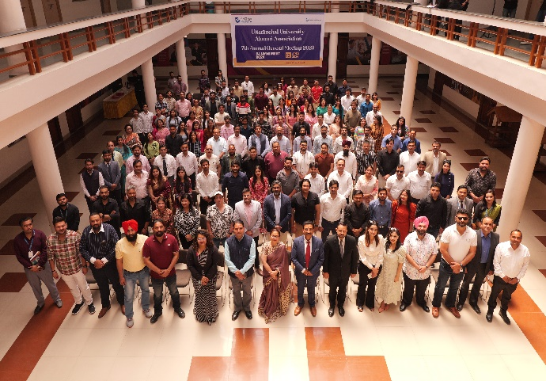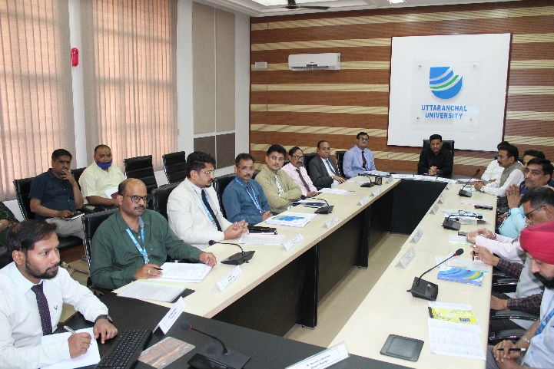

**16.2.2 Students union**

The Student Council at Uttaranchal University is dedicated to enriching the graduate experience by advocating for the overall welfare of the student body. It develops new programs and initiatives to foster growth, engagement, and communication between students, faculty, and administration.

Aligned with the University’s Vision, Mission, and Core Values, the Student Council plays a key role in offering constructive feedback on campus life, academic programs, and student services. This includes areas such as discipline, library resources, campus upkeep, and internship and placement opportunities. The Council supports the anti-ragging committee in eliminating ragging, suggests ways to enhance student conduct and discipline, and leads student projects aimed at holistic development.

Additionally, the Student Council contributes to the advancement of arts, culture, sports, and other co-curricular and extracurricular activities. It helps facilitate student participation, supports student clubs, and promotes collaboration among students, faculty, staff, and university management, fostering a vibrant academic community.

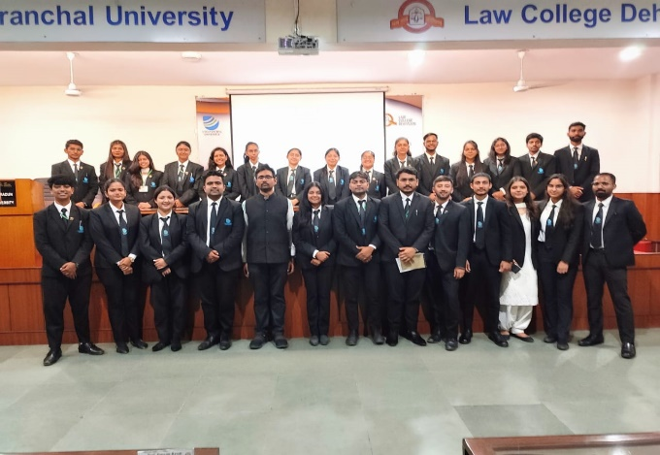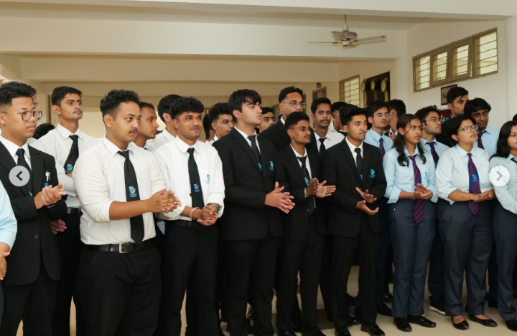

**16.2.3 Identify and engage with local stakeholders**

Uttaranchal University's policy on identifying and engaging local stakeholders emphasizes the importance of fostering meaningful partnerships with community members, businesses, NGOs, and local government bodies in Uttarakhand. The policy outlines a structured approach to ensure that external voices are integrated into the university's decision-making processes, promoting transparency and collaboration. Through stakeholder mapping, advisory committees, public consultations, and collaborative projects, the university aims to align its initiatives with regional needs and priorities. This engagement ensures that the university not only contributes to local socio-economic and environmental development but also enhances its relevance and impact as a community-focused institution.

**16.2.4 Participatory bodies for stakeholder engagement**

Our university fosters an inclusive approach to decision-making by establishing participatory bodies that actively engage a diverse range of stakeholders. These bodies are designed to bring together representatives from students, faculty, administrative staff, local community members, industry partners, and government officials. Through regular consultations, these groups ensure that all voices are heard and considered in key governance matters, policy development, and strategic planning. By involving external stakeholders, the university strengthens its connections to the local community, enhances its impact, and promotes transparency and shared responsibility in shaping the institution's future. This participatory approach ensures that university policies and initiatives are not only academically sound but also socially relevant and responsive to the needs of all involved parties.

**Statutory Bodies of the university with Faculty Members and Administrative Staff Members**

* Board of Governors
* Board of Management
* Academic Council
* Internal Quality Assurance Cell
* Board of Studies

**Non- Statutory Bodies of the university with Faculty Members, Administrative Staff Members and Students**

* Academic Review Committee
* Curriculum Review Committee
* Student Council
* Alumni Committee
* Hostel & Mess Committee

**Student Clubs & Committees**

At our university, student clubs and societies play a vital role in governance matters, policy development, and extension activities, fostering a culture of active student participation and leadership. These organizations provide a platform for students to engage in meaningful discussions on campus policies, academic reforms, and social issues, ensuring that the student body’s perspectives are integrated into university governance. Many clubs are dedicated to specific areas such as sustainability, community outreach, and social justice, aligning their activities with broader institutional goals. Through collaboration with faculty and administration, student groups contribute to policy formulation, participate in decision-making processes, and spearhead initiatives that address societal challenges. Additionally, these clubs organize extension activities like awareness campaigns, workshops, and community service projects, extending the university’s impact beyond the campus and promoting civic engagement among students. By empowering students in these roles, the university cultivates a dynamic environment where future leaders can develop skills in governance, advocacy, and community development.

*Some of the club the Societies are:*

* **Unnat Bharat Abhiyan for Community Outreach**- Our university aims to empower communities, promote sustainability, foster inclusivity, uphold ethics, and collaborate for meaningful societal impact.
* **Globe Club (Global Learning and Observations to Benefit the Environment),** under the aegis of Uttaranchal University, is a best combination of faculty and students where both combine together to perform various activities to save the environment and achieve much more than an individual can. It also plays an important role in creating environmental awareness amongst the future generation for sustainable use of resources.
* **Stakeholders Engagement in University Internal Quality Assurance Cell-** Our university's Internal Quality Assurance Cell (IQAC) actively involves stakeholders such as faculty, students, alumni, industry partners, and local community members, ensuring collaborative efforts in maintaining academic excellence and continuous improvement.

**Feedback & Surveys:**

Feedback and surveys are collected annually from all stakeholders as part of a regular practice. Only relevant feedback from these stakeholders is considered to implement comprehensive improvements within the university.

|  |  |  |  |  |
| --- | --- | --- | --- | --- |
| **S. No.** | **Feedback Type** | **Method** | **Frequency** | **% Of respondents** |
| 1 | Students feedback on Curriculum | Feedback | Twice in a Session | 100 % |
| 2 | Faculty members feedback on Curriculum | Feedback | Twice in a Session | 100 % |
| 3 | Alumni feedback on Curriculum | Feedback | Once in a Session | 30 % |
| 4 | Employer feedback on Curriculum | Feedback | Once in a Session | 100 % |
| 5 | Parents feedback on Curriculum | Feedback | Once in a Session | 30 % |
| 6 | Program Exit Survey | Survey | Once in a Session | 50 % |
| 7 | General Exit Survey | Survey | Once in a Session | 50 % |
| 8 | Feedback on Teaching-Learning | Feedback | Twice in a Session | 100 % |
| 9 | Feedback on Infrastructure & Other Facilities (Students) | Feedback | Once in a Session | 100 % |
| 10 | Feedback on Infrastructure & Other Facilities (Parents) | Feedback | Once in a Session | 100 % |
| 11 | Student Satisfaction Survey | Survey | Once in a Session | 100 % |





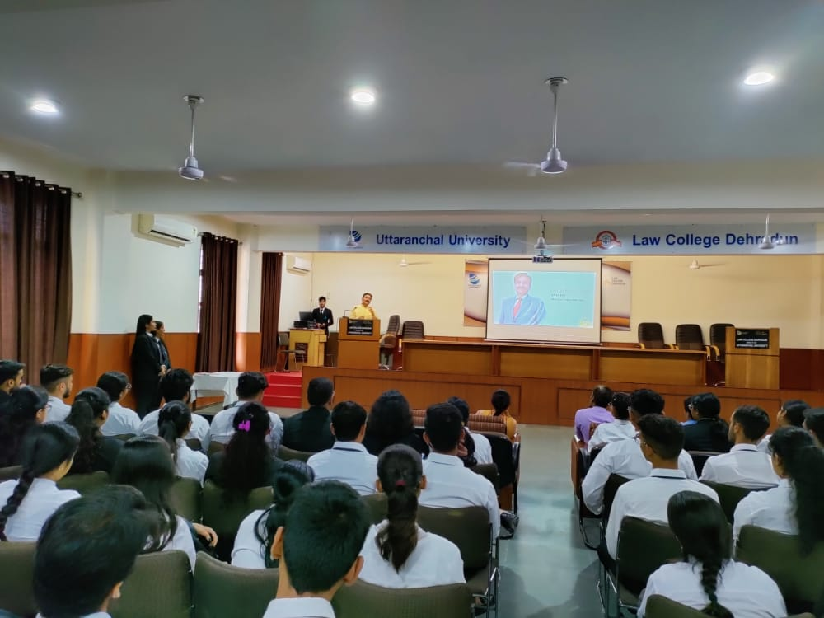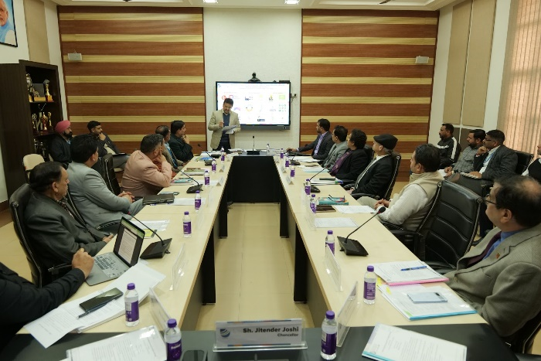

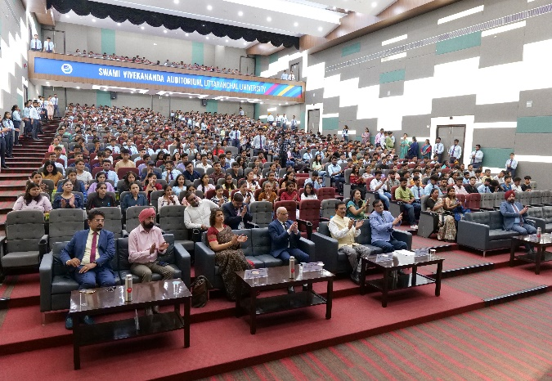 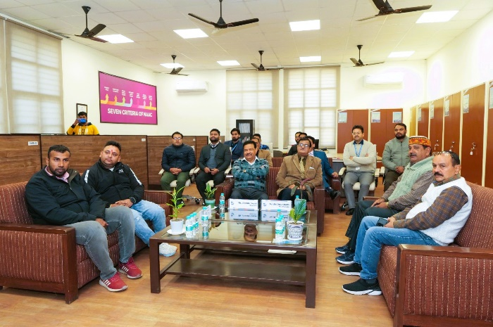

**16.2.5 University principles on corruption and bribery**

Uttaranchal University places a high priority on ethics, integrating them into every level of the institution. All faculty, staff, and students receive guidance on unacceptable practices that must never be compromised. To support this commitment, the university adheres to the guidelines outlined in its policy document on bribery and corruption.

**16.2.6 Academic freedom policy**

Uttaranchal University emphasizes the importance of academic freedom as a cornerstone of knowledge development. Genuine intellectual growth can only flourish in an environment where research and the sharing of information are pursued without fear of repercussions, particularly when such information challenges prevailing political narratives or authority figures. Academic freedom encompasses the ability to express opinions on institutional policies and broader societal issues. Faculty members are encouraged to engage in these discussions while maintaining their individuality, avoiding the impression that they speak on behalf of the university. It is essential for those in positions of authority to uphold a commitment to honesty, exercise thoughtful restraint, and honor the free speech rights of others, recognizing the weight of their influence within the community.

**16.2.7 Publish financial data**

The financial status of Uttaranchal University can vary based on several factors, including its size, location, endowment, revenue sources, and expenses. It's important to recognize that this financial status can change over time due to various internal and external influences. Prospective students, faculty, staff, and donors often consider the university's financial health when making decisions about their involvement with the institution. To assess the financial status of Uttaranchal University, you can refer to annual reports, audits, and information provided by university authorities. Additionally, the university promotes transparency through its website and public relations offices, offering insights into its financial standing.

**16.3.1 Provide expert advice to the government**

Our Vice Chancellor, Pro Vice Chancellors, and Senior Professors are actively engaged in advising the Uttarakhand state government on a range of topics, including sustainable practices, legal frameworks, and health aid initiatives. Their expertise contributes to informed decision-making and the advancement of policies that promote sustainability and well-being in the region.

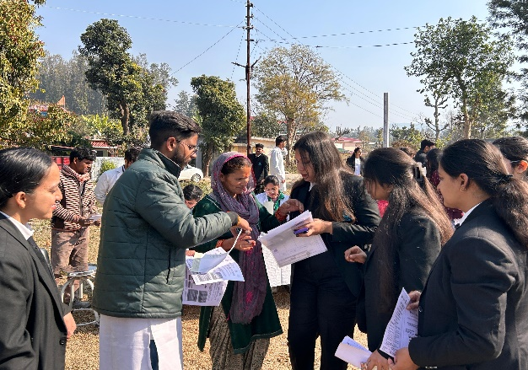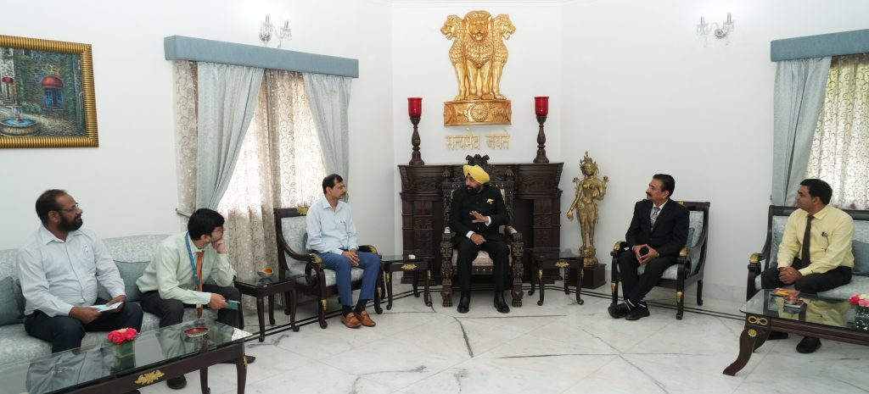

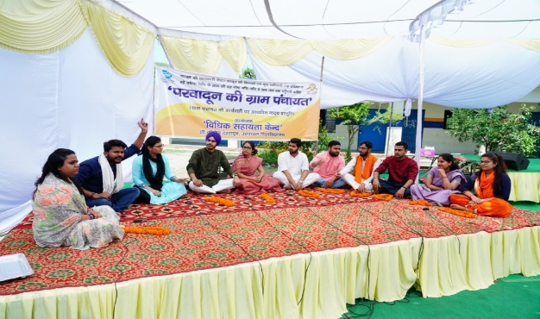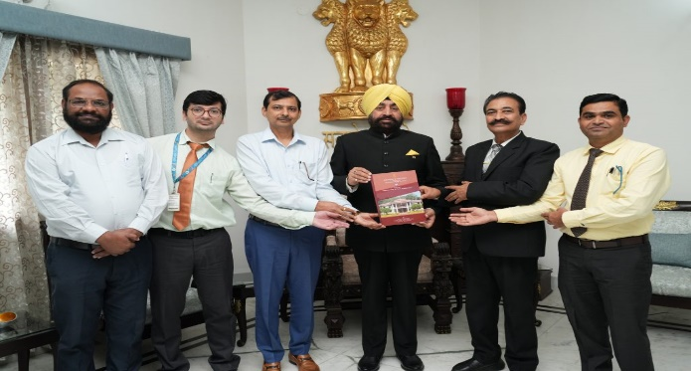

**16.3.2 Policy- and lawmakers outreach and education**

Education, training, and coaching are vital for everyone, from students to seasoned professionals, as they navigate their careers. At Uttaranchal University, we pride ourselves on being a multidisciplinary knowledge hub that goes beyond traditional academics to provide valuable life lessons. This approach uniquely positions us to support the continuous learning needs of government professionals across diverse departments and sectors.

Throughout the years, the university has become a leader in delivering training programs in critical areas such as legal aid, technology, management, leadership, health, and ethics, empowering professionals to excel in their fields.

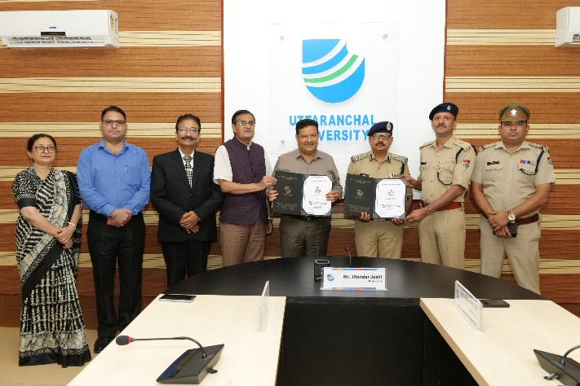

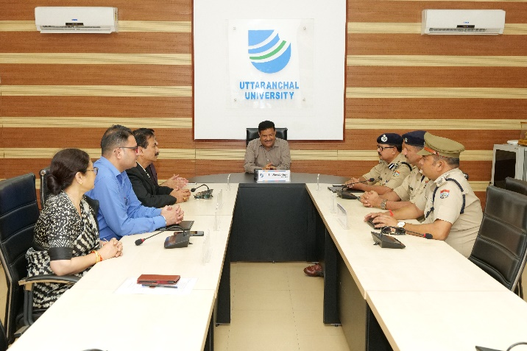

**MoU is signed between the Police Training College Narendra Nagar and Uttaranchal University**. This MoU will benefit Uttarakhand's police officers by providing access to the advanced infrastructure and expertise of Law College Dehradun. Conversely, Law College students will gain valuable insights from practical experiences with police officers, enhancing their understanding of law implementation.

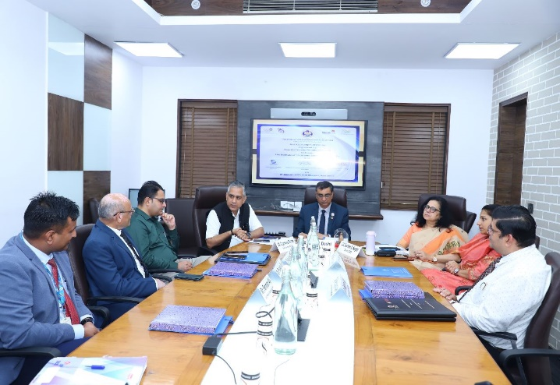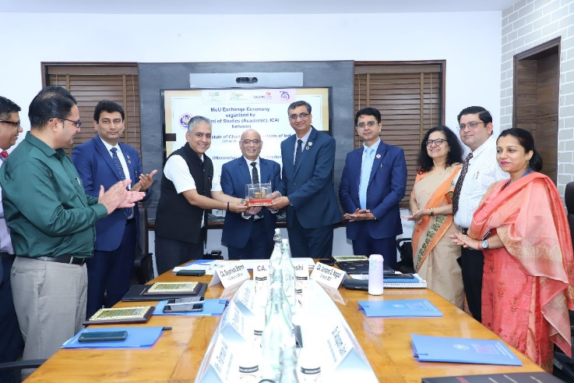

**Uttaranchal Institute of Management, Uttaranchal University and Institute of Chartered Accountants of India (ICAI)** have signed an educational Memorandum of Understanding (MoU). The objective of this MoU is to extend academic co-operation in B Com, B Com (Hons), M Com and Certificate and Diploma in Commerce Courses and to stimulate and facilitate the development of collaborative and mutually beneficial programmes, which will serve to enhance the intellectual life and cultural development in both organizations.

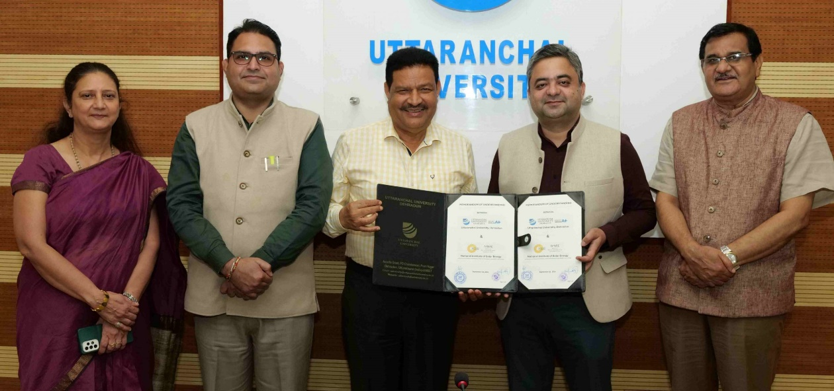

**Uttaranchal University has signed an MoU with the National Institute of Solar Energy (NISE), Union Ministry of New and Renewable Energy.**

The aim of the MOU is to undertake the Design, Development and promotion of Renewable Energy Systems in Uttarakhand. Uttarakhand state has enormous potential for renewable energy resources. The MoU will contribute towards the socio-economic growth of Uttarakhand by reducing carbon emissions and by providing skilled manpower for projects, technology and policy.

**Faculty Development Programs, workshops, and expert sessions**

The university organizes Faculty Development Programs, workshops, and expert sessions to provide knowledge and training on various topics, including technology, health, social issues, agriculture, and sustainable practices. These initiatives aim to enhance faculty expertise and foster a deeper understanding of current challenges and innovations in these fields.

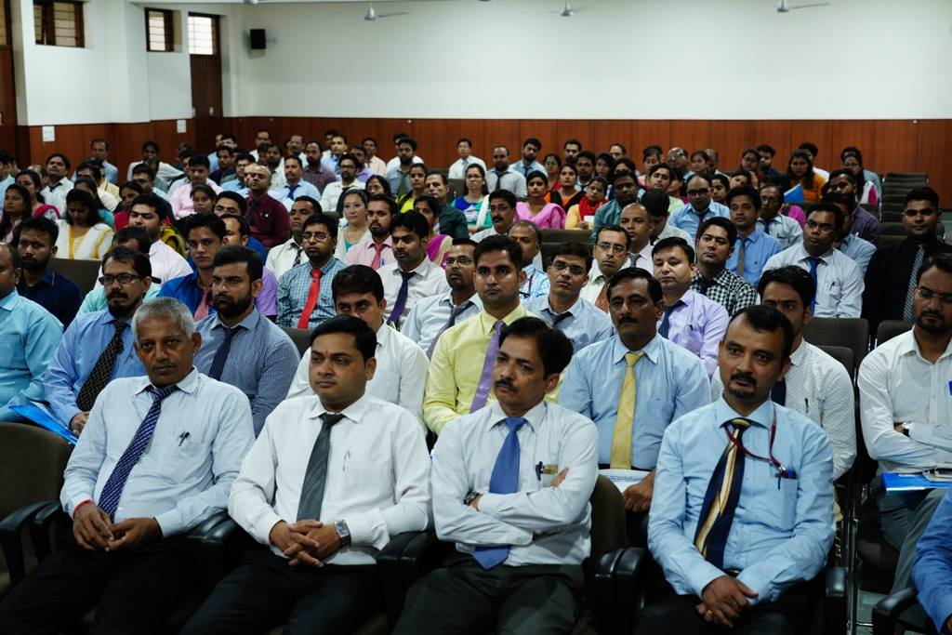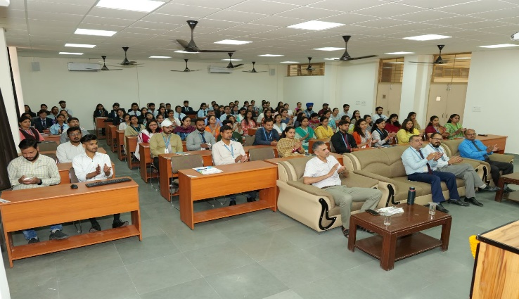

**16.3.3 Participation in government research**

Since its inception, Uttaranchal University has prioritized quality research both within academia and beyond. The university has partnered with numerous government institutes and organizations at both the state and national levels to engage in impactful research across a wide range of domains. This collaborative approach not only advances knowledge but also addresses pressing societal challenges, reinforcing the university’s commitment to fostering innovation and excellence in research.

Here is a list of government institutes and other agencies with which the university has partnered to conduct research and outreach activities:

* Uttarakhand State Council for Science and Technology
* Uttarakhand State Education & Research Centre
* Ministry of Law, Government of India
* Vidyasthal Children Academy
* Indian Council of Social Science Research (ICSSR)
* Department of Justice, Ministry of India
* Unnat Bharat Abhiyan

**16.3.4 Neutral platform to discuss issues**

Uttaranchal University is committed to fostering a neutral platform that provides a safe space for diverse political stakeholders to engage in open and honest discussions about the challenges they face. By encouraging collaboration and dialogue among different perspectives, the university promotes a constructive environment where ideas can be exchanged freely. This initiative aims to bridge gaps between various political viewpoints and facilitate meaningful conversations that contribute to informed decision-making and collaborative problem-solving within the community.

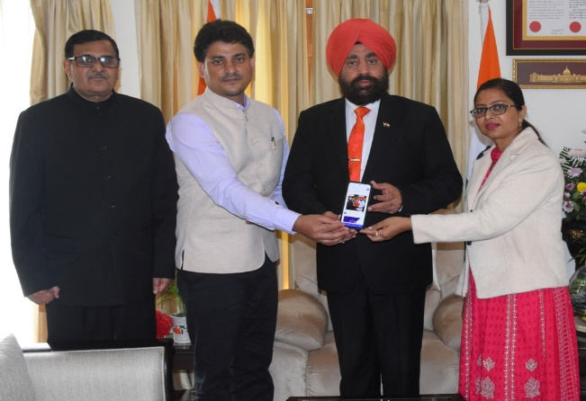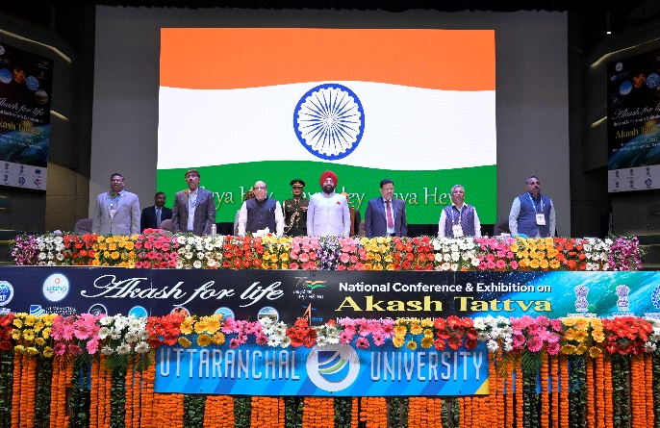

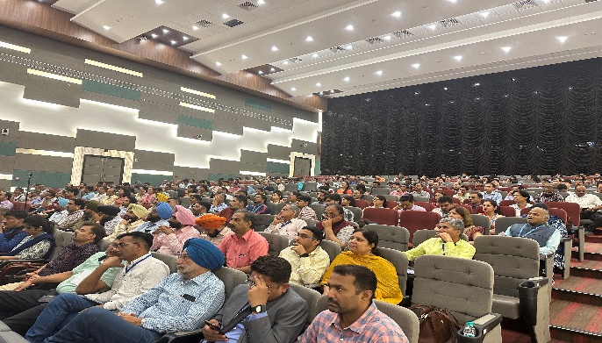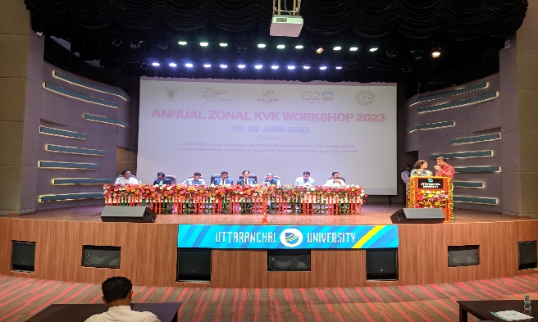

**16.4.1 Proportion of graduates in law**



**17.4.4 Does your university as a body measure the sustainability literacy of students?**

Uttaranchal University assesses sustainability literacy through a comprehensive approach that integrates multiple elements. Sustainability topics are embedded within the curriculum across various programs, ensuring that students gain foundational knowledge in this area. Assessments such as projects, exams, and research work further evaluate students' understanding of sustainability principles. Active engagement is promoted through workshops, seminars, and student-led initiatives, which encourage students to become more involved in sustainability efforts. Additionally, real-world experience is facilitated through internships and industry collaborations, providing practical exposure to sustainable practices. Feedback from surveys and course evaluations is also collected to gauge and enhance students' awareness of sustainability. This holistic strategy enables the university to continuously monitor and improve sustainability literacy among its students.



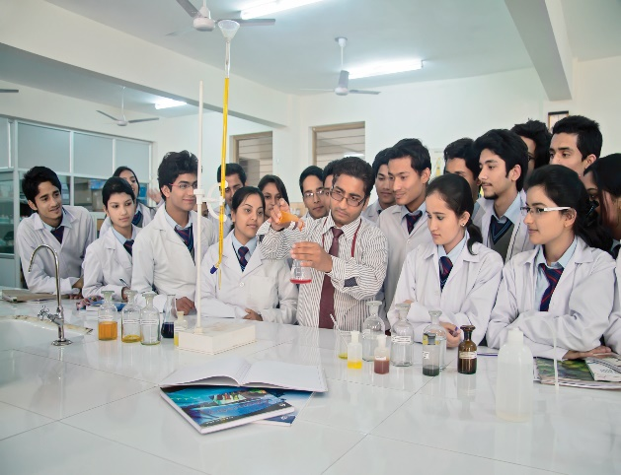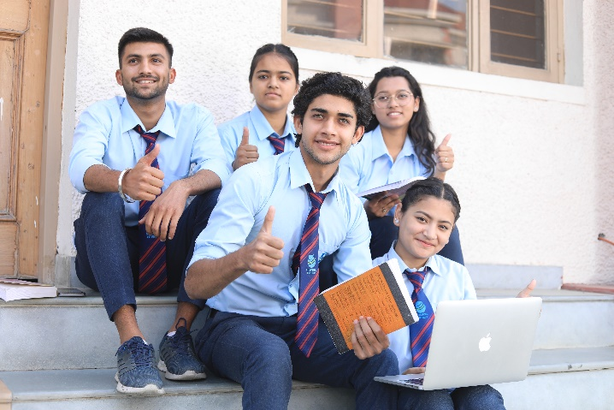

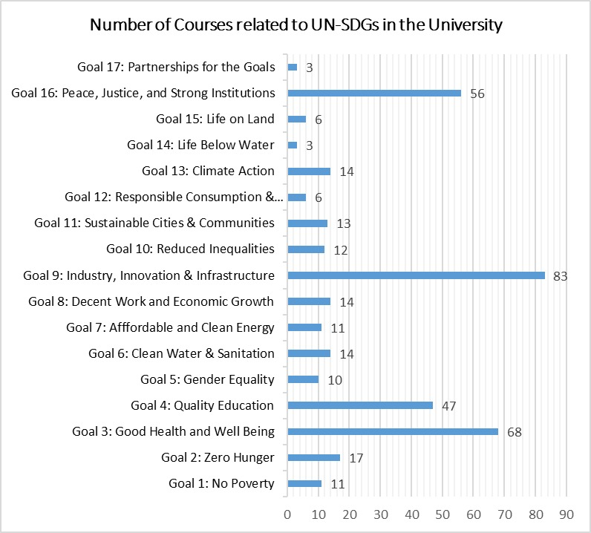

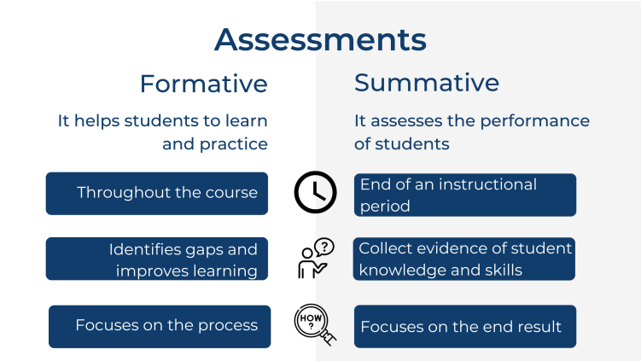

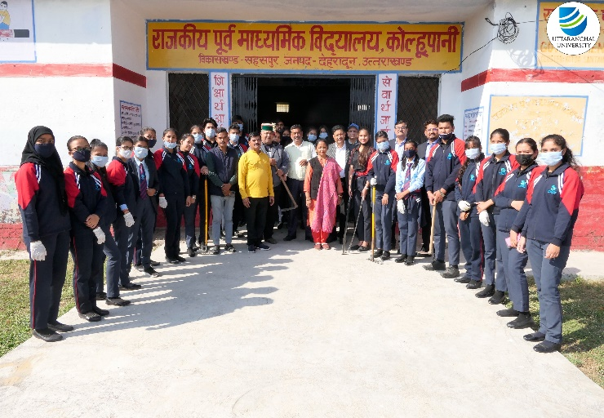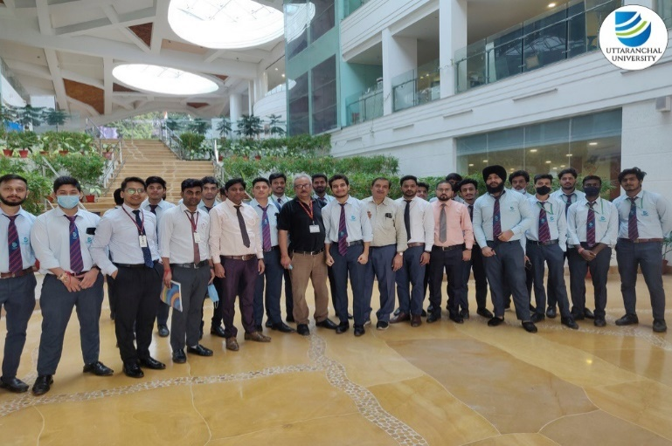

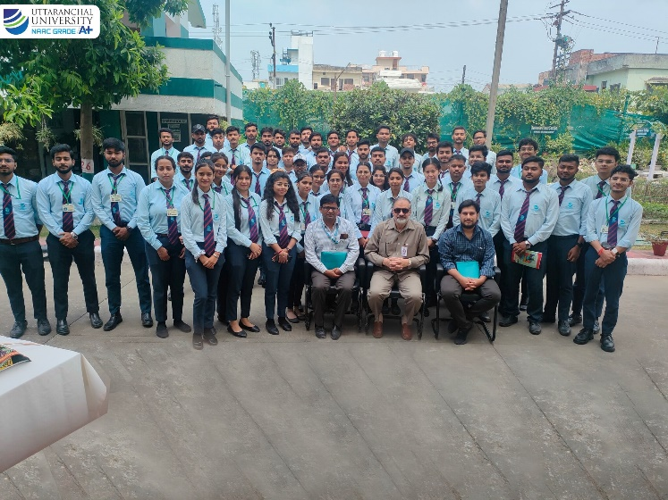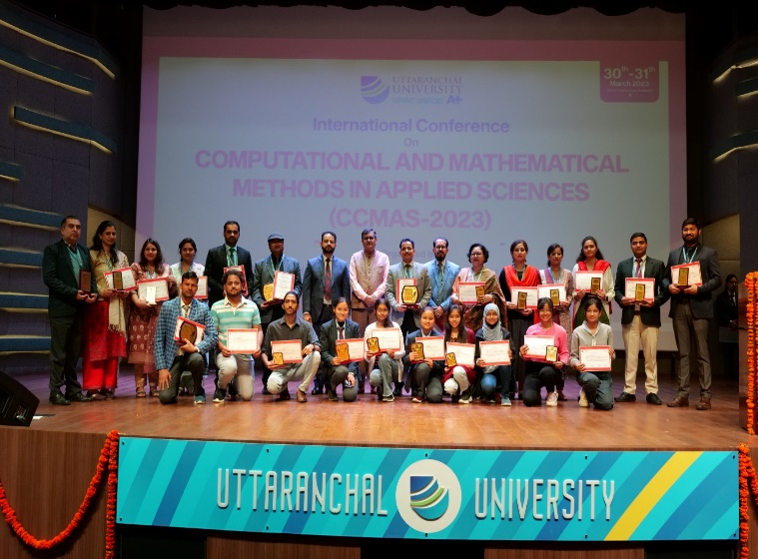

**Training**

**Community Projects**

**Conference**

**Workshop**

**Seminar**

**Internship**

